**Solution Symbol Resource**

**Access Points**

**Symbol Name:**

**Symbol Picture:** C:\Data\Symbology\Utilities\Water\CCTVProcessor\web\Access-Points.png

**Symbol Source:**

**Symbol Date:** May 2015

**Created by:** Esri Solutions Team

**License:** None

**Acknowledgement:** None required

**Notes:** None

**Act of Nature**

**Symbol Name:** [Storm](https://thenounproject.com/search/?q=storm&i=24502)

**Symbol Picture:** C:\Users\heat5533\Documents\GitHub\solutions-symbology-data\symbology\web\png\Natural-Disaster-Incident.png

**Symbol Source:**  The Noun Project

**Symbol Date:** December 2015

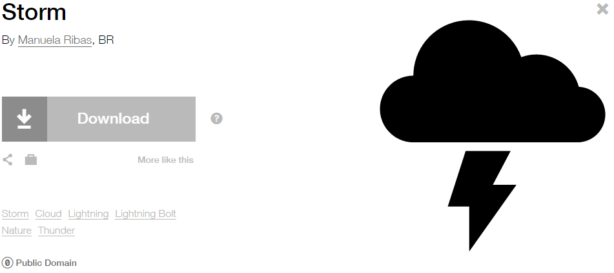

**Modified by:** Esri Solutions Team

**License:** Public Domain

**Acknowledgement:** None required

**Notes:** None

**Address Not Verified**

**Symbol Name:** P

**Symbol Picture:** C:\Data\Symbology\LocalGov\Address Verification\mobile\Address-not-verified.png

**Symbol Source:** Arial Rounded MT Bold font

**Symbol Date:** May 2016

**Modified by:** Esri Solutions Team

**License:** None

**Acknowledgement:** None required

**Notes:** None

**Address Verified**

**Symbol Name:** A

**Symbol Picture:** C:\Data\Symbology\LocalGov\Address Verification\mobile\Address-verified.png

**Symbol Source:** Arial Rounded MT Bold font

**Symbol Date:** May 2016

**Modified by:** Esri Solutions Team

**License:** None

**Acknowledgement:** None required

**Notes:** None

**Alarm Control Panels - Other**

**Symbol Name:** [Alarm](http://napsg-web.s3.amazonaws.com/symbology/index.html#/single?PREPLN%20ALARM%20RED%20%20SOLID%20GENERIC%20Alarm%20128x128)

**Symbol Picture:**



**Symbol Source:** NAPSG (National Alliance for Public Safety GIS Foundation)

**Symbol Date:** March 2017

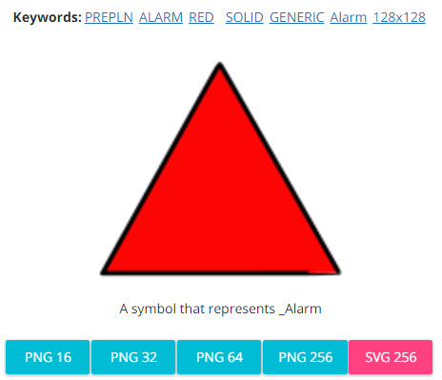

**Modified by:** Esri Solutions Team

**License:** None

**Acknowledgement:** None required

**Notes:** None

**Alternative Entry Point**

**Symbol Name:** P

**Symbol Picture:** Alternative-Entry-Point

**Symbol Source:** Arial font

**Symbol Date:** December 2015

**Modified by:** Esri Solutions Team

**License:** None

**Acknowledgement:** None required

**Notes:** None

**Adult Care**

**Symbol Name:** L1 Adult Day Care

**Symbol Picture:** C:\Data\Symbology\StateGov\MyHealthServices\web\Adult-Care.png

**Symbol Source:** ERS Homeland Security style file

**Symbol Date:** March 2015

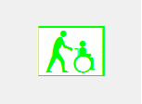

**Modified by:** Esri Solutions Team

**License:** None

**Acknowledgement:** None Required

**Notes:** None

**Agriculture Animal Health Incident**

**Symbol Name:** L1 Animal Feedlots

**Symbol Picture:** C:\Data\Symbology\Solutions\OpsIncident\web\Agriculture-Animal-Health.png

**Symbol Source:** ERS Homeland Security style file

**Symbol Date:** February 2015

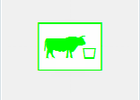

**Modified** **by:** Esri Solutions Team

**License:** None

**Acknowledgement:** None required

**Notes:** None

**Air Incident**

**Symbol Name:** Air Incident

**Symbol Picture:** C:\Data\Symbology\Solutions\OpsIncident\web\Air-Incident.png

**Symbol Source:** ERS Homeland Security style file

**Symbol Date:** February 2015



**Modified** **by:** Esri Solutions Team

**License:** None

**Acknowledgement:** None required

**Notes:** None

**Airplane Crash**

**Symbol Name:** Air Incident

**Symbol Picture:** C:\Data\Symbology\Solutions\HazardandRiskAssessment\web\Air-Plane-Crash.png

**Symbol Source:** ERS Homeland Security style file

**Symbol Date:** September 2015



**Modified by:** EsriSolutions Team

**License:** None

**Acknowledgement:** None required

**Notes:** None

**Airports**

**Symbol Name:** Airport

**Symbol Picture:** C:\Users\heat5533\Documents\GitHub\solutions-symbology-data\symbology\web\png\Airports.png

**Symbol Source:** Forestry style file

**Symbol Date:** May 2014



**Modified by:** Esri Solutions Team

**License:** None

**Acknowledgement:** None required

**Notes:** None

**Amphibian**

**Symbol Name:** [Toad](https://thenounproject.com/term/toad/4708/)

**Symbol Picture:** C:\Data\Symbology\StateGov\CitizenScience\web\Amphibians.png

**Symbol Source:** The Noun Project

**Symbol Date:** March 2015

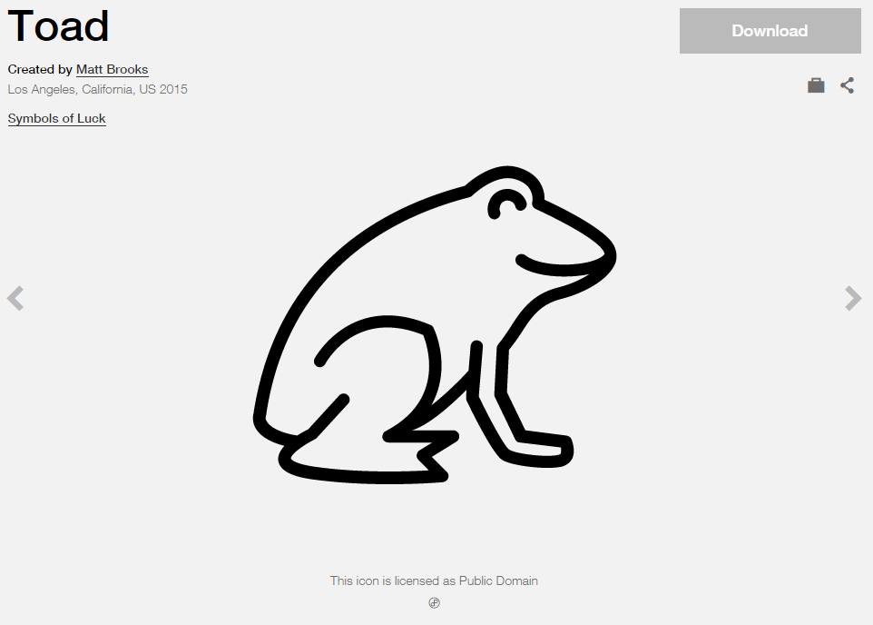

**Modified by:** Esri Solutions Team

**License:** Public Domain

**Acknowledgement:** None required

**Notes:** None

**Animal Disease Outbreak**

**Symbol Name:** [Substance Abuse Service](https://thenounproject.com/term/substance-abuse-service/41339/)

**Symbol Picture:** C:\Data\Symbology\Solutions\HazardandRiskAssessment\web\Animal-Disease-Outbreak.png

**Symbol Source:** The Noun Project

**Symbol Date:** September 2015

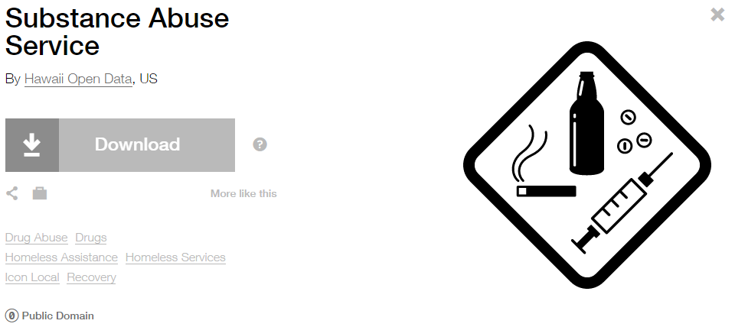

**Modified by:** EsriSolutions Team

**License:** Public Domain

**Acknowledgement:** None required

**Notes:** None

**Animal Feeding Operations Permit**

**Symbol Name:** Horse Area

**Symbol Picture:** **C:\Users\heat5533\Documents\GitHub\solutions-symbology-data\symbology\web\png\Animal-Feeding-Operation.png**

**Symbol Source:** Forestry style file

**Symbol Date:** August 2014

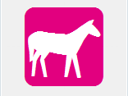

**Modified by:** Esri Solutions Team

**License:** None

**Acknowledgement:** None required

**Notes:** None

**Animal Health Emergency**

**Symbol Name:** Cross 2

**Symbol Picture:** C:\Data\UC\UC2015\SituationalAwareness\web\Animal-Health-Emergency.png

**Symbol Source:**  ESRI Default style file

**Symbol Date:** July 2015

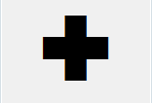

**Modified by:** Esri Solutions Team

**License:** None

**Acknowledgement:** None required

**Notes:** None

**Animal Problem – Completed, In – Progress, Received, and Submitted**

**Symbol Name:**

**Symbol Picture:** C:\Users\heat5533\Documents\GitHub\solutions-symbology-data\symbology\web\png\Animal-Problem-Completed.pngC:\Users\heat5533\Documents\GitHub\solutions-symbology-data\symbology\web\png\Animal-Problem-In-Progress.pngC:\Users\heat5533\Documents\GitHub\solutions-symbology-data\symbology\web\png\Animal-Problem-Received.pngC:\Users\heat5533\Documents\GitHub\solutions-symbology-data\symbology\web\png\Animal-Problem-Submitted.png

**Symbol Source:**

**Symbol Date:** March 2016

**Created** **by:** EsriSolutions Team

**License:** None

**Acknowledgement:** None required

**Notes:** None

**Appliances**

**Symbol Name:**

**Symbol Picture:** C:\Data\Symbology\Solutions\Debris\web\Appliances.png

**Symbol Source:**

**Symbol Date:** March 2015

**Created** **by:** Esri Solutions Team

**License:** None

**Acknowledgement:** None required

**Notes:** None

**Aquatic Resource Alteration Permit**

**Symbol Name:** Water Recreation

**Symbol Picture:** C:\Users\heat5533\Documents\GitHub\solutions-symbology-data\symbology\web\png\Aquatic-Resource-Alteration.png

**Symbol Source:** Forestry style file

**Symbol Date:** August 2014



**Modified by:** Esri Solutions Team

**License:** None

**Acknowledgement:** None required

**Notes:** None

**Art Galleries**

**Symbol Name:**

**Symbol Picture:** C:\Users\heat5533\Documents\GitHub\solutions-symbology-data\symbology\web\png\Art-Galleries.png

**Symbol Source:**

**Symbol Date:** March 2015

**Created by:** Esri Solutions Team

**License:** None

**Acknowledgement:** None required

**Notes:** None

**Arts and Cultural Centers**

**Symbol Name:** [Arts-And-Culture](http://thenounproject.com/term/arts-and-culture/13644/)

**Symbol Picture:** C:\Users\heat5533\Documents\GitHub\solutions-symbology-data\symbology\web\png\Arts-and-Culture.png

**Symbol Source:** The Noun Project

**Symbol Date:** February 2015

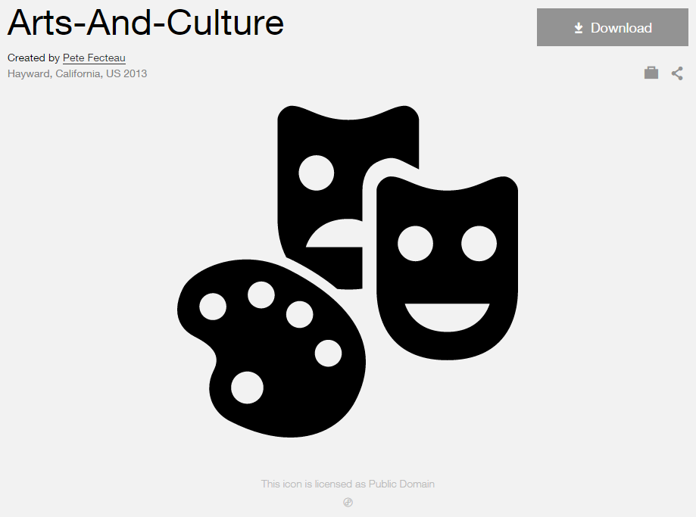

**Modified by:** Esri Solutions Team

**License:** Public Domain

**Acknowledgement:** None required

**Notes:** None

**Assessment Appeal Applicant**

**Symbol Name:** [Coordinated Assessment](https://thenounproject.com/search/?q=Appeal+Assessment&i=4190)

**Symbol Picture:** C:\Data\Symbology\LocalGov\AssessmentAppeals\web\AssessmentAppeals12.png

**Symbol Source:** The Noun Project

**Symbol Date:** October 2015

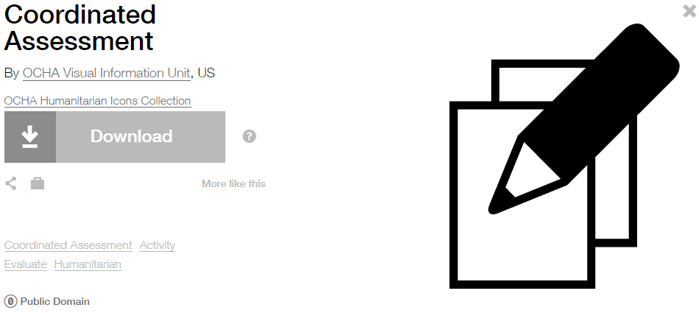

**Modified by:** Esri Solutions Team

**License:** Public Domain

**Acknowledgement:** None required

**Notes:** None

**Asset Misplaced**

**Symbol Name:** [Map](https://thenounproject.com/term/map/2312/)

**Symbol Picture:** C:\Users\heat5533\Documents\GitHub\solutions-symbology-data\symbology\mobile\png\Asset-Misplaced.pngC:\Users\heat5533\Documents\GitHub\solutions-symbology-data\symbology\web\png\Asset-Misplaced.png

**Symbol Source:** The Noun Project

**Symbol Date:** May 2015

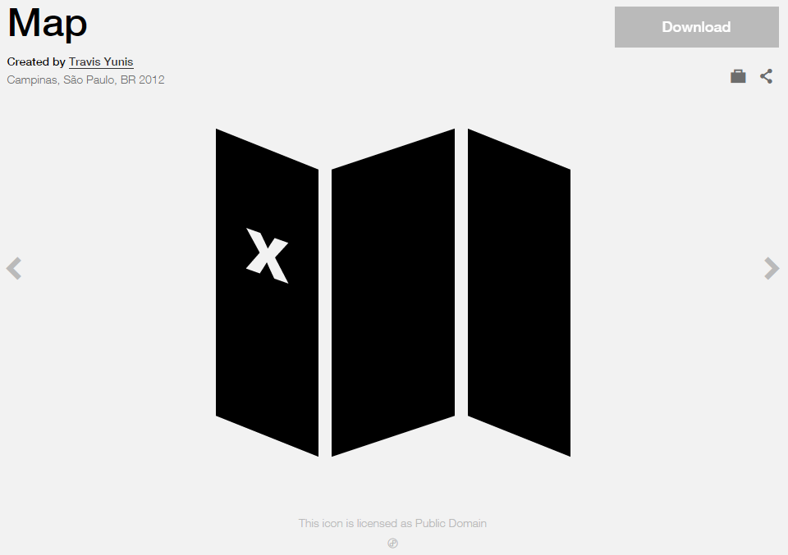

**Modified by:** Esri Solutions Team

**License:** Public Domain

**Acknowledgement:** None required

**Notes:** None

**ATM**

**Symbol Name:** ATM

**Symbol Picture:** C:\Users\heat5533\Documents\GitHub\solutions-symbology-data\symbology\web\png\ATM.png

**Symbol Source:** Arial Rounded MT Bold

**Symbol Date:** August 2015

**Modified by:** Esri Solutions Team

**License:** None

**Acknowledgement:** None required

**Notes:** None

**Attic Access**

**Symbol Name:** [Attic Access](http://napsg-web.s3.amazonaws.com/symbology/index.html#/single?PREPLN%20ACCESS%20GREEN%20SOLID%20SIMPLE%20Attic%20Access%20128x128)

**Symbol Picture:**



**Symbol Source:** NAPSG (National Alliance for Public Safety GIS Foundation)

**Symbol Date:** March 2017

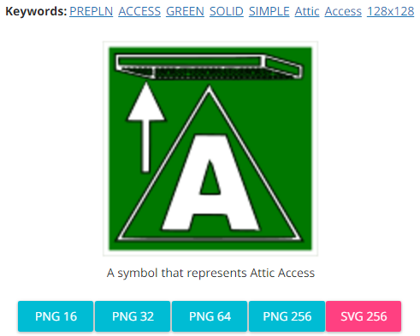

**Modified by:** Esri Solutions Team

**License:** None

**Acknowledgement:** None required

**Notes:** None

**Automated External Defibrillators**

**Symbol Name:** Bolt & [Heart](https://thenounproject.com/search/?q=heart&i=822)

**Symbol Picture:** C:\Data\Symbology\LocalGov\AEDInventory\mobile\AED.png

**Symbol Source:** Esri style file & The Noun Project

**Symbol Date:** July 2015

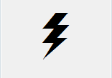 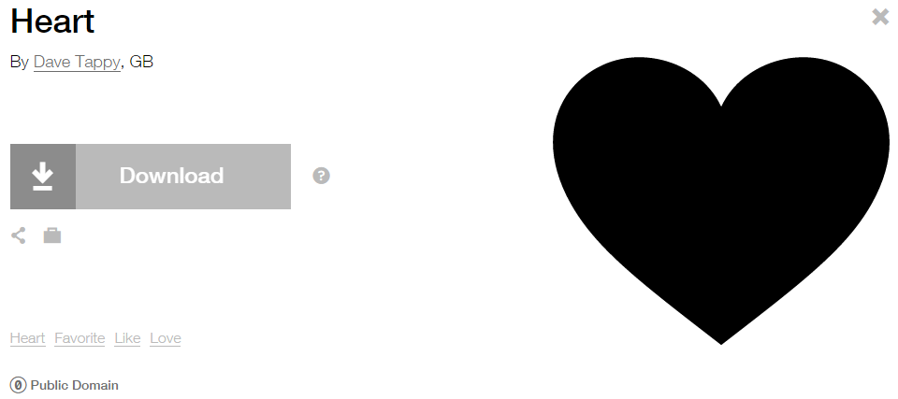

**Modified by:** Esri Solutions Team

**License:** Public Domain

**Acknowledgement:** None required

**Notes:** None

**Avalanche**

**Symbol Name:** [Avalanche](https://thenounproject.com/search/?q=avalanche&i=4246)

**Symbol Picture:** C:\Data\Symbology\Solutions\HazardandRiskAssessment\web\Avalanche.png

**Symbol Source:** The Noun Project

**Symbol Date:** August 2015

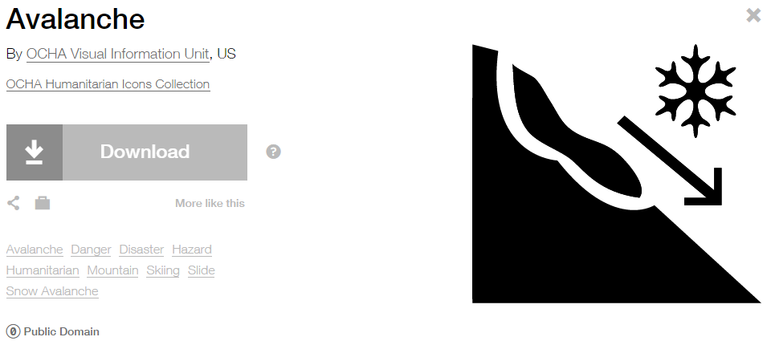

**Modified by:** EsriSolutions Team

**License:** Public Domain

**Acknowledgement:** None required

**Notes:** None

**Barricade**

**Symbol Name:**

**Symbol Picture:** C:\Users\heat5533\Documents\GitHub\solutions-symbology-data\symbology\web\png\Barricade.png

**Symbol Source:**

**Symbol Date:** August 2015

**Created by:** Esri Solutions Team

**License:** None

**Acknowledgement:** None required

**Notes:** None

**Basement Access**

**Symbol Name:**

**Symbol Picture:**



**Symbol Source:**

**Symbol Date:** March 2017

**Modified by:** Esri Solutions Team

**License:** None

**Acknowledgement:** None required

**Notes:** None

**Biological Attack**

**Symbol Name:** L1 Biological Sensor

**Symbol Picture:** C:\Data\Symbology\Solutions\HazardandRiskAssessment\web\Biological-Attack.png

**Symbol Source:** ERS Homeland Security

**Symbol Date:** October 2015



**Modified by:** EsriSolutions Team

**License:** None

**Acknowledgement:** None required

**Notes:** None

**Bioscience Employers**

**Symbol Name:**

**Symbol Picture:** C:\Users\heat5533\Documents\GitHub\solutions-symbology-data\symbology\web\png\Bioscience-Employers.png

**Symbol Source:**

**Symbol Date:** March 2015

**Created by:** Esri Solutions Team

**License:** None

**Acknowledgement:** None required

**Notes:** None

**Bioretention Basin**

**Symbol Name:** BB

**Symbol Picture:** C:\Data\Symbology\Utilities\Water\GreenInfrastructure\mobile\Bioretention-Basin.pngC:\Data\Symbology\Utilities\Water\GreenInfrastructure\web\Bioretention-Basin.png

**Symbol Source:** Arial Rounded MT Bold

**Symbol Date:** March 2015

**Modified** **by:** Esri Solutions Team

**License:** None

**Acknowledgement:** None required

**Notes:** None

**Biosolids Permit**

**Symbol Name:** Unicode 50

**Symbol Picture:** C:\Users\heat5533\Documents\GitHub\solutions-symbology-data\symbology\web\png\Biosolids.png

**Symbol Source:** ESRI Enviro Hazard Sites font

**Symbol Date:** September 2014

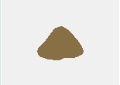

**Modified by:** Esri Solutions Team

**License:** None

**Acknowledgement:** None required

**Notes:** None

**Bioswale**

**Symbol Name:** B

**Symbol Picture:** C:\Data\Symbology\Utilities\Water\GreenInfrastructure\mobile\Bioswale.pngC:\Data\Symbology\Utilities\Water\GreenInfrastructure\web\Bioswale.png

**Symbol Source:** Arial Rounded MT Bold Font

**Symbol Date:** March 2015

**Modified** **by:** Esri Solutions Team

**License:** None

**Acknowledgement:** None required

**Notes:** None

**Bird**

**Symbol Name:** Bird Infestation

**Symbol Picture:** C:\Data\Symbology\StateGov\CitizenScience\web\Bird.png

**Symbol Source:** Esri ERS Homeland Security style file

**Symbol Date:** March 2015



**Modified by:** Esri Solutions Team

**License:** None

**Acknowledgement:** None required

**Notes:** None

**BMP Maintenance Violation**

**Symbol Name:** BMP

**Symbol Picture:** C:\Data\Symbology\Utilities\Water\ConstructionSiteViolations\mobile\BMP-Maintenance-Violation.png

**Symbol Source:** Arial Rounded MT Bold Font

**Symbol Date:** March 2015

**Modified** **by:** Esri Solutions Team

**License:** None

**Acknowledgement:** None required

**Notes:** None

**Birth Service**

**Symbol Name:** [Baby](http://thenounproject.com/term/baby/47/)

**Symbol Picture: C:\Data\Symbology\StateGov\MyHealthServices\web\Birth-Services.png**

**Symbol Source:** The Noun Project

**Symbol Date:** March 2015

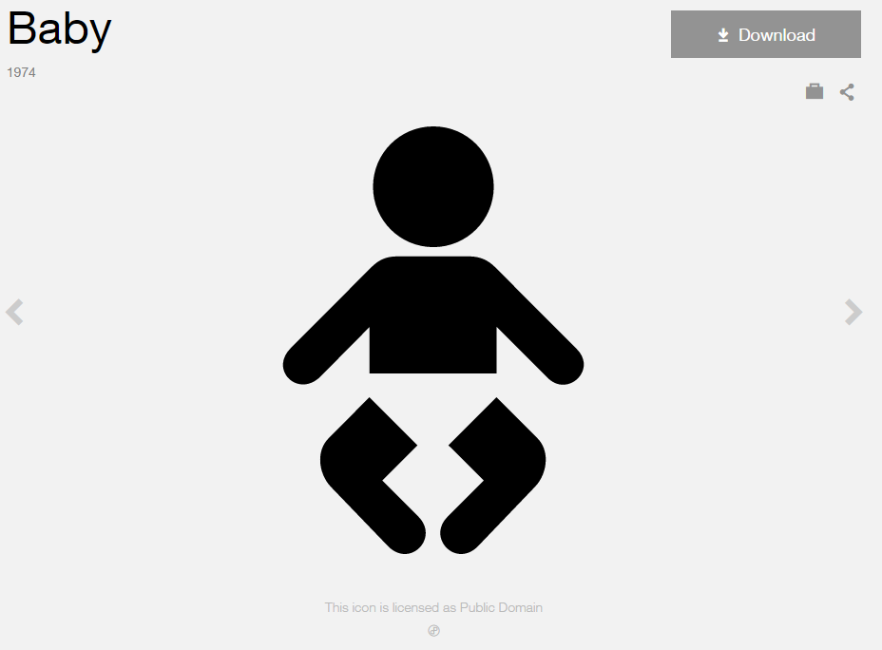

**Modified by:** Esri Solutions Team

**License:** Public Domain

**Acknowledgement:** None Required

**Notes:** None

**Bleacher**

**Symbol Name:** Waiting Room, Lounge

**Symbol Picture:** C:\Users\heat5533\Documents\GitHub\solutions-symbology-data\symbology\web\png\Bleacher.png

**Symbol Source:** Public Signs style file

**Symbol Date:** August 2015

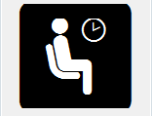

**Modified by:** Esri Solutions Team

**License:** None

**Acknowledgement:** None required

**Notes:** None

**Blight Problem – Completed, In – Progress, Received, and Submitted**

**Symbol Name:** [Graffiti Removal](https://thenounproject.com/search/?q=graffiti&i=750)

**Symbol Picture:** C:\Users\heat5533\Documents\GitHub\solutions-symbology-data\symbology\web\png\Blight-Problem-Completed.pngC:\Users\heat5533\Documents\GitHub\solutions-symbology-data\symbology\web\png\Blight-Problem-In-Progress.pngC:\Users\heat5533\Documents\GitHub\solutions-symbology-data\symbology\web\png\Blight-Problem-Received.pngC:\Users\heat5533\Documents\GitHub\solutions-symbology-data\symbology\web\png\Blight-Problem-Submitted.png

**Symbol Source:** The Noun Project

**Symbol Date:** April 2016

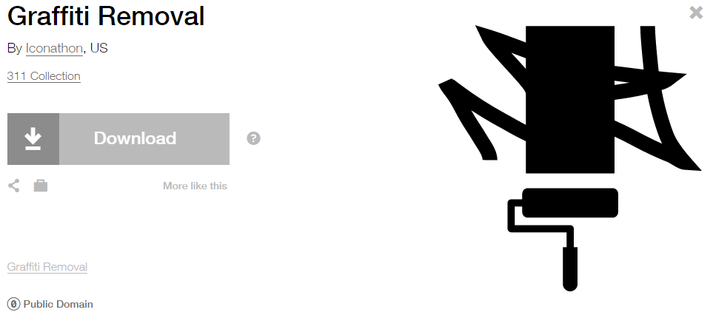

**Modified** **by:** Esri Solutions Team

**License:** Public Domain

**Acknowledgement:** None required

**Notes:** None

**Boat Launch**

**Symbol Name:** Boat Launch

**Symbol Picture:** C:\Users\heat5533\Documents\GitHub\solutions-symbology-data\symbology\web\png\Boat-Launch.png

**Symbol Source:** Forestry style file

**Symbol Date:** May 2014



**Modified by:** Esri Solutions Team

**License:** None

**Acknowledgement:** None required

**Notes:** None

**Brickwork**

**Symbol Name:**

**Symbol Picture:** C:\Data\Symbology\Utilities\Water\CCTVProcessor\web\Brickwork.png

**Symbol Source:**

**Symbol Date:** May 2015

**Created by:** Esri Solutions Team

**License:** None

**Acknowledgement:** None required

**Notes:** None

**Bridges**

**Symbol Name:** [Highway](https://thenounproject.com/search/?q=freeway&i=13084)

**Symbol Picture:** C:\Data\UC\UC2015\SituationalAwareness\web\Bridges.pngC:\Users\heat5533\Documents\GitHub\solutions-symbology-data\symbology\mobile\png\Bridges.png

**Symbol Source:** The Noun Project

**Symbol Date:** July 2015

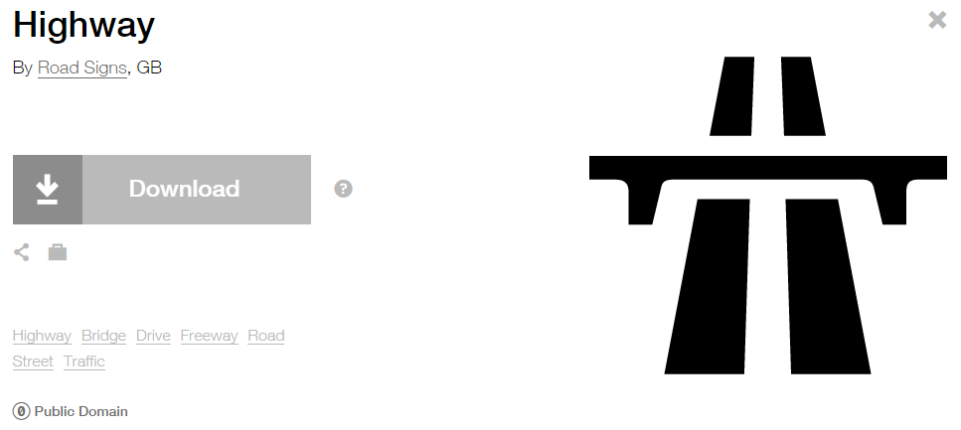

**Modified by:** Esri Solutions Team

**License:** Public Domain

**Acknowledgement:** None required

**Notes:** None

**Broken**

**Symbol Name:**

**Symbol Picture:** C:\Data\Symbology\Utilities\Water\CCTVProcessor\web\Broken.png

**Symbol Source:**

**Symbol Date:** May 2015

**Created by:** Esri Solutions Team

**License:** None

**Acknowledgement:** None required

**Notes:** None

**Building Access - Other**

**Symbol Name:**

**Symbol Picture:**



**Symbol Source:**

**Symbol Date:** March 2017

**Modified by:** Esri Solutions Team

**License:** None

**Acknowledgement:** None required

**Notes:** None

**Building Problem – Completed, In – Progress, Received, and Submitted**

**Symbol Name:** Building 3

**Symbol Picture:** **C:\Users\heat5533\Documents\GitHub\solutions-symbology-data\symbology\web\png\Building-Problem-Completed.pngC:\Users\heat5533\Documents\GitHub\solutions-symbology-data\symbology\web\png\Building-Problem-In-Progress.png**C:\Users\heat5533\Documents\GitHub\solutions-symbology-data\symbology\web\png\Building-Problem-Received.pngC:\Users\heat5533\Documents\GitHub\solutions-symbology-data\symbology\web\png\Building-Problem-Submitted.png

**Symbol Source:** Civic style file

**Symbol Date:** March 2015

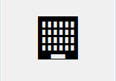

**Modified** **by:** Esri Solutions Team

**License:** None

**Acknowledgement:** None required

**Notes:** None

**Business Location**

**Symbol Name:** Building 3

**Symbol Picture:** C:\Users\heat5533\Documents\GitHub\solutions-symbology-data\symbology\mobile\png\Business-Location.pngC:\Users\heat5533\Documents\GitHub\solutions-symbology-data\symbology\web\png\Business-Location.png

**Symbol Source:** Civic style file

**Symbol Date:** April 2015

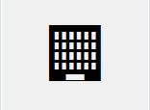

**Modified by:** Esri Solutions Team

**License:** None

**Acknowledgement:** None required

**Notes:** None

**Chemical Attack**

**Symbol Name:** [Chemical Weapon](https://thenounproject.com/term/chemical-weapon/547/)

**Symbol Picture:** C:\Data\Symbology\Solutions\HazardandRiskAssessment\web\Chemical-Attack.png

**Symbol Source:** The Noun Project

**Symbol Date:** October 2015

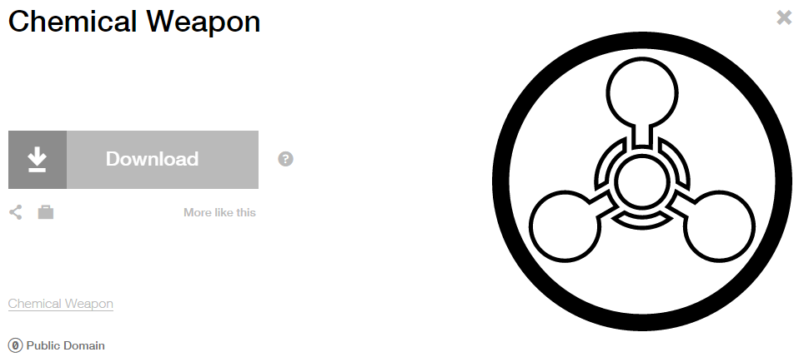

**Modified by:** EsriSolutions Team

**License:** Public Domain

**Acknowledgement:** None required

**Notes:** None

**Chikungunya**

**Symbol Name:** !

**Symbol Picture:**



**Symbol Source:**  Arial Rounded MT Bold

**Symbol Date:** December 2016

**Modified by:** Esri Solutions Team

**License:** None

**Acknowledgement:** None required

**Notes:** None

**Call Cancelled Incident**

**Symbol Name:** Phone 1

**Symbol Picture:** C:\Users\heat5533\Documents\GitHub\solutions-symbology-data\symbology\web\png\Call-Cancelled-Incident.png

**Symbol Source:**  Civic style file

**Symbol Date:** November 2015



**Modified by:** Esri Solutions Team

**License:** None

**Acknowledgement:** None required

**Notes:** None

**Camera**

**Symbol Name:**

**Symbol Picture:** C:\Data\Symbology\StateGov\Transportation511\web\Camera.png

**Symbol Source:**

**Symbol Date:** December 2015

**Created by:** Esri Solutions Team

**License:** None

**Acknowledgement:** None required

**Notes:** None

**Catch Basins - Adopted**

**Symbol Name:**

**Symbol Picture:** C:\Data\Symbology\LocalGov\Adopta\web\Adopted.pngC:\Data\Symbology\LocalGov\Adopta\web\Adopted-Small.pngC:\Data\Symbology\LocalGov\Adopta\web\Adopted-Very-Small.png

**Symbol Source:**

**Symbol Date:** May 2016

**Created by:** Esri Solutions Team

**License:** None

**Acknowledgement:** None required

**Notes:** None

**Catch Basins – Adopted By You**

**Symbol Name:**

**Symbol Picture:** C:\Data\Symbology\LocalGov\Adopta\web\Your-Adopted.pngC:\Data\Symbology\LocalGov\Adopta\web\Your-Adopted-Small.pngC:\Data\Symbology\LocalGov\Adopta\web\Your-Adopted-Very-Small.png

**Symbol Source:**

**Symbol Date:** May 2016

**Created by:** Esri Solutions Team

**License:** None

**Acknowledgement:** None required

**Notes:** None

**Catch Basins - Available**

**Symbol Name:**

**Symbol Picture:** C:\Data\Symbology\LocalGov\Adopta\web\Available.pngC:\Data\Symbology\LocalGov\Adopta\web\Available-Small.pngC:\Data\Symbology\LocalGov\Adopta\web\Available-Very-Small.png

**Symbol Source:**

**Symbol Date:** May 2016

**Created by:** Esri Solutions Team

**License:** None

**Acknowledgement:** None required

**Notes:** None

**Catch Basins – Nearest Orphan**

**Symbol Name:**

**Symbol Picture:** C:\Users\heat5533\Documents\GitHub\solutions-symbology-data\symbology\web\png\Catch-Basin-Nearest-Orphan-100-2K.pngC:\Users\heat5533\Documents\GitHub\solutions-symbology-data\symbology\web\png\Catch-Basin-Nearest-Orphan-4K-9K.pngC:\Users\heat5533\Documents\GitHub\solutions-symbology-data\symbology\web\png\Catch-Basin-Nearest-Orphan-9K-18K.png

**Symbol Source:**

**Symbol Date:** May 2016

**Created by:** Esri Solutions Team

**License:** None

**Acknowledgement:** None required

**Notes:** None

**Children’s Activities**

**Symbol Name:** Slow Children at Play

**Symbol Picture:** C:\Users\heat5533\Documents\GitHub\solutions-symbology-data\symbology\web\png\Childrens-Activities.png

**Symbol Source:** Transportation style file

**Symbol Date:** February 2015

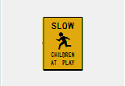

**Modified by:** Esri Solutions Team

**License:** None

**Acknowledgement:** None required

**Notes:** None

**Churches**

**Symbol Name:** Church

**Symbol Picture:** **C:\Users\heat5533\Documents\GitHub\solutions-symbology-data\symbology\web\png\Churches.png**

**Symbol Source**: Civic style file

**Symbol Date:** January 2015

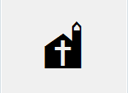

**Modified** **by:** Esri Solutions Team

**License:** None

**Acknowledgement:** None required

**Notes:** None

**Civil Disturbance Incident**

**Symbol Name:** Civil Disturbance

**Symbol Picture:** C:\Data\Symbology\Solutions\OpsIncident\web\Civil-Disturbance.png

**Symbol Source:** ERS Homeland Security style file

**Symbol Date:** February 2015

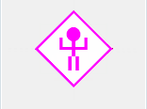

**Modified** **by:** Esri Solutions Team

**License:** None

**Acknowledgement:** None required

**Notes:** None

**Coastal Erosion**

**Symbol Name:** [Coastal](https://thenounproject.com/term/coastal/8676/)

**Symbol Picture:** C:\Data\Symbology\Solutions\HazardandRiskAssessment\web\Coastal-Errosion.png

**Symbol Source:** The Noun Project

**Symbol Date:** October 2015

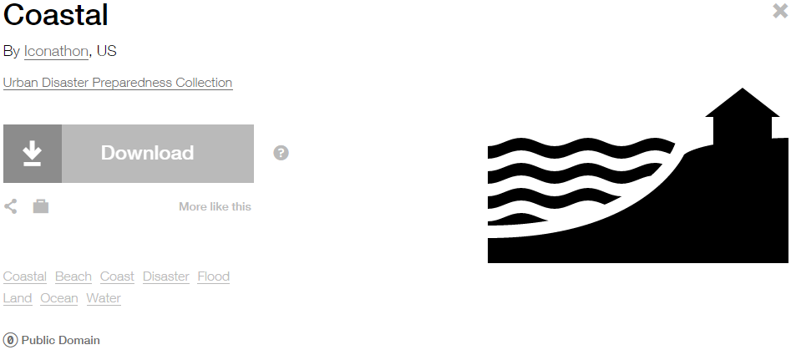

**Modified by:** EsriSolutions Team

**License:** Public Domain

**Acknowledgement:** None required

**Notes:** None

**Clinics**

**Symbol Name:** Cross 2

**Symbol Picture:** C:\Data\Symbology\StateGov\MyHealthServices\web\Hospital-and-Clinics.png

**Symbol Source:** ESRI style file

**Symbol Date:** May 2014



**Modified by:** Esri Solutions Team

**License:** None

**Acknowledgement:** None required

**Notes:** None

**Collapse**

**Symbol Name:**

**Symbol Picture:** C:\Data\Symbology\Utilities\Water\CCTVProcessor\web\Collapse.png

**Symbol Source:**

**Symbol Date:** May 2015

**Created by:** Esri Solutions Team

**License:** None

**Acknowledgement:** None required

**Notes:** None

**College/University**

**Symbol Name:** L1 College University

**Symbol Picture:** C:\Users\heat5533\Documents\GitHub\solutions-symbology-data\symbology\web\png\College-University.png

**Symbol Source:** ESRI ERS Homeland Security style file

**Symbol Date:** January 2015



**Modified** **by:** Esri Solutions Team

**License:** None

**Acknowledgement:** None required

**Notes:** None

**Command Post**

**Symbol Name:** [Command Post Plain](http://napsg-web.s3.amazonaws.com/symbology/index.html#/single?INCDNT%20COMAND%20MLTCLRhttp://napsg-web.s3.amazonaws.com/symbology/index.html)

**Symbol Picture:** Command-Post

**Symbol Source:** NAPSG (National Alliance for Public Safety GIS Foundation)

**Symbol Date:** February 2017

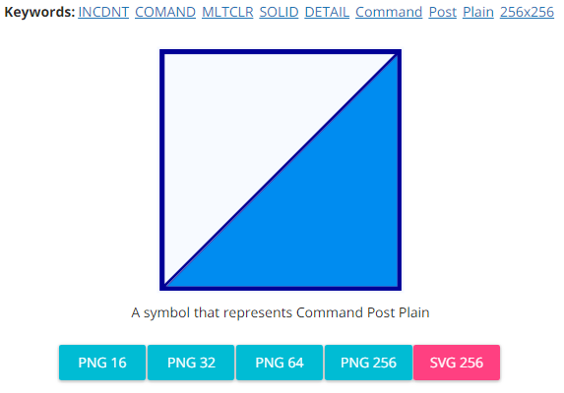

**Modified by:** Esri Solutions Team

**License:** None

**Acknowledgement:** None required

**Notes:** None

**Community Center**

**Symbol Name:** [Leadership](https://thenounproject.com/term/leadership/4199/)

**Symbol Picture:** C:\Users\heat5533\Documents\GitHub\solutions-symbology-data\symbology\web\png\Community-Center.png

**Symbol Source:** The Noun Project

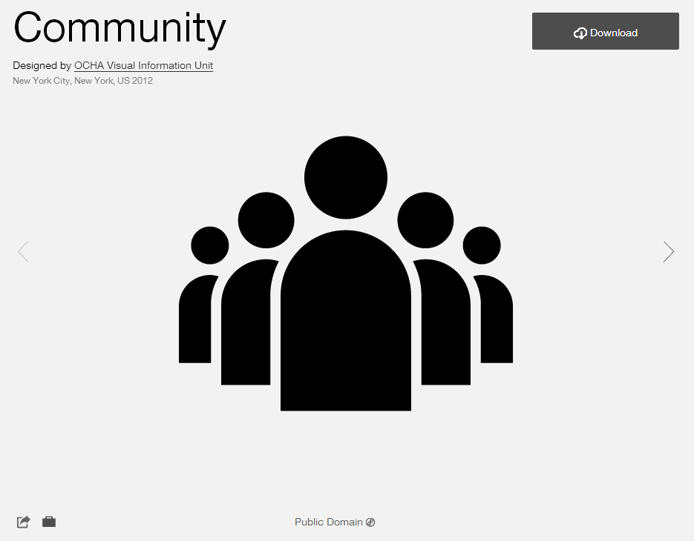

**Symbol Date:** February 2015

**Modified** **by:** Esri Solutions Team

**License:** Public Domain

**Acknowledgement:** None required

**Notes:** None

**Community Event – Approved, Denied, More Information Required, Other, Proposed, Submitted, Under Review**

**Symbol Name:**

**Symbol Picture:** C:\Users\heat5533\Documents\GitHub\solutions-symbology-data\symbology\web\png\Community-Event-Approved.pngC:\Users\heat5533\Documents\GitHub\solutions-symbology-data\symbology\web\png\Community-Event-Denied.pngC:\Users\heat5533\Documents\GitHub\solutions-symbology-data\symbology\web\png\Community-Event-More-Information-Required.pngC:\Users\heat5533\Documents\GitHub\solutions-symbology-data\symbology\web\png\Community-Event-Other.pngC:\Users\heat5533\Documents\GitHub\solutions-symbology-data\symbology\web\png\Community-Events-Proposed.pngC:\Users\heat5533\Documents\GitHub\solutions-symbology-data\symbology\web\png\Community-Event-Submitted.pngC:\Users\heat5533\Documents\GitHub\solutions-symbology-data\symbology\web\png\Community-Event-Under-Review.png

**Symbol Source:** Arial Rounded MT Bold

**Symbol Date:** June 2015

**Modified by:** Esri Solutions Team

**License:** None

**Acknowledgement:** None required

**Notes:** None

**Compressed Natural Gas Shut Off**

**Symbol Name:** [CNG Main\_With Line](http://napsg-web.s3.amazonaws.com/symbology/index.html#/single?PREPLAN%20SHUTOF%20BLUE%20%20DETAIL%20CNG%20Main%20With%20Line%20128x128)

**Symbol Picture:**



**Symbol Source:** NAPSG (National Alliance for Public Safety GIS Foundation)

**Symbol Date:** March 2017

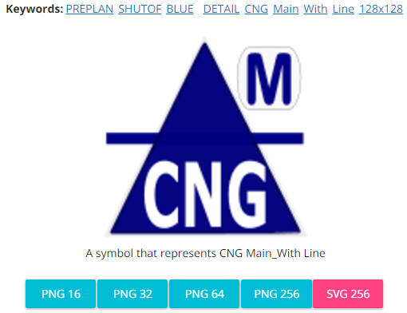

**Modified** **by:** Esri Solutions Team

**License:** None

**Acknowledgement:** None required

**Notes:** None

**Construction/Demolition**

**Symbol Name:** [Construction](http://thenounproject.com/term/construction/4275/)

**Symbol Picture:** C:\Data\Symbology\Solutions\Debris\web\Construction_Demolition.png

**Symbol Source:** The Noun Project

**Symbol Date:** March 2015

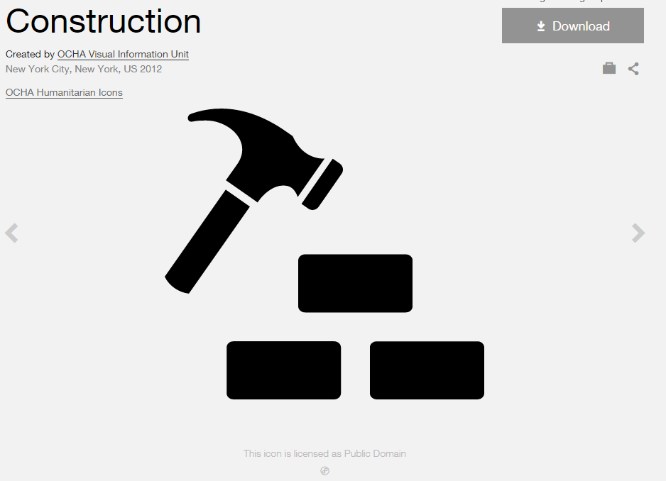

**Modified by:** Esri Solutions Team

**License:** Public Domain

**Acknowledgement:** None required

**Notes:** None

**Construction Permit**

**Symbol Name:** [Construction](http://thenounproject.com/term/construction/4275/)

**Symbol Picture:** C:\Users\heat5533\Documents\GitHub\solutions-symbology-data\symbology\web\png\Construction.png

**Symbol Source:** The Noun Project

**Symbol Date:** March 2015



**Modified by:** Esri Solutions Team

**License:** Public Domain

**Acknowledgement:** None required

**Notes:** None

**Cooling Center**

**Symbol Name:** Unicode 160

**Symbol Picture:** C:\Users\heat5533\Documents\GitHub\solutions-symbology-data\symbology\web\png\Cooling-Center.png

**Symbol Source**: ESRI US MUTCD 3 font

**Symbol Date:** February 2015

**Modified** **by:** Esri Solutions Team

**License:** None

**Acknowledgement:** None required

**Notes:** None

**Coral**

**Symbol Name:** Coral

**Symbol Picture:** C:\Data\Symbology\StateGov\CitizenScience\web\Coral.png

**Symbol Source**: Environmental style file

**Symbol Date:** May 2016

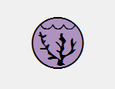

**Modified** **by:** Esri Solutions Team

**License:** None

**Acknowledgement:** None required

**Notes:** None

**Corporate Headquarters**

**Symbol Name:** Building 4

**Symbol Picture:** C:\Users\heat5533\Documents\GitHub\solutions-symbology-data\symbology\web\png\Corportate-Headquarters.png

**Symbol Source:** Civic style file

**Symbol Date:** January 2015

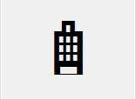

**Modified** **by:** Esri Solutions Team

**License:** None

**Acknowledgement:** None required

**Notes:** None

**Crab**

**Symbol Name:** Crab

**Symbol Picture:** C:\Data\Symbology\StateGov\CitizenScience\web\Crab.png

**Symbol Source:** Environmental style file

**Symbol Date:** May 2016



**Modified** **by:** Esri Solutions Team

**License:** None

**Acknowledgement:** None required

**Notes:** None

**Crack**

**Symbol Name:**

**Symbol Picture:** C:\Data\Symbology\Utilities\Water\CCTVProcessor\web\Crack.png

**Symbol Source:**

**Symbol Date:** May 2015

**Created by:** Esri Solutions Team

**License:** None

**Acknowledgement:** None required

**Notes:** None

**Criminal Activity Incident**

**Symbol Name:** Criminal Activity

**Symbol Picture:** C:\Data\Symbology\Solutions\OpsIncident\web\Criminal-Activity-Incident.png

**Symbol Source:** ERS Homeland Security style file

**Symbol Date:** February 2015



**Modified** **by:** Esri Solutions Team

**License:** None

**Acknowledgement:** None required

**Notes:** None

**Curb Ramps**

**Symbol Name:** Walk 1

**Symbol Picture:** C:\Data\Symbology\LocalGov\SidewalkInventory\mobile\Curb-Ramps.png

**Symbol Source:** Transportation style file

**Symbol Date:** July 2015

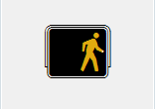

**Modified** **by:** Esri Solutions Team

**License:** None

**Acknowledgement:** None required

**Notes:** None

**Customer Contacted**

**Symbol Name:**

**Symbol Picture:** C:\Data\Symbology\Utilities\Gas\PotentialNewCustomers\web\Customer-Contacted.png

**Symbol Source:**

**Symbol Date:** May 2015

**Created by:** Esri Solutions Team

**License:** None

**Acknowledgement:** None required

**Notes:** None

**Customer Interested**

**Symbol Name:**

**Symbol Picture:** C:\Data\Symbology\Utilities\Gas\PotentialNewCustomers\web\Customer-Interested.png

**Symbol Source:**

**Symbol Date:** May 2015

**Created by:** Esri Solutions Team

**License:** None

**Acknowledgement:** None required

**Notes:** None

**Customer Not Contacted**

**Symbol Name:**

**Symbol Picture:** C:\Data\Symbology\Utilities\Gas\PotentialNewCustomers\web\Customer-Not-Contacted.png

**Symbol Source:**

**Symbol Date:** May 2015

**Created by:** Esri Solutions Team

**License:** None

**Acknowledgement:** None required

**Notes:** None

**Customer Not Interested**

**Symbol Name:**

**Symbol Picture:** C:\Data\Symbology\Utilities\Gas\PotentialNewCustomers\web\Customer-Not-Interested.png

**Symbol Source:**

**Symbol Date:** May 2015

**Created by:** Esri Solutions Team

**License:** None

**Acknowledgement:** None required

**Notes:** None

**Cyber Incident**

**Symbol Name:** [Monitor](https://thenounproject.com/term/computer-monitor/79282/)

**Symbol Picture:** C:\Data\Symbology\Solutions\HazardandRiskAssessment\web\Cyber-Incident.png

**Symbol Source:** The Noun Project

**Symbol Date:** October 2015

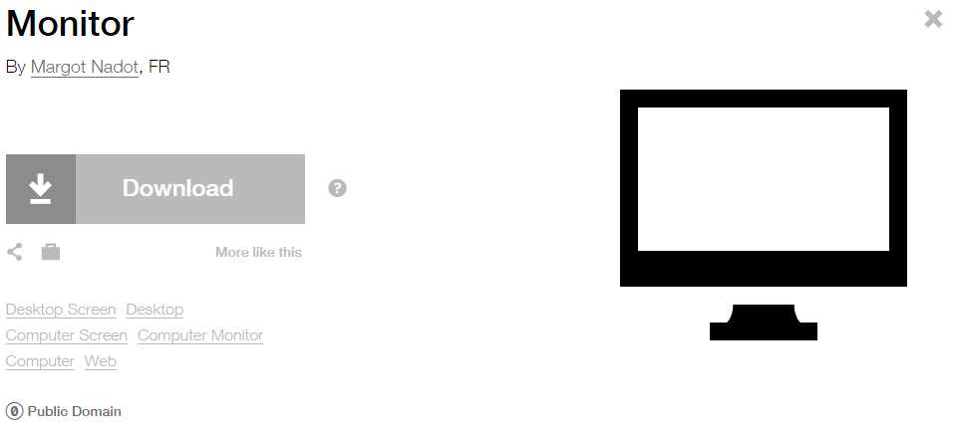

**Modified by:** EsriSolutions Team

**License:** Public Domain

**Acknowledgement:** None required

**Notes:** None

**Damage Assessment - Commercial Buildings – Affected**

**Symbol Name:** Building 3

**Symbol Picture:** C:\Data\Symbology\Solutions\DamageAssessment\mobile\CommericalBuilding-Affected.png

**Symbol Source:** Civic style file

**Symbol Date:** March 2015



**Modified** **by:** Esri Solutions Team

**License:** None

**Acknowledgement:** None required

**Notes:** None

**Damage Assessment - Commercial Buildings – Destroyed**

**Symbol Name:** Building 3

**Symbol Picture:** C:\Data\Symbology\Solutions\DamageAssessment\mobile\Commerical-Buildings-Destroyed.png

**Symbol Source:** Civic style file

**Symbol Date:** March 2015



**Modified** **by:** Esri Solutions Team

**License:** None

**Acknowledgement:** None required

**Notes:** None

**Damage Assessment - Commercial Buildings – Inaccessible**

**Symbol Name:** Building 3

**Symbol Picture:** C:\Data\Symbology\Solutions\DamageAssessment\mobile\CommericalBuilding-Inaccessible.png

**Symbol Source:** Civic style file

**Symbol Date:** March 2015



**Modified** **by:** Esri Solutions Team

**License:** None

**Acknowledgement:** None required

**Notes:** None

**Damage Assessment - Commercial Buildings – Major**

**Symbol Name:** Building 3

**Symbol Picture:** C:\Data\Symbology\Solutions\DamageAssessment\mobile\Commerical-Buildings-Major.png

**Symbol Source:** Civic style file

**Symbol Date:** March 2015



**Modified** **by:** Esri Solutions Team

**License:** None

**Acknowledgement:** None required

**Notes:** None

**Damage Assessment - Commercial Buildings – Minor**

**Symbol Name:** Building 3

**Symbol Picture:** C:\Data\Symbology\Solutions\DamageAssessment\mobile\Commerical-Buildings-Minor.png

**Symbol Source:** Civic style file

**Symbol Date:** March 2015



**Modified** **by:** Esri Solutions Team

**License:** None

**Acknowledgement:** None required

**Notes:** None

**Damage Locations - High**

**Symbol Name:** [Light Bulb](https://thenounproject.com/search?q=light-bulb&i=8699)

**Symbol Picture:** C:\Data\Symbology\Utilities\Electric\DamageAssessment\mobile\Damage-Assessment-Electric-High-Damage.pngC:\Data\Symbology\Utilities\Electric\DamageAssessment\web\Damage-Assessment-Electric-High-Damage.png

**Symbol Source:** The Noun Project

**Symbol Date:** April 2015

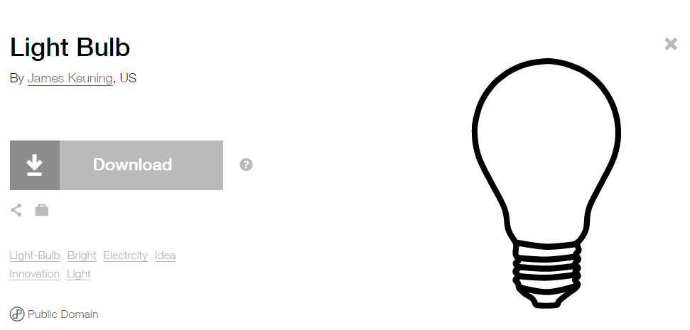

**Modified by:** Esri Solutions Team

**License:** Public Domain

**Acknowledgement:** None required

**Notes:** None

**Damage Locations - Low**

**Symbol Name:** [Light Bulb](https://thenounproject.com/search?q=light-bulb&i=8699)

**Symbol Picture:** C:\Data\Symbology\Utilities\Electric\DamageAssessment\mobile\Damage-Assessment-Electric-Low-Damage.pngC:\Data\Symbology\Utilities\Electric\DamageAssessment\web\Damage-Assessment-Electric-Low-Damage.png

**Symbol Source:** The Noun Project

**Symbol Date:** April 2015



**Modified by:** Esri Solutions Team

**License:** Public Domain

**Acknowledgement:** None required

**Notes:** None

**Damage Locations - Medium**

**Symbol Name:** [Light Bulb](https://thenounproject.com/search?q=light-bulb&i=8699)

**Symbol Picture:** C:\Data\Symbology\Utilities\Electric\DamageAssessment\mobile\Damage-Assessment-Electric-Medium-Damage.pngC:\Data\Symbology\Utilities\Electric\DamageAssessment\web\Damage-Assessment-Electric-Medium-Damage.png

**Symbol Source:** The Noun Project

**Symbol Date:** April 2015



**Modified by:** Esri Solutions Team

**License:** Public Domain

**Acknowledgement:** None required

**Notes:** None

**Damage Locations - No Damage**

**Symbol Name:** [Light Bulb](https://thenounproject.com/search?q=light-bulb&i=8699)

**Symbol Picture:** C:\Data\Symbology\Utilities\Electric\DamageAssessment\mobile\Damage-Assessment-Electric-No-Damage.pngC:\Data\Symbology\Utilities\Electric\DamageAssessment\web\Damage-Assessment-Electric-No-Damage.png

**Symbol Source:** The Noun Project

**Symbol Date:** April 2015



**Modified by:** Esri Solutions Team

**License:** Public Domain

**Acknowledgement:** None required

**Notes:** None

**Damage Locations – Other/Unknown**

**Symbol Name:** [Light Bulb](https://thenounproject.com/search?q=light-bulb&i=8699)

**Symbol Picture:** C:\Data\Symbology\Utilities\Electric\DamageAssessment\mobile\Damage-Assessment-Electric-Other-Unknown.pngC:\Data\Symbology\Utilities\Electric\DamageAssessment\web\Damage-Assessment-Electric-Other-Unknown.png

**Symbol Source:** The Noun Project

**Symbol Date:** April 2015



**Modified by:** Esri Solutions Team

**License:** Public Domain

**Acknowledgement:** None required

**Notes:** None

**Damage Locations - Urgent**

**Symbol Name:** [Light Bulb](https://thenounproject.com/search?q=light-bulb&i=8699)

**Symbol Picture:** C:\Data\Symbology\Utilities\Electric\DamageAssessment\mobile\Damage-Assessment-Electric-Urgent.pngC:\Data\Symbology\Utilities\Electric\DamageAssessment\web\Damage-Assessment-Electric-Urgent.png

**Symbol Source:** The Noun Project

**Symbol Date:** April 2015



**Modified by:** Esri Solutions Team

**License:** Public Domain

**Acknowledgement:** None required

**Notes:** None

**Damage Locations - High**

**Symbol Name:** [Gas](https://thenounproject.com/term/gas/37872/)

**Symbol Picture:** C:\Users\heat5533\Documents\GitHub\solutions-symbology-data\symbology\mobile\png\Damage-Assessment-Gas-High-Damage.png

**Symbol Source:** The Noun Project

**Symbol Date:** April 2015

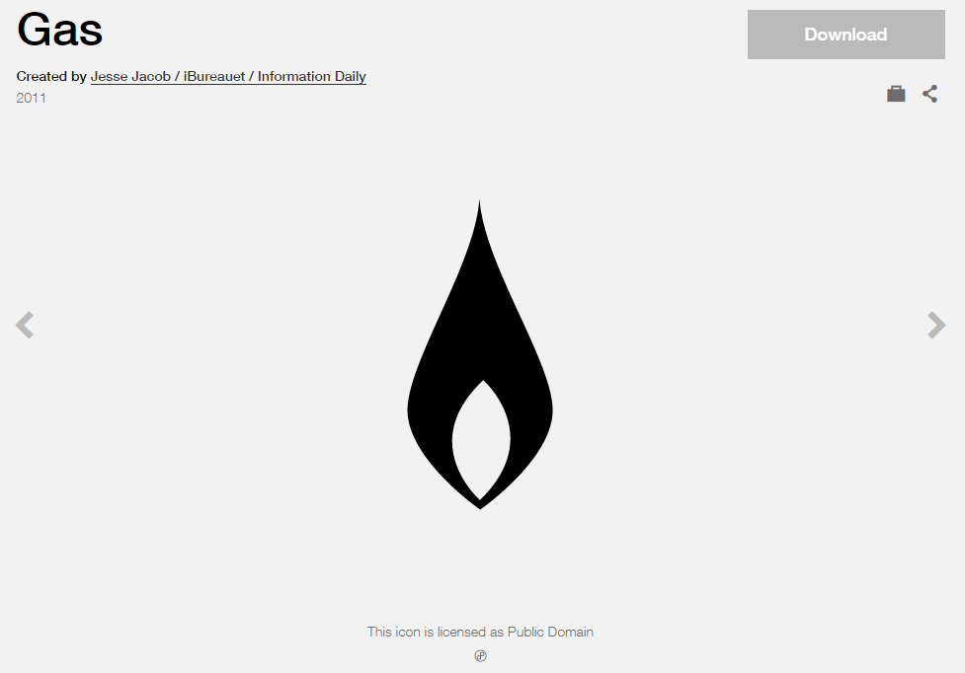

**Modified by:** Esri Solutions Team

**License:** Public Domain

**Acknowledgement:** None required

**Notes:** None

**Damage Locations - Low**

**Symbol Name:** [Gas](https://thenounproject.com/term/gas/37872/)

**Symbol Picture:** C:\Users\heat5533\Documents\GitHub\solutions-symbology-data\symbology\mobile\png\Damage-Assessment-Gas-Low-Damage.png

**Symbol Source:** The Noun Project

**Symbol Date:** April 2015



**Modified by:** Esri Solutions Team

**License:** Public Domain

**Acknowledgement:** None required

**Notes:** None

**Damage Locations - Medium**

**Symbol Name:** [Gas](https://thenounproject.com/term/gas/37872/)

**Symbol Picture:** C:\Users\heat5533\Documents\GitHub\solutions-symbology-data\symbology\mobile\png\Damage-Assessment-Gas-Medium-Damage.png

**Symbol Source:** The Noun Project

**Symbol Date:** April 2015



**Modified by:** Esri Solutions Team

**License:** Public Domain

**Acknowledgement:** None required

**Notes:** None

**Damage Locations – No Damage**

**Symbol Name:** [Gas](https://thenounproject.com/term/gas/37872/)

**Symbol Picture:** C:\Users\heat5533\Documents\GitHub\solutions-symbology-data\symbology\mobile\png\Damage-Assessment-Gas-No-Damage.png

**Symbol Source:** The Noun Project

**Symbol Date:** April 2015



**Modified by:** Esri Solutions Team

**License:** Public Domain

**Acknowledgement:** None required

**Notes:** None

**Damage Locations - No Damage**

**Symbol Name:** [Gas](https://thenounproject.com/term/gas/37872/)

**Symbol Picture:**

**Symbol Source:** The Noun Project

**Symbol Date:** April 2015



**Modified by:** Esri Solutions Team

**License:** Public Domain

**Acknowledgement:** None required

**Notes:** None

**Damage Locations - Other/Unknown**

**Symbol Name:** [Gas](https://thenounproject.com/term/gas/37872/)

**Symbol Picture:** C:\Users\heat5533\Documents\GitHub\solutions-symbology-data\symbology\mobile\png\Damage-Assessment-Gas-Other-Unknown.png

**Symbol Source:** The Noun Project

**Symbol Date:** April 2015



**Modified by:** Esri Solutions Team

**License:** Public Domain

**Acknowledgement:** None required

**Notes:** None

**Damage Locations - Urgent**

**Symbol Name:** [Gas](https://thenounproject.com/term/gas/37872/)

**Symbol Picture:** C:\Users\heat5533\Documents\GitHub\solutions-symbology-data\symbology\mobile\png\Damage-Assessment-Gas-Urgent.png

**Symbol Source:** The Noun Project

**Symbol Date:** April 2015



**Modified by:** Esri Solutions Team

**License:** Public Domain

**Acknowledgement:** None required

**Notes:** None

**Damage Assessment - Residential Buildings – Affected**

**Symbol Name:** House 2

**Symbol Picture:** C:\Data\Symbology\Solutions\DamageAssessment\mobile\Residential-Buildings-Affected.png

**Symbol Source:** Business style file

**Symbol Date:** March 2015

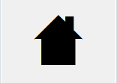

**Modified** **by:** Esri Solutions Team

**License:** None

**Acknowledgement:** None required

**Notes:** None

**Damage Assessment - Residential Buildings – Destroyed**

**Symbol Name:** House 2

**Symbol Picture:** C:\Data\Symbology\Solutions\DamageAssessment\mobile\Residential-Buildings-Destroyed.png

**Symbol Source:** Business style file

**Symbol Date:** March 2015



**Modified** **by:** Esri Solutions Team

**License:** None

**Acknowledgement:** None required

**Notes:** None

**Damage Assessment - Residential Buildings – Inaccessible**

**Symbol Name:** House 2

**Symbol Picture:** C:\Data\Symbology\Solutions\DamageAssessment\mobile\Residential-Buildings-Inaccessible.png

**Symbol Source:** Business style file

**Symbol Date:** March 2015



**Modified** **by:** Esri Solutions Team

**License:** None

**Acknowledgement:** None required

**Notes:** None

**Damage Assessment - Residential Buildings – Major**

**Symbol Name:** House 2

**Symbol Picture:** C:\Data\Symbology\Solutions\DamageAssessment\mobile\Residential-Buildings-Major.png

**Symbol Source:** Business style file

**Symbol Date:** March 2015



**Modified** **by:** Esri Solutions Team

**License:** None

**Acknowledgement:** None required

**Notes:** None

**Damage Assessment - Residential Buildings – Minor**

**Symbol Name:** House 2

**Symbol Picture:** C:\Data\Symbology\Solutions\DamageAssessment\mobile\Residential-Buildings-Minor.png

**Symbol Source:** Business style file

**Symbol Date:** March 2015



**Modified** **by:** Esri Solutions Team

**License:** None

**Acknowledgement:** None required

**Notes:** None

**Damage Assessment - Public Facilities - CAT-A-Debris-Removal**

**Symbol Name:** A

**Symbol Picture:** C:\Data\Symbology\Solutions\DamageAssessment\mobile\Public-Facilities-CAT-A-Debris-Removal.png

**Symbol Source:** Arial Rounded MT Bold Font

**Symbol Date:** March 2015

**Modified** **by:** Esri Solutions Team

**License:** None

**Acknowledgement:** None required

**Notes:** None

**Damage Assessment - Public Facilities - CAT-B-Protective-Measures**

**Symbol Name:** B

**Symbol Picture:** C:\Data\Symbology\Solutions\DamageAssessment\mobile\Public-Facilities-CAT-B-Protective-Measures.png

**Symbol Source:** Arial Rounded MT Bold

**Symbol Date:** March 2015

**Modified** **by:** Esri Solutions Team

**License:** None

**Acknowledgement:** None required

**Notes:** None

**Damage Assessment - Public Facilities - CAT-C-Roads-and-Bridges**

**Symbol Name:** C

**Symbol Picture:** C:\Data\Symbology\Solutions\DamageAssessment\mobile\Public-Facilities-CAT-C-Roads-and-Bridges.png

**Symbol Source:** Arial Rounded MT Bold

**Symbol Date:** March 2015

**Modified** **by:** Esri Solutions Team

**License:** None

**Acknowledgement:** None required

**Notes:** None

**Damage Assessment - Public Facilities - CAT-D-Water-Control-Facilities**

**Symbol Name:** D

**Symbol Picture:** C:\Data\Symbology\Solutions\DamageAssessment\mobile\Public-Facilities-CAT-D-Water-Control-Facilities.png

**Symbol Source:** Arial Rounded MT Bold

**Symbol Date:** March 2015

**Modified** **by:** Esri Solutions Team

**License:** None

**Acknowledgement:** None required

**Notes:** None

**Damage Assessment - Public Facilities - CAT-E-Public-Buildings**

**Symbol Name:** E

**Symbol Picture:** C:\Data\Symbology\Solutions\DamageAssessment\mobile\Public-Facilities-CAT-E-Public-Buildings.png

**Symbol Source:** Arial Rounded MT Bold

**Symbol Date:** March 2015

**Modified** **by:** Esri Solutions Team

**License:** None

**Acknowledgement:** None required

**Notes:** None

**Damage Assessment - Public Facilities - CAT-F-Public-Utilities**

**Symbol Name:** F

**Symbol Picture:** C:\Data\Symbology\Solutions\DamageAssessment\mobile\Public-Facilities-CAT-F-Public-Utilities.png

**Symbol Source:** Arial Rounded MT Bold

**Symbol Date:** March 2015

**Modified** **by:** Esri Solutions Team

**License:** None

**Acknowledgement:** None required

**Notes:** None

**Damage Assessment - Public Facilities - CAT-G-Parks-Other**

**Symbol Name:** G

**Symbol Picture:** C:\Data\Symbology\Solutions\DamageAssessment\mobile\Public-Facilities-CAT-G-Parks-Other.png

**Symbol Source:** Arial Rounded MT Bold

**Symbol Date:** March 2015

**Modified** **by:** Esri Solutions Team

**License:** None

**Acknowledgement:** None required

**Notes:** None

**Debris Mixed**

**Symbol Name:**

**Symbol Picture:** C:\Data\Symbology\Solutions\Debris\web\Debris-Mixed.png

**Symbol Source:** ESRI Enviro Hazard Sites Unicode 50

**Symbol Date:** March 2015

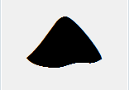

**Modified** **by:** Esri Solutions Team

**License:** None

**Acknowledgement:** None required

**Notes:** None

**Dangerous Animal**

**Symbol Name:**

**Symbol Picture:** C:\Data\Symbology\Utilities\Electric\HazardReportingCollector\mobile\Dangerous-Animal.pngC:\Data\Symbology\Utilities\Electric\HazardReportingCollector\web\Dangerous-Animal.png

**Symbol Source:**

**Symbol Date:** June 2015

**Created by:** Esri Solutions Team

**License:** None

**Acknowledgement:** None required

**Notes:** None

**Debris Other**

**Symbol Name:**

**Symbol Picture:** C:\Data\Symbology\Solutions\Debris\web\Debris-Other.png

**Symbol Source:** ESRI Enviro Hazard Sites Unicode 50

**Symbol Date:** May 2014



**Modified** **by:** Esri Solutions Team

**License:** None

**Acknowledgement:** None required

**Notes:** None

**Dam Failure**

**Symbol Name:** Dam

**Symbol Picture:** C:\Data\Symbology\Solutions\HazardandRiskAssessment\web\Dam-Failure.png

**Symbol Source:** Forestry style file

**Symbol Date:** September 2015

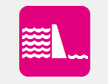

**Modified by:** EsriSolutions Team

**License:** None

**Acknowledgement:** None required

**Notes:** None

**Deformed**

**Symbol Name:**

**Symbol Picture:** C:\Data\Symbology\Utilities\Water\CCTVProcessor\web\Deformed.png

**Symbol Source:**

**Symbol Date:** May 2015

**Created by:** Esri Solutions Team

**License:** None

**Acknowledgement:** None required

**Notes:** None

**Dengue**

**Symbol Name:** !

**Symbol Picture:**



**Symbol Source:**  Arial Rounded MT Bold

**Symbol Date:** December 2016

**Modified by:** Esri Solutions Team

**License:** None

**Acknowledgement:** None required

**Notes:** None

**Department of Public Works**

**Symbol Name:** L3 Traffic Control Point

**Symbol Picture:** C:\Users\heat5533\Documents\GitHub\solutions-symbology-data\symbology\web\png\Department-Public-Works.png

**Symbol Source:** ERS Traffic Control Point

**Symbol Date:** March 2015

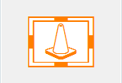

**Modified** **by:** Esri Solutions Team

**License:** None

**Acknowledgement:** None required

**Notes:** None

**Deposits**

**Symbol Name:**

**Symbol Picture:** C:\Data\Symbology\Utilities\Water\CCTVProcessor\web\Deposits.png

**Symbol Source:**

**Symbol Date:** May 2015

**Created by:** Esri Solutions Team

**License:** None

**Acknowledgement:** None required

**Notes:** None

**Dialysis**

**Symbol Name:** [Kidney](http://thenounproject.com/term/kidney/600/)

**Symbol Picture: C:\Data\Symbology\StateGov\MyHealthServices\web\Dialysis.png**

**Symbol Source:** The Noun Project

**Symbol Date:** March 2015

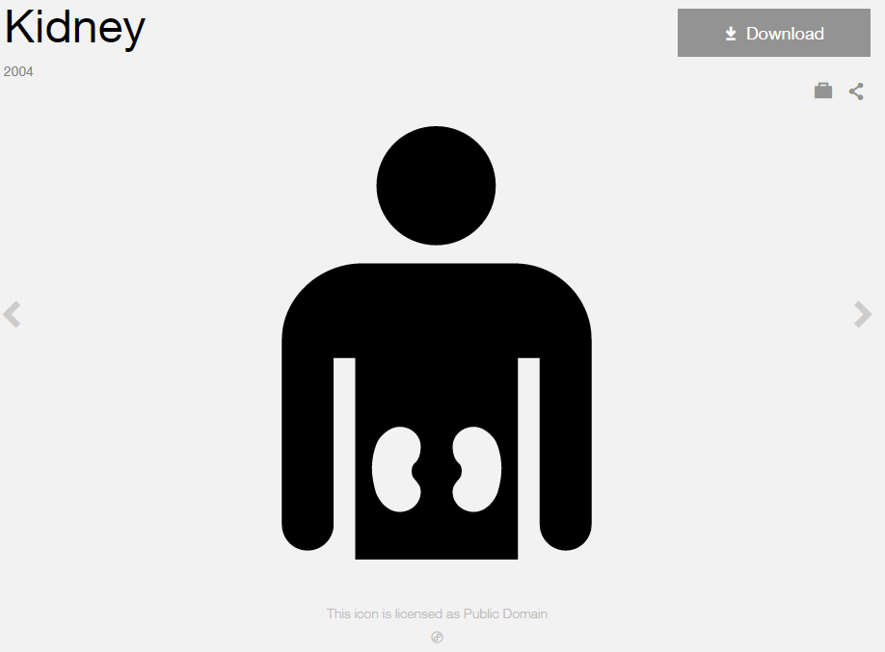

**Modified by:** Esri Solutions Team

**License:** Public Domain

**Acknowledgement:** None Required

**Notes:** None

**Disaster Recovery Center**

**Symbol Name:** [Community](http://thenounproject.com/term/community/288/)

**Symbol Picture:** C:\Data\UC\UC2015\SituationalAwareness\web\Disaster-Recovery-Center.png

**Symbol Source:** The Noun Project



**Symbol Date:** February 2015

**Modified** **by:** Esri Solutions Team

**License:** Public Domain

**Acknowledgement:** None required

**Notes:** None

**Discharge Point**

**Symbol Name:** Discharge Point

**Symbol Picture:** C:\Users\heat5533\Documents\GitHub\solutions-symbology-data\symbology\mobile\png\Discharge-Points.pngC:\Users\heat5533\Documents\GitHub\solutions-symbology-data\symbology\web\png\Discharge-Point.png

**Symbol Source:** Water Wastewater style file

**Symbol Date:** April 2015

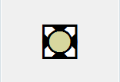

**Modified by:** Esri Solutions Team

**License:** None

**Acknowledgement:** None required

**Notes:** None

**Dissatisfied Customer**

**Symbol Name:**

**Symbol Picture:** C:\Data\Symbology\Utilities\Electric\HazardReportingCollector\mobile\Dissatisfied-Customer.pngC:\Data\Symbology\Utilities\Electric\HazardReportingCollector\web\Dissatisfied-Customer.png

**Symbol Source:**

**Symbol Date:** June 2015

**Created by:** Esri Solutions Team

**License:** None

**Acknowledgement:** None required

**Notes:** None

**Drinking Fountain**

**Symbol Name:** Drinking Fountain

**Symbol Picture:** C:\Data\Symbology\Solutions\SpecialEventPlanning\mobile\Drinking-Water.png

**Symbol Source:** Public Signs style file

**Symbol Date:** August 2015



**Modified by:** Esri Solutions Team

**License:** None

**Acknowledgement:** None required

**Notes:** None

**Ditch and Channel Stabilization Violation**

**Symbol Name:** DCS

**Symbol Picture:** C:\Data\Symbology\Utilities\Water\ConstructionSiteViolations\mobile\Ditch-and-Channel-Stabilization-Violation.png

**Symbol Source:** Arial Rounded MT Bold Font

**Symbol Date:** March 2015

**Modified** **by:** Esri Solutions Team

**License:** None

**Acknowledgement:** None required

**Notes:** None

**Door**

**Symbol Name:** [Close The Door](https://thenounproject.com/search/?q=door&i=138058)

**Symbol Picture:** Door

**Symbol Source:** The Noun Project

**Symbol Date:** February 2017

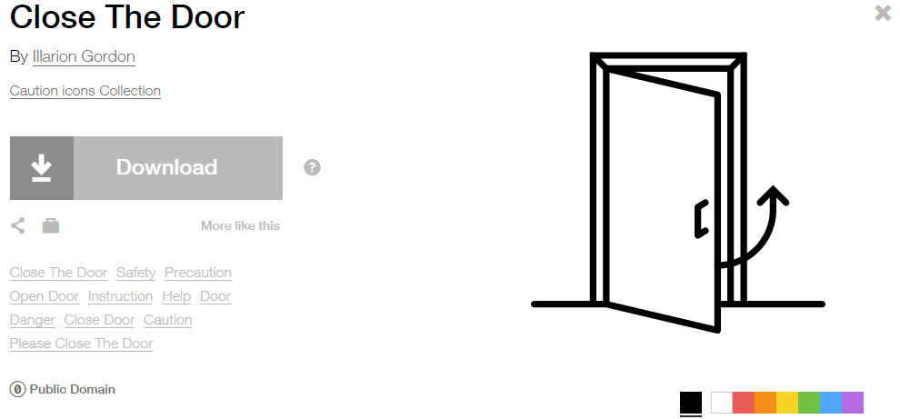

**Modified by:** Esri Solutions Team

**License:** Public Domain

**Acknowledgement:** None required

**Notes:** None

**Drainage Management Violation**

**Symbol Name:** DM

**Symbol Picture:** C:\Data\Symbology\Utilities\Water\ConstructionSiteViolations\mobile\Drainage-Management-Violation.png

**Symbol Source:** Arial Rounded MT Bold Font

**Symbol Date:** March 2015

**Modified** **by:** Esri Solutions Team

**License:** None

**Acknowledgement:** None required

**Notes:** None

**Drought**

**Symbol Name:** [Drought](https://thenounproject.com/term/drought/4231/)

**Symbol Picture:** C:\Data\Symbology\Solutions\HazardandRiskAssessment\web\Drought.png

**Symbol Source:** The Noun Project

**Symbol Date:** September 2015

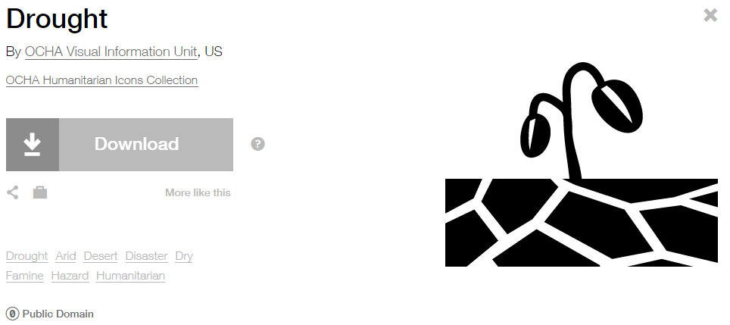

**Modified by:** EsriSolutions Team

**License:** Public Domain

**Acknowledgement:** None required

**Notes:** None

**Earthquake**

**Symbol Name:** [Earthquake](http://thenounproject.com/term/earthquake/8681/)

**Symbol Picture:** C:\Data\Symbology\Solutions\HazardandRiskAssessment\web\Earthquake.png

**Symbol Source:** The Noun Project

**Symbol Date:** September 2015

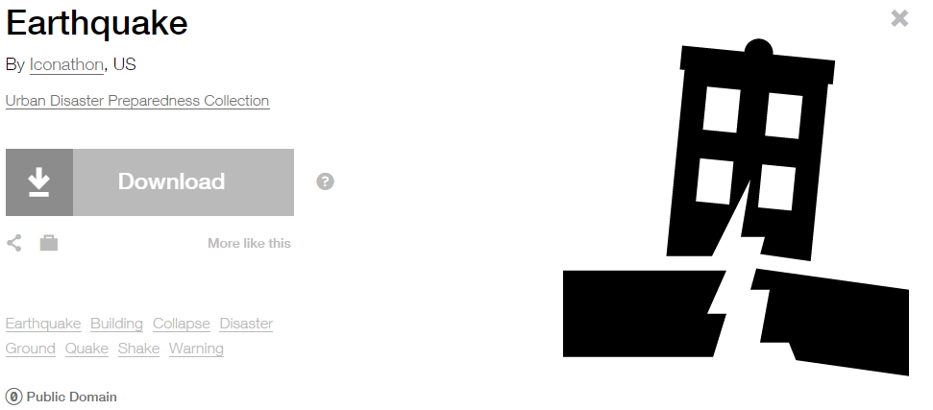

**Modified by:** EsriSolutions Team

**License:** Public Domain

**Acknowledgement:** None required

**Notes:** None

**Electrical Shut Off**

**Symbol Name:** Electrical Inverter Shutoff

**Symbol Picture:**



**Symbol Source:** NAPSG (National Alliance for Public Safety GIS Foundation) – NAPSG\_PrePlan.style file

**Symbol Date:** March 2017



**Modified** **by:** Esri Solutions Team

**License:** None

**Acknowledgement:** None required

**Notes:** None

**Elevator**

**Symbol Name:** Elevator

**Symbol Picture:**



**Symbol Source:** Public Signs style file

**Symbol Date:** March 2017



**Modified** **by:** Esri Solutions Team

**License:** None

**Acknowledgement:** None required

**Notes:** None

**Erosion Protection Violation**

**Symbol Name:** EP

**Symbol Picture:** C:\Data\Symbology\Utilities\Water\ConstructionSiteViolations\mobile\Erosion-Protection-Violation.png

**Symbol Source:** Arial Rounded MT Bold Font

**Symbol Date:** March 2015

**Modified** **by:** Esri Solutions Team

**License:** None

**Acknowledgement:** None required

**Notes:** None

**Emergency Assistance**

**Symbol Name:** [Protection](https://thenounproject.com/search/?q=protection&i=4218)

**Symbol Picture:** **C:\Users\heat5533\Documents\GitHub\solutions-symbology-data\symbology\web\png\Emergency-Assistance.png**

**Symbol Source:** The Noun Project

**Symbol Date:** July 2015



**Modified** **by:** Esri Solutions Team

**License:** Public Domain

**Acknowledgement:** None required

**Notes:** None

**Emergency Clothing Distribution Center**

**Symbol Name:** [Clothes](https://thenounproject.com/term/clothes/4309/)

**Symbol Picture:** C:\Data\UC\UC2015\SituationalAwareness\web\Emergency-Clothing-Distribution-Center.png

**Symbol Source:** The Noun Project

**Symbol Date:** July 2015

**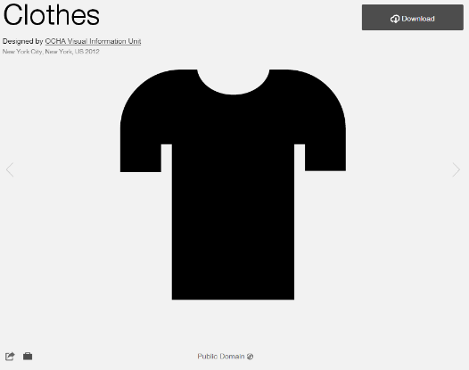**

**Modified by:** Esri Solutions Team

**License:** Public Domain

**Acknowledgement:** None required

**Notes:** None

**Emergency Medical Services**

**Symbol Name:** Emergency Medical Services

**Symbol Picture:** C:\Data\UC\UC2015\SituationalAwareness\web\Emergency-Medical-Services.png

**Symbol Source:**  Transportation style file

**Symbol Date:** July 2015

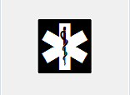

**Modified by:** Esri Solutions Team

**License:** None

**Acknowledgement:** None required

**Notes:** None

**Encephalitis - (Eastern-Equine)**

**Symbol Name:** !

**Symbol Picture:**



**Symbol Source:**  Arial Rounded MT Bold

**Symbol Date:** December 2016

**Modified by:** Esri Solutions Team

**License:** None

**Acknowledgement:** None required

**Notes:** None

**Encephalitis - (Japanese)**

**Symbol Name:** !

**Symbol Picture:**



**Symbol Source:**  Arial Rounded MT Bold

**Symbol Date:** December 2016

**Modified by:** Esri Solutions Team

**License:** None

**Acknowledgement:** None required

**Notes:** None

**Encephalitis - (La-Crosse)**

**Symbol Name:** !

**Symbol Picture:**



**Symbol Source:**  Arial Rounded MT Bold

**Symbol Date:** December 2016

**Modified by:** Esri Solutions Team

**License:** None

**Acknowledgement:** None required

**Notes:** None

**Encephalitis - (Saint-Louis)**

**Symbol Name:** !

**Symbol Picture:**



**Symbol Source:**  Arial Rounded MT Bold

**Symbol Date:** December 2016

**Modified by:** Esri Solutions Team

**License:** None

**Acknowledgement:** None required

**Notes:** None

**Encephalitis - (Venezuelan-Equine)**

**Symbol Name:** !

**Symbol Picture:**



**Symbol Source:**  Arial Rounded MT Bold

**Symbol Date:** December 2016

**Modified by:** Esri Solutions Team

**License:** None

**Acknowledgement:** None required

**Notes:** None

**Encephalitis - (Western-Equine)**

**Symbol Name:** !

**Symbol Picture:**



**Symbol Source:**  Arial Rounded MT Bold

**Symbol Date:** December 2016

**Modified by:** Esri Solutions Team

**License:** None

**Acknowledgement:** None required

**Notes:** None

**Epidemic**

**Symbol Name:** [Epidemic](https://thenounproject.com/search/?q=epidemic&i=4233)

**Symbol Picture:** C:\Data\Symbology\Solutions\HazardandRiskAssessment\web\Epidemic.png

**Symbol Source:** The Noun Project

**Symbol Date:** September 2015

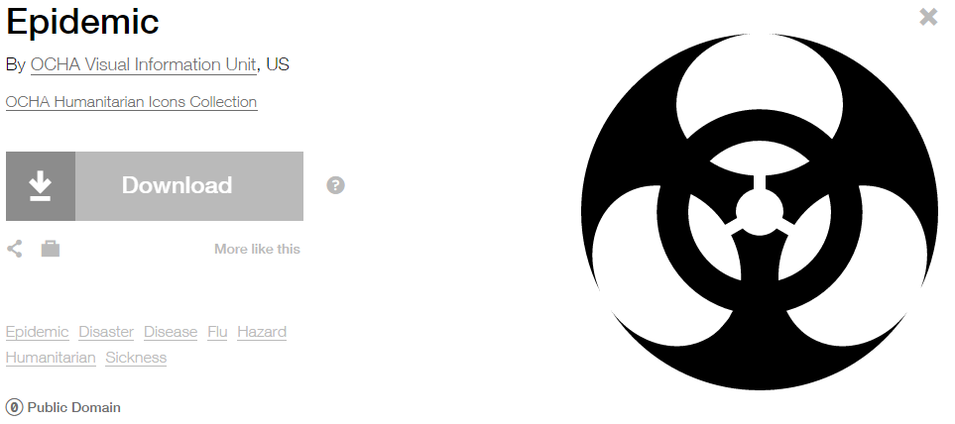

**Modified by:** EsriSolutions Team

**License:** Public Domain

**Acknowledgement:** None required

**Notes:** None

**Erosion Protection Violation**

**Symbol Name:** EP

**Symbol Picture:** C:\Data\Symbology\Utilities\Water\ConstructionSiteViolations\mobile\Erosion-Protection-Violation.png

**Symbol Source:** Arial Rounded MT Bold Font

**Symbol Date:** March 2015

**Modified** **by:** Esri Solutions Team

**License:** None

**Acknowledgement:** None required

**Notes:** None

**Escalator**

**Symbol Name:** Escalator

**Symbol Picture:**



**Symbol Source:** Public Signs style file

**Symbol Date:** March 2017



**Modified** **by:** Esri Solutions Team

**License:** None

**Acknowledgement:** None required

**Notes:** None

**Event**

**Symbol Name:** 1

**Symbol Picture:** C:\Data\Symbology\StateGov\Transportation511\web\Event.png

**Symbol Source:** Arial Rounded MT Bold

**Symbol Date:** June 2015

**Modified by:** Esri Solutions Team

**License:** None

**Acknowledgement:** None required

**Notes:** None

**Event Calendar**

**Symbol Name:** 1

**Symbol Picture:** C:\Data\Symbology\Solutions\EventCalendar\web\Event-Calendar.png

**Symbol Source:** Arial Rounded MT Bold

**Symbol Date:** June 2015

**Modified by:** Esri Solutions Team

**License:** None

**Acknowledgement:** None required

**Notes:** None

**Event Plan Notes**

**Symbol Name:**

**Symbol Picture:** C:\Data\Symbology\Solutions\SpecialEventPlanning\mobile\Event-Plan-Notes.png

**Symbol Source:**

**Symbol Date:** August 2015

**Created by:** Esri Solutions Team

**License:** None

**Acknowledgement:** None required

**Notes:** None

**Event Sign**

**Symbol Name:**

**Symbol Picture:** C:\Data\Symbology\Solutions\SpecialEventPlanning\mobile\Event-Sign.png

**Symbol Source:**

**Symbol Date:** August 2015

**Created by:** Esri Solutions Team

**License:** None

**Acknowledgement:** None required

**Notes:** None

**Explosive Attack**

**Symbol Name:** [Conflict](https://thenounproject.com/term/explosion/4229/)

**Symbol Picture:** C:\Data\Symbology\Solutions\HazardandRiskAssessment\web\Explosive-Attack.png

**Symbol Source:** The Noun Project

**Symbol Date:** October 2015

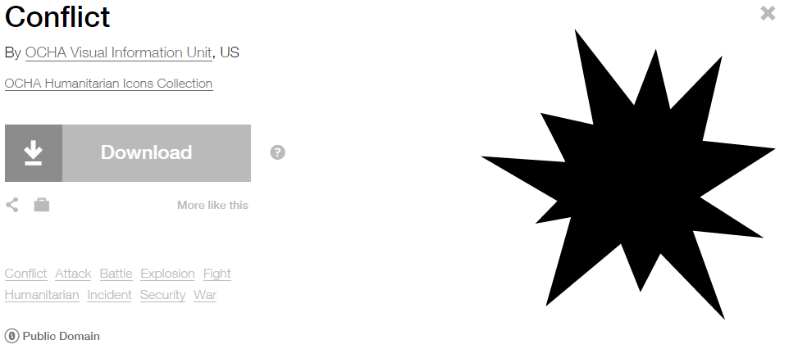

**Modified by:** EsriSolutions Team

**License:** Public Domain

**Acknowledgement:** None required

**Notes:** None

**Extreme Heat**

**Symbol Name:** Unicode 113

**Symbol Picture:** C:\Data\Symbology\Solutions\HazardandRiskAssessment\web\Extreme-Heat.png

**Symbol Source:** ESRI Enviro Hazard Analysis

**Symbol Date:** October 2015



**Modified by:** EsriSolutions Team

**License:** Public Domain

**Acknowledgement:** None required

**Notes:** None

**Failure of equipment or heat source**

**Symbol Name:** [Cog](https://thenounproject.com/search/?q=cog&i=222491)

**Symbol Picture:** C:\Users\heat5533\Documents\GitHub\solutions-symbology-data\symbology\web\png\Failure-of-equipment-or-heat-source.png

**Symbol Source:**  The Noun Project

**Symbol Date:** December 2015

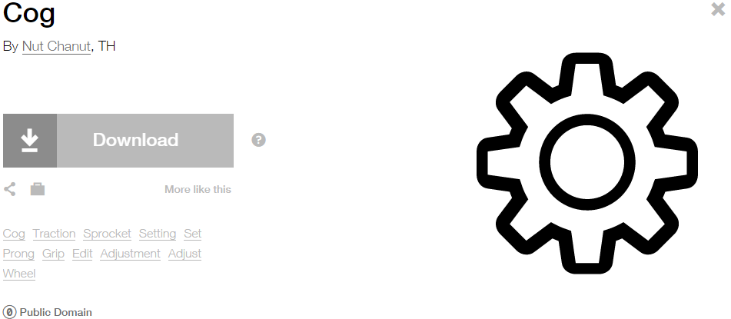

**Modified by:** Esri Solutions Team

**License:** Public Domain

**Acknowledgement:** None required

**Notes:** None

**False Alarm Incident**

**Symbol Name:** Phone 1

**Symbol Picture:** C:\Users\heat5533\Documents\GitHub\solutions-symbology-data\symbology\web\png\False-Alarm-Incident.png

**Symbol Source:**  Civic style file

**Symbol Date:** November 2015



**Modified by:** Esri Solutions Team

**License:** None

**Acknowledgement:** None required

**Notes:** None

**Filariasis**

**Symbol Name:** !

**Symbol Picture:**



**Symbol Source:**  Arial Rounded MT Bold

**Symbol Date:** December 2016

**Created by:** Esri Solutions Team

**License:** None

**Acknowledgement:** None required

**Notes:** None

**Field Interviews**

**Symbol Name:**

**Symbol Picture:** C:\Data\Symbology\LocalGov\FieldInterview\mobile\Field-Interviews.png

**Symbol Source:**

**Symbol Date:** July 2015

**Created by:** The Solutions Team

**License:** None

**Acknowledgement:** None required

**Notes:** None

**Fire Alarm Control Panel**

**Symbol Name:** [Alarm Control Panel FAC](http://napsg-web.s3.amazonaws.com/symbology/index.html#/single?PREPLN%20ALARM%20RED%20%20SOLID%20DETAIL%20Alarm%20Control%20Panel%20FAC%20128x128)

**Symbol Picture:**



**Symbol Source:** NAPSG (National Alliance for Public Safety GIS Foundation)

**Symbol Date:** March 2017

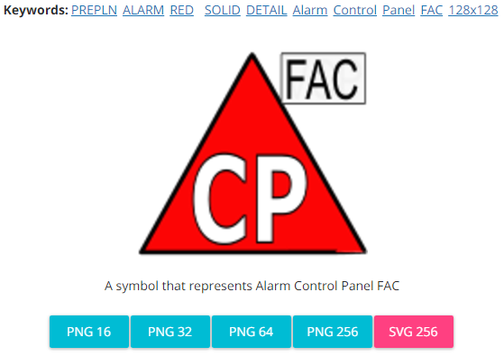

**Modified by:** The Solutions Team

**License:** None

**Acknowledgement:** None required

**Notes:** None

**Fire Alarm Reset Panel**

**Symbol Name:** [Reset Panel](http://napsg-web.s3.amazonaws.com/symbology/index.html#/single?PREPLN%20ALARM%20RED%20%20SOLID%20DETAIL%20Reset%20Panel%20128x128)

**Symbol Picture:**



**Symbol Source:** NAPSG (National Alliance for Public Safety GIS Foundation)

**Symbol Date:** March 2017

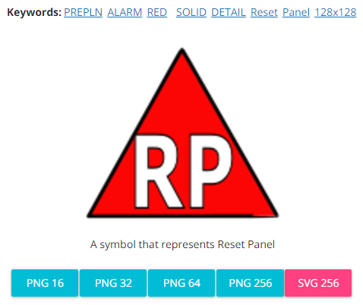

**Modified by:** The Solutions Team

**License:** None

**Acknowledgement:** None required

**Notes:** None

**Fire and Hazardous Materials**

**Symbol Name:** Fire Incident

**Symbol Picture:** C:\Data\UC\UC2015\SituationalAwareness\web\Fire-and-Hazardous-Material.pngC:\Users\heat5533\Documents\GitHub\solutions-symbology-data\symbology\web\png\Fire-Incident-Circle.png

**Symbol Source:** ERS Homeland Security style file

**Symbol Date:** July 2015



**Modified** **by:** Esri Solutions Team

**License:** None

**Acknowledgement:** None required

**Notes:** None

**Fire Annunciator**

**Symbol Name:** [Alarm Communications Annunciator Panel](http://napsg-web.s3.amazonaws.com/symbology/index.html#/single?PREPLN%20ALARM%20RED%20%20SOLID%20DETAIL%20Alarm%20Communications%20Annunciator%20Panel%20128x128)

**Symbol Picture:**



**Symbol Source:** NAPSG (National Alliance for Public Safety GIS Foundation)

**Symbol Date:** March 2017

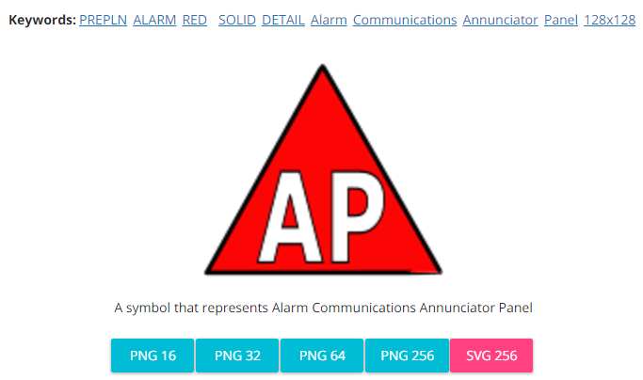

**Modified by:** The Solutions Team

**License:** None

**Acknowledgement:** None required

**Notes:** None

**Fire Department Connection**

**Symbol Name:** [Fire Department Connection FDC1](http://napsg-web.s3.amazonaws.com/symbology/index.html#/single?PREPLN%20FIRSUP%20RED%20%20SOLID%20DETAIL%20Fire%20Department%20Connection%20FDC1%20128x128)

**Symbol Picture:**



**Symbol Source:** NAPSG (National Alliance for Public Safety GIS Foundation)

**Symbol Date:** March 2017

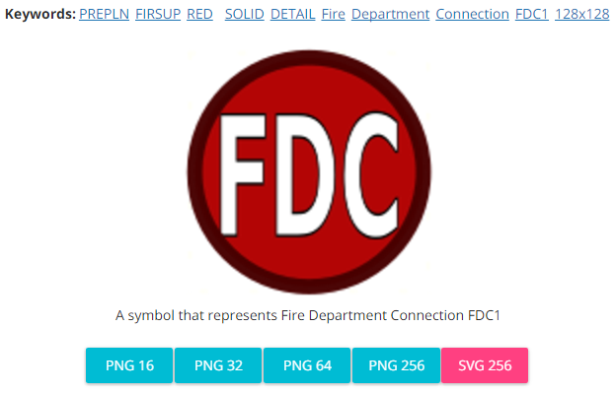

**Modified by:** The Solutions Team

**License:** None

**Acknowledgement:** None required

**Notes:** None

**Fire Escape**

**Symbol Name:** Use Stairs 1

**Symbol Picture:**



**Symbol Source:** Hazmat style file

**Symbol Date:** March 2017

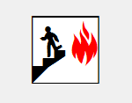

**Modified by:** The Solutions Team

**License:** None

**Acknowledgement:** None required

**Notes:** None

**Fire Extinguisher**

**Symbol Name:** Fire Extinguisher

**Symbol Picture:** C:\Data\Symbology\Solutions\SpecialEventPlanning\mobile\Fire-Extinguisher.png

**Symbol Source:** Public Signs style file

**Symbol Date:** August 2015

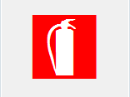

**Modified by:** Esri Solutions Team

**License:** None

**Acknowledgement:** None required

**Notes:** None

**Fire Incident**

**Symbol Name:** Fire Incident

**Symbol Picture:** C:\Data\Symbology\Solutions\OpsIncident\web\Fire-Incident.png

**Symbol Source:** ERS Homeland Security style file

**Symbol Date:** February 2015



**Modified** **by:** Esri Solutions Team

**License:** None

**Acknowledgement:** None required

**Notes:** None

**Fire Safety Survey - Inspected**

**Symbol Name:**

**Symbol Picture:** C:\Users\heat5533\Documents\GitHub\solutions-symbology-data\symbology\mobile\png\Fire-Safety-Survey-Yes.png

**Symbol Source:**

**Symbol Date:** April 2014

**Created by:** Esri Solutions Team

**License:** None

**Acknowledgement:** None required

**Notes:** None

**Fire Safety Survey – Not Inspected**

**Symbol Name:**

**Symbol Picture:** C:\Users\heat5533\Documents\GitHub\solutions-symbology-data\symbology\mobile\png\Fire-Safety-Survey-No.png

**Symbol Source:**

**Symbol Date:** April 2014

**Created by:** Esri Solutions Team

**License:** None

**Acknowledgement:** None required

**Notes:** None

**Fire Stations**

**Symbol Name:** Fire Rescue 2

**Symbol Picture:** C:\Users\heat5533\Documents\GitHub\solutions-symbology-data\symbology\web\png\Fire-Station.png

**Symbol Source:** Hazmat style file

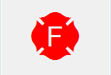

**Symbol Date:** February 2015

**Modified** **by:** Esri Solutions Team

**License:** None

**Acknowledgement:** None required

**Notes:** None

**Fire Suppression Systems - Other**

**Symbol Name:**

**Symbol Picture:**



**Symbol Source:**

**Symbol Date:** March 2017

**Created by:** Esri Solutions Team

**License:** None

**Acknowledgement:** None required

**Notes:** None

**Fireworks Launch Site**

**Symbol Name:** Unicode 81

**Symbol Picture:** C:\Data\Symbology\Solutions\SpecialEventPlanning\mobile\Fireworks-Launch-Site.png

**Symbol Source:** Esri Crime Analysis font

**Symbol Date:** August 2015



**Modified by:** Esri Solutions Team

**License:** None

**Acknowledgement:** None required

**Notes:** None

**First Aid**

**Symbol Name:**

**Symbol Picture:C:\Data\Symbology\Solutions\SpecialEventPlanning\mobile\First-Aid.png**

**Symbol Source:**

**Symbol Date:** August 2015

**Created by:** Esri Solutions Team

**License:** None

**Acknowledgement:** None required

**Notes:** None

**First Aid Station**

**Symbol Name:**

**Symbol Picture:** C:\Data\UC\UC2015\SituationalAwareness\web\First-Aid-Station.png

**Symbol Source:**

**Symbol Date:** July 2015

**Created by:** Esri Solutions Team

**License:** None

**Acknowledgement:** None required

**Notes:** None

**Fishing Site**

**Symbol Name:** Fishing Area

**Symbol Picture: C:\Users\heat5533\Documents\GitHub\solutions-symbology-data\symbology\web\png\Fishing-Site.png**

**Symbol Source:** Forestry style file

**Symbol Date:** May 2014



**Modified by:** Esri Solutions Team

**License:** None

**Acknowledgement:** None Required

**Notes:** None

**Flood**

**Symbol Name:** House 2 and Water Recreation

**Symbol Picture:** C:\Data\Symbology\Solutions\HazardandRiskAssessment\web\Flood.pngC:\Data\Symbology\Utilities\Electric\HazardReportingCollector\mobile\Flooding.png

**Symbol Source:** Business style file and Forestry style file

**Symbol Date:** June 2015

 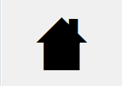

**Modified by:** Esri Solutions Team

**License:** None

**Acknowledgement:** None required

**Notes:** None

**Flooding**

**Symbol Name:** [Highway](https://thenounproject.com/search/?q=bridges&i=13084)

**Symbol Picture:** C:\Data\Symbology\StateGov\Transportation511\web\Flooding.png

**Symbol Source:** The Noun Project

**Symbol Date:** June 2015

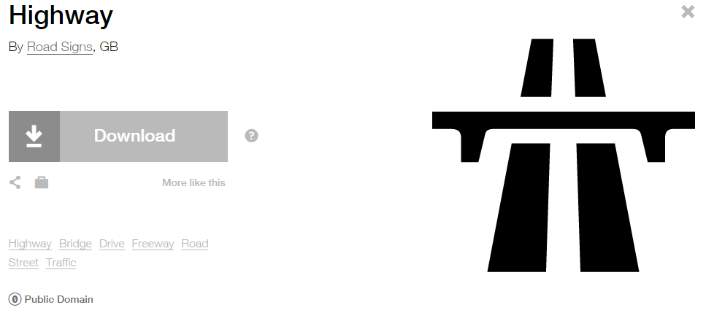

**Modified by:** Esri Solutions Team

**License:** Public Domain

**Acknowledgement:** None required

**Notes:** None

**Fog**

**Symbol Name:** Fog

**Symbol Picture:** C:\Data\Symbology\Solutions\HazardandRiskAssessment\web\Fog.png

**Symbol Source:** Weather style file

**Symbol Date:** January 2016



**Modified** **by:** Esri Solutions Team

**License:** None

**Acknowledgement:** None required

**Notes:** None

**Food Concessions**

**Symbol Name:** [Fast Food](https://thenounproject.com/search/?q=food+concessions&i=159)

**Symbol Picture:** C:\Data\Symbology\Solutions\SpecialEventPlanning\mobile\Food-Consessions.png

**Symbol Source:** The Noun Project

**Symbol Date:** August 2015

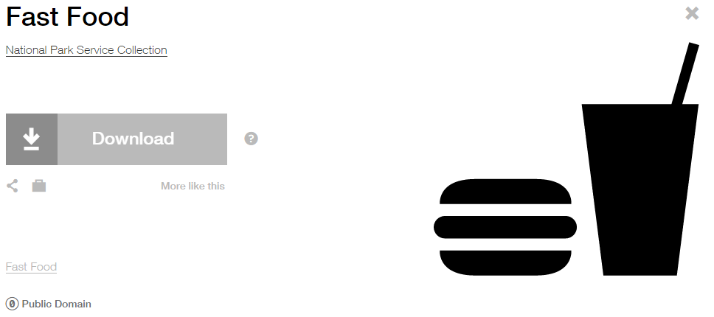

**Modified by:** Esri Solutions Team

**License:** Public Domain

**Acknowledgement:** None required

**Notes:** None

**Food Distribution Center**

**Symbol Name:** [Food Warehouse](https://thenounproject.com/search/?q=food-warehouse&i=5858)

**Symbol Picture:** C:\Data\UC\UC2015\SituationalAwareness\web\Food-Distribution-Center.png

**Symbol Source:** The Noun Project

**Symbol Date:** July 2015

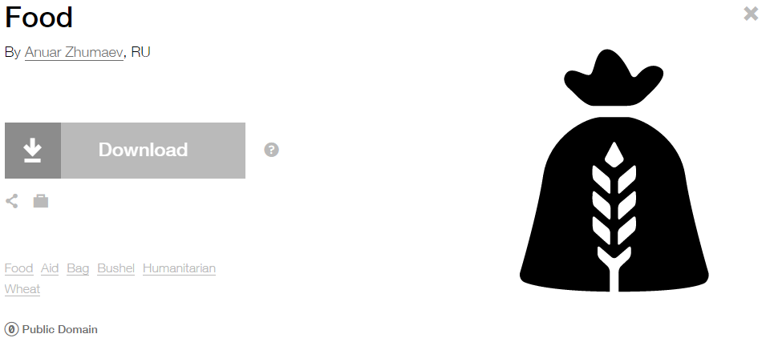

**Modified by:** Esri Solutions Team

**License:** Public Domain

**Acknowledgement:** None required

**Notes:** None

**Food Preparation Equipment**

**Symbol Name:** [Kettle](https://thenounproject.com/search/?q=pots&i=1696)

**Symbol Picture:** C:\Data\Symbology\Solutions\SpecialEventPlanning\mobile\Food-Preparation-Equipment.png

**Symbol Source:** The Noun Project

**Symbol Date:** August 2015

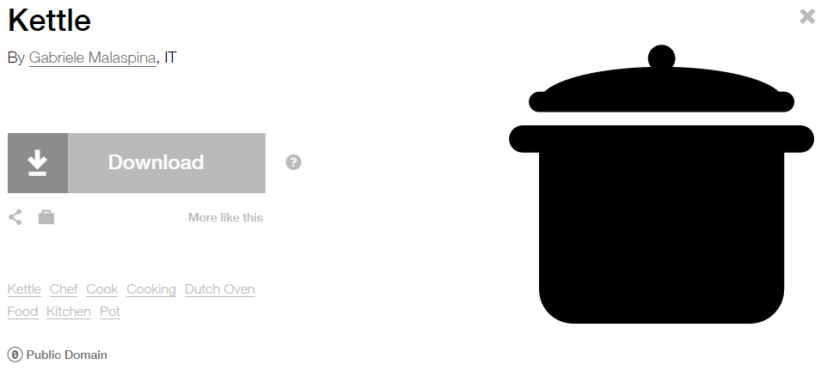

**Modified by:** Esri Solutions Team

**License:** Public Domain

**Acknowledgement:** None required

**Notes:** None

**Foreclosure**

**Symbol Name:** House 2

**Symbol Picture:**



**Symbol Source:** Business style file

**Symbol Date:** February 2017



**Modified by:** Esri Solutions Team

**License:** None

**Acknowledgement:** None Required

**Notes:** None

**For Sale**

**Symbol Name:** House 2

**Symbol Picture:**



**Symbol Source:** Business style file

**Symbol Date:** February 2017



**Modified by:** Esri Solutions Team

**License:** None

**Acknowledgement:** None Required

**Notes:** None

**Form Completed and Attached**

**Symbol Name:** [Paper-Clip](https://thenounproject.com/term/paper-clip/45494/)

**Symbol Picture:** C:\Users\heat5533\Documents\GitHub\solutions-symbology-data\symbology\mobile\png\Form-Completed-and-Attached.png

**Symbol Source:** The Noun Project

**Symbol Date:** May 2015

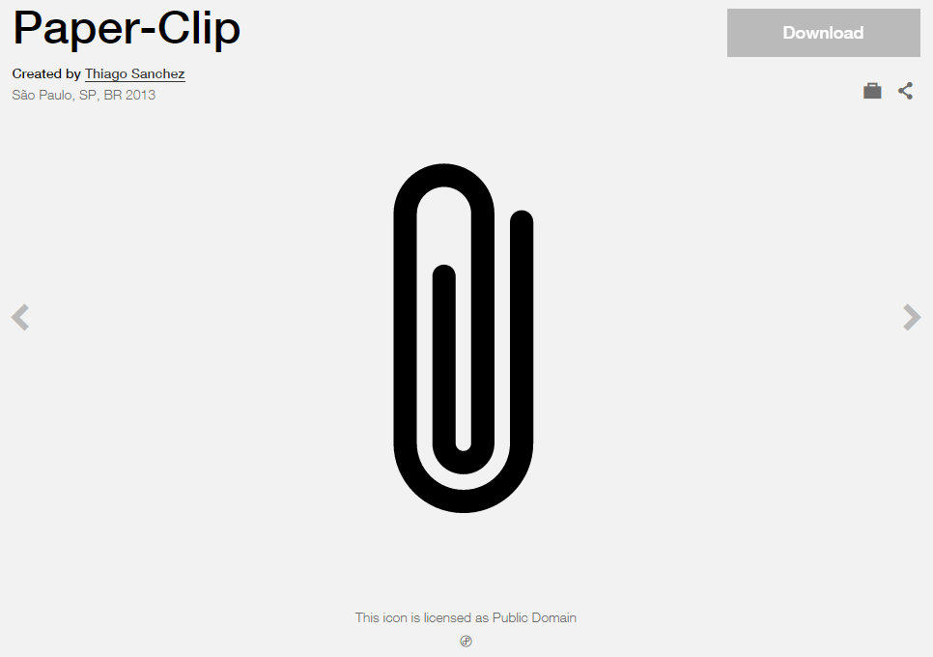

**Modified by:** Esri Solutions Team

**License:** Public Domain

**Acknowledgement:** None required

**Notes:** None

**Form Received by Office**

**Symbol Name:** [Mail](https://thenounproject.com/term/mail/31283/)

**Symbol Picture:** C:\Users\heat5533\Documents\GitHub\solutions-symbology-data\symbology\mobile\png\Form-Recieved-by-Office.png

**Symbol Source:** The Noun Project

**Symbol Date:** May 2015

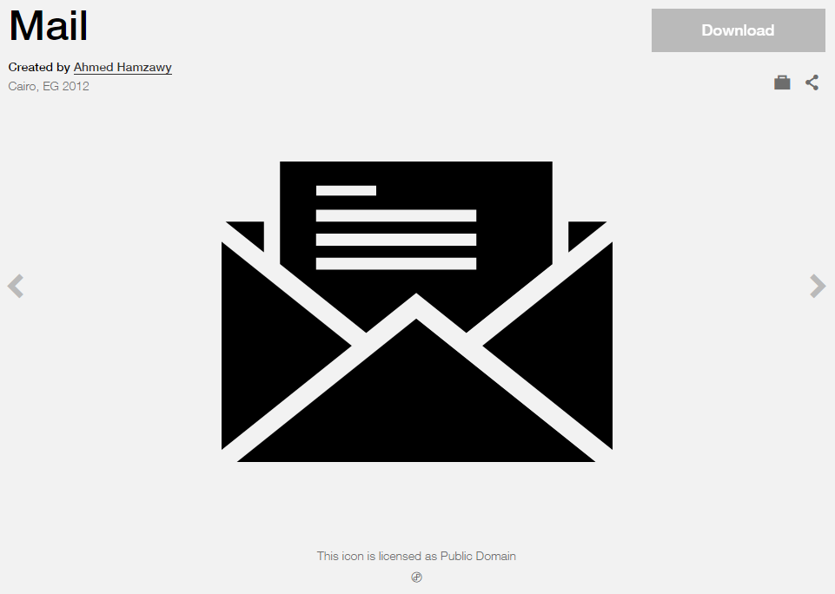

**Modified by:** Esri Solutions Team

**License:** Public Domain

**Acknowledgement:** None required

**Notes:** None

**Form Recorded by Office**

**Symbol Name:** [Write](https://thenounproject.com/term/write/43189/)

**Symbol Picture:** C:\Users\heat5533\Documents\GitHub\solutions-symbology-data\symbology\mobile\png\Form-Recorded-by-Office.png

**Symbol Source:** The Noun Project

**Symbol Date:** May 2015

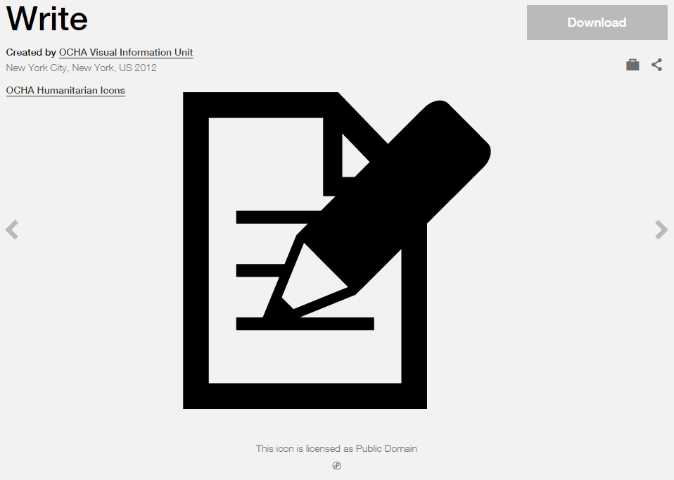

**Modified by:** Esri Solutions Team

**License:** Public Domain

**Acknowledgement:** None required

**Notes:** None

**Fracture**

**Symbol Name:**

**Symbol Picture:** C:\Data\Symbology\Utilities\Water\CCTVProcessor\web\Fracture.png

**Symbol Source:**

**Symbol Date:** May 2015

**Created by:** Esri Solutions Team

**License:** None

**Acknowledgement:** None required

**Notes:** None

**Fortification**

**Symbol Name:**

**Symbol Picture:** C:\Users\heat5533\Documents\GitHub\solutions-symbology-data\symbology\web\png\Barricade.png

**Symbol Source:**

**Symbol Date:** August 2015

**Created by:** Esri Solutions Team

**License:** None

**Acknowledgement:** None required

**Notes:** None

**Gas Shut Off**

**Symbol Name:** Gas Shutoff – Natural Main

**Symbol Picture:**



**Symbol Source:** NAPSG (National Alliance for Public Safety GIS Foundation) – NAPSG\_Preplans.style file

**Symbol Date:** March 2017



**Modified** **by:** Esri Solutions Team

**License:** None

**Acknowledgement:** None required

**Notes:** None

**Gate**

**Symbol Name:**

**Symbol Picture:** C:\Data\Symbology\Solutions\SpecialEventPlanning\mobile\Gate.png

**Symbol Source:**

**Symbol Date:** August 2015

**Created by:** Esri Solutions Team

**License:** None

**Acknowledgement:** None required

**Notes:** None

**Generator**

**Symbol Name:** [Power](https://thenounproject.com/search/?q=power&i=94)

**Symbol Picture:** C:\Data\Symbology\Solutions\SpecialEventPlanning\mobile\Generator.png

**Symbol Source:** The Noun Project

**Symbol Date:** August 2015

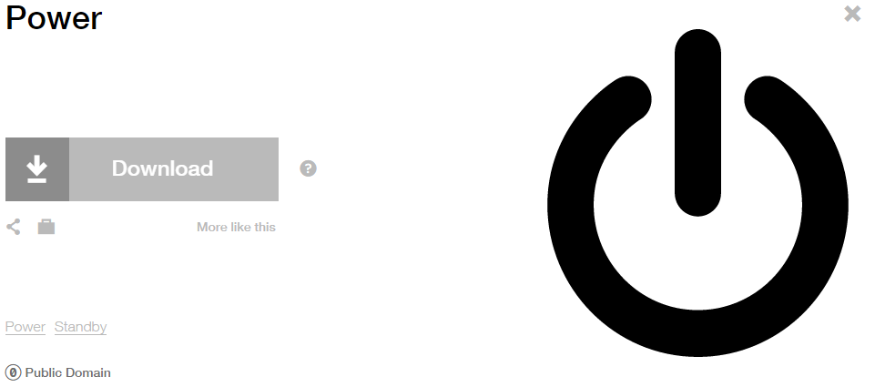

**Modified by:** Esri Solutions Team

**License:** Public Domain

**Acknowledgement:** None required

**Notes:** None

**Geologic Incident**

**Symbol Name:** Rock Collecting

**Symbol Picture:** C:\Data\Symbology\Solutions\OpsIncident\web\Geological-Incident.png

**Symbol Source:** Forestry style file

**Symbol Date:** February 2015



**Modified** **by:** Esri Solutions Team

**License:** None

**Acknowledgement:** None required

**Notes:** None

**Green Landscaping**

**Symbol Name:** GL

**Symbol Picture:** C:\Data\Symbology\Utilities\Water\GreenInfrastructure\mobile\Green-Landscaping.pngC:\Data\Symbology\Utilities\Water\GreenInfrastructure\web\Green-Landscaping.png

**Symbol Source:** Arial Rounded MT Bold Font

**Symbol Date:** March 2015

**Modified** **by:** Esri Solutions Team

**License:** None

**Acknowledgement:** None required

**Notes:** None

**Green Roof**

**Symbol Name:** GR

**Symbol Picture:** C:\Data\Symbology\Utilities\Water\GreenInfrastructure\mobile\Green-Roof.pngC:\Data\Symbology\Utilities\Water\GreenInfrastructure\web\Green-Roof.png

**Symbol Source:** Arial Rounded MT Bold Font

**Symbol Date:** March 2015

**Modified** **by:** Esri Solutions Team

**License:** None

**Acknowledgement:** None required

**Notes:** None

**Grout Test and Seal**

**Symbol Name:**

**Symbol Picture:** C:\Data\Symbology\Utilities\Water\CCTVProcessor\web\Grout-Test-and-Seal.png

**Symbol Source:**

**Symbol Date:** May 2015

**Created by:** Esri Solutions Team

**License:** None

**Acknowledgement:** None required

**Notes:** None

**Guest Services**

**Symbol Name:** Ticket Purchase 2

**Symbol Picture:** C:\Data\Symbology\Solutions\SpecialEventPlanning\mobile\Guest-Services.png

**Symbol Source:** Public Signs style file

**Symbol Date:** August 2015



**Modified by:** Esri Solutions Team

**License:** None

**Acknowledgement:** None required

**Notes:** None

**Habilitation Facility**

**Symbol Name:** [Charity](https://thenounproject.com/term/hands/4060/)

**Symbol Picture: C:\Data\Symbology\StateGov\MyHealthServices\web\Habilitation-Facility.png**

**Symbol Source:** The Noun Project

**Symbol Date:** March 2015

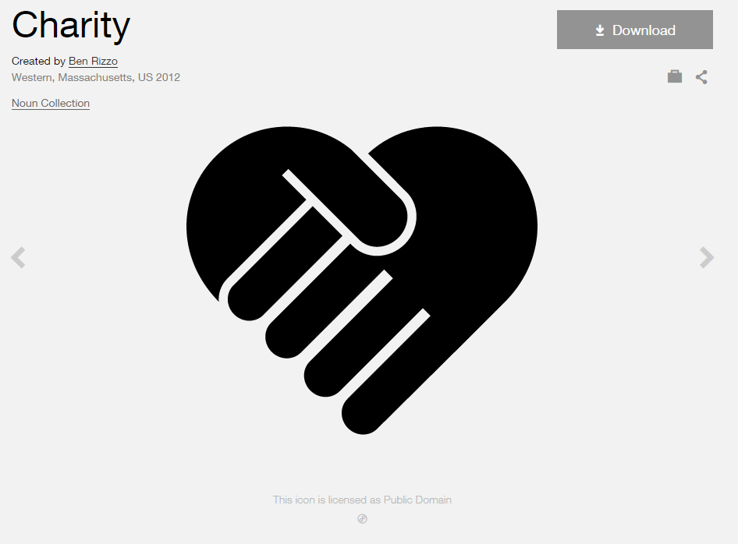

**Modified by:** Esri Solutions Team

**License:** Public Domain

**Acknowledgement:** None Required

**Notes:** None

**Hail**

**Symbol Name:**

**Symbol Picture:** C:\Data\Symbology\Solutions\HazardandRiskAssessment\web\Hail.png

**Symbol Source:**

**Symbol Date:** January 2016

**Created** **by:** Esri Solutions Team

**License:** None

**Acknowledgement:** None required

**Notes:** None

**Handicap Access**

**Symbol Name:** Handicapped 1

**Symbol Picture:** C:\Data\Symbology\Solutions\SpecialEventPlanning\mobile\Handicap-Access.png

**Symbol Source:** ESRI style file

**Symbol Date:** August 2015



**Modified by:** Esri Solutions Team

**License:** None

**Acknowledgement:** None required

**Notes:** None

**Hazardous**

**Symbol Name:** Hazardous

**Symbol Picture:** C:\Data\Symbology\Solutions\HazardandRiskAssessment\web\Hazardous.png

**Symbol Source:** Environmental style file

**Symbol Date:** June 2015

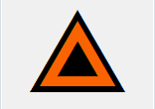

**Modified** **by:** Esri Solutions Team

**License:** None

**Acknowledgement:** None required

**Notes:** None

**Hazardous Condition Incident**

**Symbol Name:** !

**Symbol Picture:** C:\Users\heat5533\Documents\GitHub\solutions-symbology-data\symbology\web\png\Hazardous-Condition-Incident.png

**Symbol Source:**  Arial Rounded MT Bold

**Symbol Date:** July 2015

**Modified by:** Esri Solutions Team

**License:** None

**Acknowledgement:** None required

**Notes:** None

**Hazardous Materials**

**Symbol Name:** NFPA Diamond

**Symbol Picture:**



**Symbol Source:** Hazmat style file

**Symbol Date:** March 2017

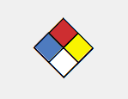

**Modified** **by:** Esri Solutions Team

**License:** None

**Acknowledgement:** None required

**Notes:** None

**Hazardous Materials Release**

**Symbol Name:** Hazardous Material

**Symbol Picture:** C:\Data\Symbology\Solutions\Debris\web\Hazardous-Waste.png

**Symbol Source:** ERS Homeland Security style file

**Symbol Date:** February 2015

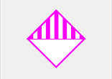

**Modified** **by:** Esri Solutions Team

**License:** None

**Acknowledgement:** None required

**Notes:** None

**Hose Connections**

**Symbol Name:** [Fire Hose Connection Hose Connection](http://napsg-web.s3.amazonaws.com/symbology/index.html#/single?PREPLN%20FIRSUP%20RED%20%20SOLID%20DETAIL%20Fire%20Hose%20Connection%20Hose%20Connection%20128x128)

**Symbol Picture:**



**Symbol Source:** NAPSG (National Alliance for Public Safety GIS Foundation)

**Symbol Date:** March 2017

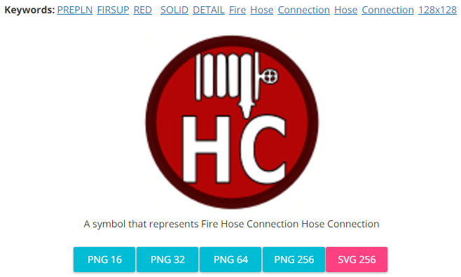

**Modified** **by:** Esri Solutions Team

**License:** None

**Acknowledgement:** None required

**Notes:** None

**Golf Courses**

**Symbol Name:** Golf Course 1

**Symbol Picture:** C:\Users\heat5533\Documents\GitHub\solutions-symbology-data\symbology\web\png\Golf-Courses.png

**Symbol Source:** Civic style file

**Symbol Date:** January 2015



**Modified** **by:** Esri Solutions Team

**License:** None

**Acknowledgement:** None required

**Notes:** None

**Hazardous Facilities**

**Symbol Name:** Hazardous Material Incident

**Symbol Picture:** C:\Users\heat5533\Documents\GitHub\solutions-symbology-data\symbology\web\png\Hazardous-Facilities.png

**Symbol Source:** ERS Homeland Security style file

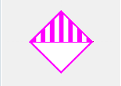

**Symbol Date:** February 2015

**Modified** **by:** Esri Solutions Team

**License:** None

**Acknowledgement:** None required

**Notes:** None

**Hazardous Material Incident**

**Symbol Name:** Hazardous Material Incident

**Symbol Picture:** C:\Data\Symbology\Solutions\OpsIncident\web\Hazardous-Material-Incident.png

**Symbol Source:** ERS Homeland Security style file

**Symbol Date:** February 2015



**Modified** **by:** Esri Solutions Team

**License:** None

**Acknowledgement:** None required

**Notes:** None

**Hazardous Waste**

**Symbol Name:** Hazardous Material

**Symbol Picture:** C:\Data\Symbology\Solutions\Debris\web\Hazardous-Waste.png

**Symbol Source:** ERS Homeland Security style file

**Symbol Date:** February 2015



**Modified** **by:** Esri Solutions Team

**License:** None

**Acknowledgement:** None required

**Notes:** None

**Hazards - Other**

**Symbol Name:** Hazardous

**Symbol Picture:** C:\Data\Symbology\Utilities\Electric\HazardReportingCollector\mobile\Hazards-Other.pngC:\Data\Symbology\Utilities\Electric\HazardReportingCollector\web\Hazards-Other.png

**Symbol Source:** Environmental style file

**Symbol Date:** June 2015



**Modified** **by:** Esri Solutions Team

**License:** None

**Acknowledgement:** None required

**Notes:** None

**Hazmat**

**Symbol Name:** Fire Incident

**Symbol Picture:** Hazmat

**Symbol Source:** ERS Homeland Security style file

**Symbol Date:** July 2015



**Modified** **by:** Esri Solutions Team

**License:** None

**Acknowledgement:** None required

**Notes:** None

**Healthcare Facilities**

**Symbol Name:** Cross 2

**Symbol Picture:** C:\Users\heat5533\Documents\GitHub\solutions-symbology-data\symbology\web\png\Healthcare-Facilities.png

**Symbol Source:** ESRI style file

**Symbol Date:** May 2014



**Modified by:** Esri Solutions Team

**License:** None

**Acknowledgement:** None required

**Notes:** None

**Health Problem – Completed, In – Progress, Received, and Submitted**

**Symbol Name:** [First Aid Kit](https://thenounproject.com/term/medical-bag/70543/)

**Symbol Picture:** C:\Users\heat5533\Documents\GitHub\solutions-symbology-data\symbology\web\png\Health-Problem-Completed.pngC:\Users\heat5533\Documents\GitHub\solutions-symbology-data\symbology\web\png\Health-Problem-In-Progress.pngC:\Users\heat5533\Documents\GitHub\solutions-symbology-data\symbology\web\png\Health-Problem-Received.pngC:\Users\heat5533\Documents\GitHub\solutions-symbology-data\symbology\web\png\Health-Problem-Submitted.png

**Symbol Source:** The Noun Project

**Symbol Date:** April 2016

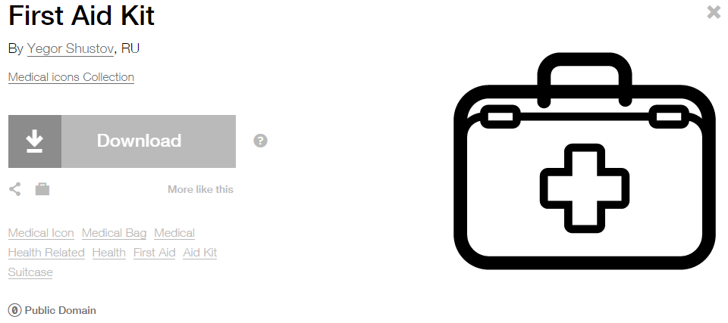

**Modified** **by:** Esri Solutions Team

**License:** Public Domain

**Acknowledgement:** None required

**Notes:** None

**Hearing**

**Symbol Name:** [Hear](http://thenounproject.com/term/hear/1583/)

**Symbol Picture: C:\Data\Symbology\StateGov\MyHealthServices\web\Hearing.png**

**Symbol Source:** The Noun Project

**Symbol Date:** March 2015

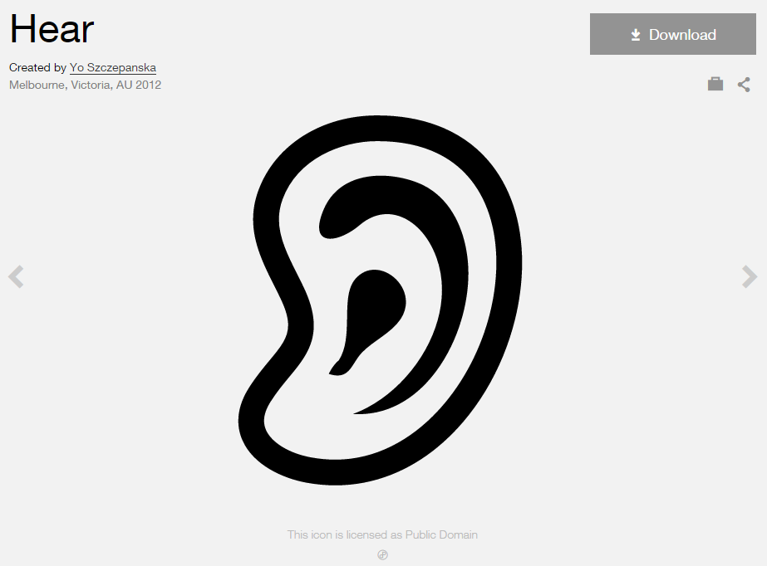

**Modified by:** Esri Solutions Team

**License:** Public Domain

**Acknowledgement:** None Required

**Notes:** None

**Heater - Cooler**

**Symbol Name:** Unicode 160 & Unicode 113

**Symbol Picture:** C:\Data\Symbology\Solutions\SpecialEventPlanning\mobile\Heater-Cooler.png

**Symbol Source:** ESRI US MUTCD 3 font & ESRI Enviro Hazard Analysis

**Symbol Date:** August 2015

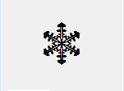

**Modified by:** Esri Solutions Team

**License:** None

**Acknowledgement:** None required

**Notes:** None

**Hole**

**Symbol Name:**

**Symbol Picture:** C:\Data\Symbology\Utilities\Water\CCTVProcessor\web\Hole.png

**Symbol Source:**

**Symbol Date:** May 2015

**Created by:** Esri Solutions Team

**License:** None

**Acknowledgement:** None required

**Notes:** None

**Home Health, Residential Care**

**Symbol Name:** House 2

**Symbol Picture: C:\Data\Symbology\StateGov\MyHealthServices\web\Home-Health.png**

**Symbol Source:** Business style file

**Symbol Date:** March 2015



**Modified by:** Esri Solutions Team

**License:** None

**Acknowledgement:** None Required

**Notes:** None

**Hospice**

**Symbol Name:** [Bunk-Bed](https://thenounproject.com/term/bunk-bed/3365/)

**Symbol Picture: C:\Data\Symbology\StateGov\MyHealthServices\web\Hospice.png**

**Symbol Source:** The Noun Project

**Symbol Date:** March 2015

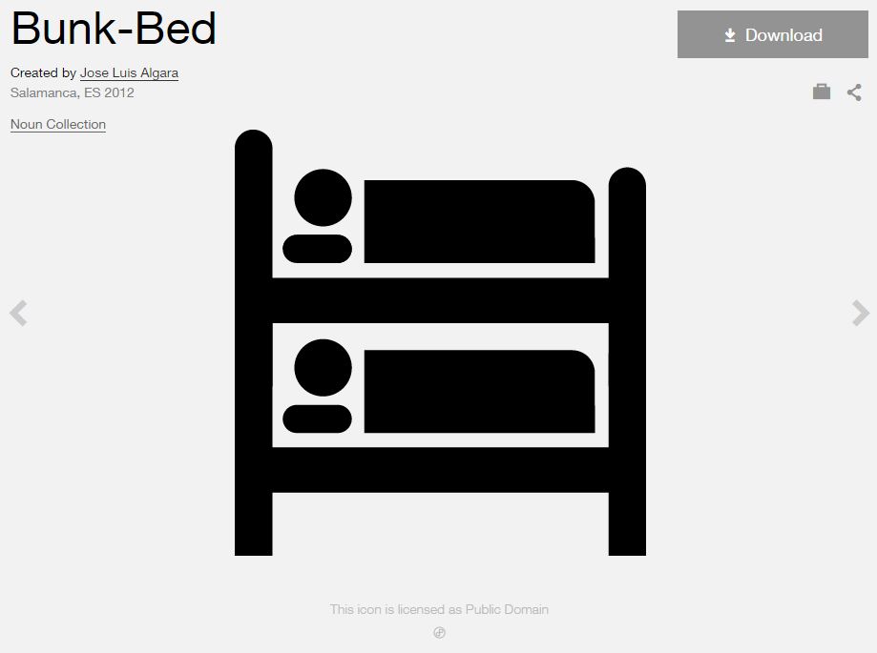

**Modified by:** Esri Solutions Team

**License:** Public Domain

**Acknowledgement:** None Required

**Notes:** None

**Hospital**

**Symbol Name:** Hospital

**Symbol Picture:** C:\Data\Symbology\Solutions\Live-Work-Locate\web\Hospital.png

**Symbol Source:** Business style file

**Symbol Date:** January 2015

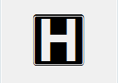

**Modified** **by:** Esri Solutions Team

**License:** None

**Acknowledgement:** None required

**Notes:** None

**Hurricane**

**Symbol Name:** Hurricane

**Symbol Picture:** C:\Data\Symbology\Solutions\HazardandRiskAssessment\web\Hurricane.png

**Symbol Source:** Weather style file

**Symbol Date:** September 2015



**Modified by:** Esri Solutions Team

**License:** None

**Acknowledgement:** None required

**Notes:** None

**Hydrant - Adopted**

**Symbol Name:** FireHydrant 1

**Symbol Picture:** C:\Data\Symbology\LocalGov\Adopta\web\Hydrant-Adopted-100-2K.pngC:\Data\Symbology\LocalGov\Adopta\web\Hydrant-Adopted-4K-9K.pngC:\Data\Symbology\LocalGov\Adopta\web\Hydrant-Adopted-9K-18K.png

**Symbol Source:** Hazmat style file

**Symbol Date:** March 2015

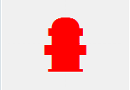

**Modified by:** Esri Solutions Team

**License:** None

**Acknowledgement:** None required

**Notes:** None

**Hydrant – Adopted By You**

**Symbol Name:** FireHydrant 1

**Symbol Picture:** C:\Data\Symbology\LocalGov\Adopta\web\Hydrant-Adopted-by-you-100-2K.pngC:\Data\Symbology\LocalGov\Adopta\web\Hydrant-Adopted-by-you-4K-9K.pngC:\Data\Symbology\LocalGov\Adopta\web\Hydrant-Adopted-by-you-9K-18K.png

**Symbol Source:** Hazmat style file

**Symbol Date:** March 2015



**Modified by:** Esri Solutions Team

**License:** None

**Acknowledgement:** None required

**Notes:** None

**Hydrant – Available**

**Symbol Name:** FireHydrant 1

**Symbol Picture:C:\Data\Symbology\LocalGov\Adopta\web\Hydrant-Avaliable-100-2K.pngC:\Data\Symbology\LocalGov\Adopta\web\Hydrant-Avaliable-4K-9K.pngC:\Data\Symbology\LocalGov\Adopta\web\Hydrant-Avaliable-9K-18K.png**

**Symbol Source:** Hazmat style file

**Symbol Date:** March 2015



**Modified by:** Esri Solutions Team

**License:** None

**Acknowledgement:** None required

**Notes:** None

**Hydrant - Inoperable**

**Symbol Name:** FireHydrant 1

**Symbol Picture:** C:\Data\Symbology\LocalGov\Hydrant\Hydrant-Inoperable.png

**Symbol Source:** Hazmat style file

**Symbol Date:** March 2015



**Modified by:** Esri Solutions Team

**License:** None

**Acknowledgement:** None required

**Notes:** None

**Hydrant - Operable**

**Symbol Name:** FireHydrant 1

**Symbol Picture:** C:\Data\Symbology\LocalGov\Hydrant\Hydrant.png

**Symbol Source:** Hazmat style file

**Symbol Date:** March 2015



**Modified by:** Esri Solutions Team

**License:** None

**Acknowledgement:** None required

**Notes:** None

**Hydrant – Out of Order**

**Symbol Name:** FireHydrant 1

**Symbol Picture:** C:\Data\Symbology\LocalGov\Hydrant\mobile\Hydrant-Out-of-Order.pngC:\Data\Symbology\LocalGov\Adopta\web\Hydrant-Out-Of-Order-100-2K.pngC:\Data\Symbology\LocalGov\Adopta\web\Hydrant-Out-Of-Order-4K-9K.pngC:\Data\Symbology\LocalGov\Adopta\web\Hydrant-Out-Of-Order-9K-18K.png

**Symbol Source:** Hazmat style file

**Symbol Date:** March 2015



**Modified by:** Esri Solutions Team

**License:** None

**Acknowledgement:** None required

**Notes:** None

**Hydrant – Unclear**

**Symbol Name:** FireHydrant 1

**Symbol Picture:** C:\Data\Symbology\LocalGov\Adopta\web\Hydrant-Unclear-100-2K.pngC:\Data\Symbology\LocalGov\Adopta\web\Hydrant-Unclear-4K-9K.pngC:\Data\Symbology\LocalGov\Adopta\web\Hydrant-Unclear-9K-18K.png

**Symbol Source:** Hazmat style file

**Symbol Date:** March 2015



**Modified by:** Esri Solutions Team

**License:** None

**Acknowledgement:** None required

**Notes:** None

**Hydro-Meteorological Incident**

**Symbol Name:**

**Symbol Picture:** C:\Data\Symbology\Solutions\OpsIncident\web\Hydro-Meteorological-Incident.png

**Symbol Source:**

**Symbol Date:** February 2015

**Created** **by:** Esri Solutions Team

**License:** None

**Acknowledgement:** None required

**Notes:** None

**Hydrostatic Permit**

**Symbol Name:** Droplet, Water

**Symbol Picture:** C:\Users\heat5533\Documents\GitHub\solutions-symbology-data\symbology\web\png\Hydrostatic.png

**Symbol Source:** Environmental style file

**Symbol Date:** September 2014

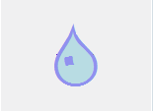

**Modified by:** Esri Solutions Team

**License:** None

**Acknowledgement:** None required

**Notes:** None

**Ice Snow Problem – Completed, In – Progress, Received, and Submitted**

**Symbol Name:** [Snow](https://thenounproject.com/term/snow/24499/)

**Symbol Picture:** C:\Users\heat5533\Documents\GitHub\solutions-symbology-data\symbology\web\png\Ice-Snow-Problem-Completed.pngC:\Users\heat5533\Documents\GitHub\solutions-symbology-data\symbology\web\png\Ice-Snow-Problem-In-Progress.pngC:\Users\heat5533\Documents\GitHub\solutions-symbology-data\symbology\web\png\Ice-Snow-Problem-Received.pngC:\Users\heat5533\Documents\GitHub\solutions-symbology-data\symbology\web\png\Ice-Snow-Problem-Submitted.png

**Symbol Source:** The Noun Project

**Symbol Date:** January 2016

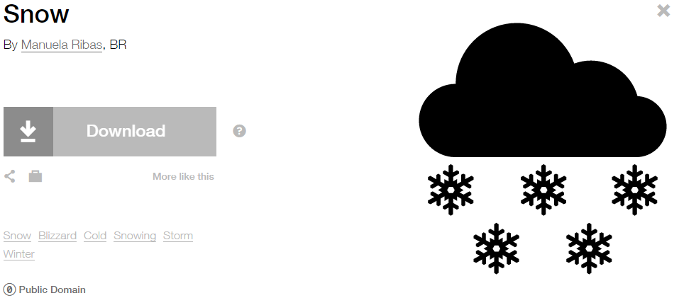

**Modified** **by:** Esri Solutions Team

**License:** Public Domain

**Acknowledgement:** None required

**Notes:** None

**Incident**

**Symbol Name:** !

**Symbol Picture:** C:\Data\Symbology\StateGov\Transportation511\web\Incident.png

**Symbol Source:** Arial Rounded MT Bold

**Symbol Date:** May 2015

**Modified by:** Esri Solutions Team

**License:** None

**Acknowledgement:** None required

**Notes:** None

**Incident Command Post**

**Symbol Name:** Incident Command Post

**Symbol Picture:** C:\Data\UC\UC2015\SituationalAwareness\web\Incident-Command-Post.png

**Symbol Source:** Forestry style file

**Symbol Date:** July 2015



**Modified by:** Esri Solutions Team

**License:** None

**Acknowledgement:** None required

**Notes:** None

**Incident Management**

**Symbol Name:** !

**Symbol Picture:** C:\Data\UC\UC2015\SituationalAwareness\web\Incident-Management.png

**Symbol Source:**  Arial Rounded MT Bold

**Symbol Date:** July 2015

**Modified by:** Esri Solutions Team

**License:** None

**Acknowledgement:** None required

**Notes:** None

**Incorrect Attribute**

**Symbol Name:** [Map](https://thenounproject.com/term/map/2312/)

**Symbol Picture:** C:\Users\heat5533\Documents\GitHub\solutions-symbology-data\symbology\mobile\png\Incorrect-Attribute.pngC:\Users\heat5533\Documents\GitHub\solutions-symbology-data\symbology\web\png\Incorrect-Attribute.png

**Symbol Source:** The Noun Project

**Symbol Date:** May 2015



**Modified by:** Esri Solutions Team

**License:** Public Domain

**Acknowledgement:** None required

**Notes:** None

**Incubators**

**Symbol Name:** [Business-Incubator](http://thenounproject.com/term/business-incubator/21040/)

**Symbol Picture:** C:\Data\Symbology\Solutions\Live-Work-Locate\web\Incubator.png

**Symbol Source:** The Noun Project

**Symbol Date:** March 2015

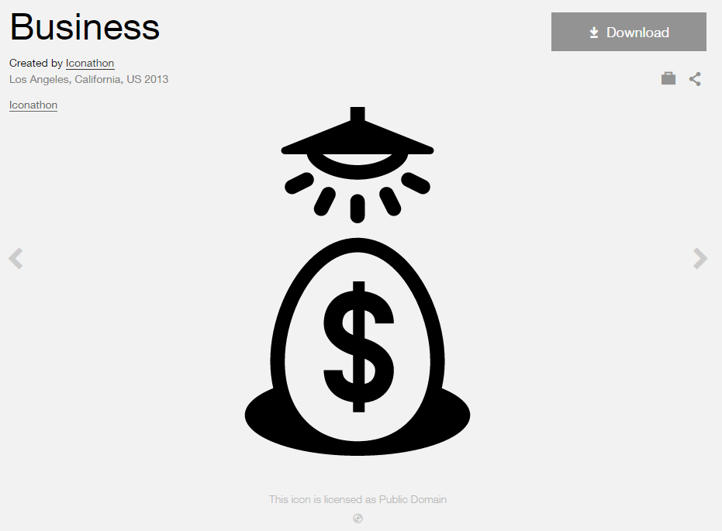

**Modified by:** Esri Solutions Team

**License:** Public Domain

**Acknowledgement:** None required

**Notes:** None

**Individual Permit**

**Symbol Name:**

**Symbol Picture:** C:\Users\heat5533\Documents\GitHub\solutions-symbology-data\symbology\web\png\Individual.png

**Symbol Source:**

**Symbol Date:** September 2014

**Created by:** Esri Solutions Team

**License:** None

**Acknowledgement:** None required

**Notes:** None

**Infestation Incident**

**Symbol Name:** [Ant](https://thenounproject.com/term/ant/4002/)

**Symbol Picture:** C:\Data\Symbology\Solutions\OpsIncident\web\Infestation-Incident.png

**Symbol Source:** The Noun Project

**Symbol Date:** March 2015

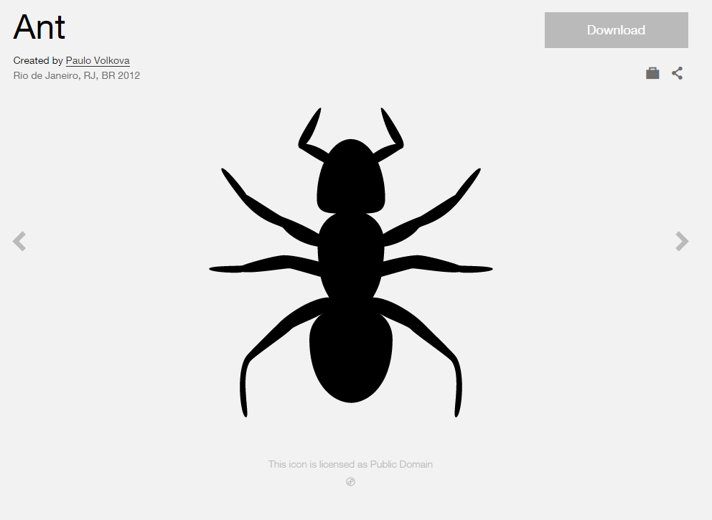

**Modified** **by:** Esri Solutions Team

**License:** Public Domain

**Acknowledgement:** None required

**Notes:** None

**Infiltration**

**Symbol Name:**

**Symbol Picture:** C:\Data\Symbology\Utilities\Water\CCTVProcessor\web\Infiltration.png

**Symbol Source:**

**Symbol Date:** May 2015

**Created by:** Esri Solutions Team

**License:** None

**Acknowledgement:** None required

**Notes:** None

**Information**

**Symbol Name:** i

**Symbol Picture:** C:\Data\Symbology\StateGov\Transportation511\web\Information.png

**Symbol Source:** Arial Rounded MT Bold

**Symbol Date:** April 2014

**Modified by:** Esri Solutions Team

**License:** None

**Acknowledgement:** None Required

**Notes:** None

**Information Center**

**Symbol Name:** [Information](https://thenounproject.com/term/information/5134/)

**Symbol Picture:** C:\Data\Symbology\StateGov\Transportation511\web\Information-Center.png

**Symbol Source:** The Noun Project

**Symbol Date:** February 2016



**Modified by:** Esri Solutions Team

**License:** Public Domain

**Acknowledgement:** None required

**Notes:** None

**Information Kiosk**

**Symbol Name:** [Information](https://thenounproject.com/term/information/5134/)

**Symbol Picture:** C:\Data\Symbology\StateGov\Transportation511\web\Information-Center.png

**Symbol Source:** The Noun Project

**Symbol Date:** February 2016



**Modified by:** Esri Solutions Team

**License:** Public Domain

**Acknowledgement:** None required

**Notes:** None

**Inlet Protection Violation**

**Symbol Name:** IP

**Symbol Picture:** C:\Data\Symbology\Utilities\Water\ConstructionSiteViolations\mobile\Inlet-Protection-Violation.png

**Symbol Source:** Arial Rounded MT Bold Font

**Symbol Date:** March 2015

**Modified** **by:** Esri Solutions Team

**License:** None

**Acknowledgement:** None required

**Notes:** None

**Inlets**

**Symbol Name:**

**Symbol Picture:** C:\Data\Symbology\Utilities\Water\IllicitDischarge\mobile\Inlets.pngC:\Data\Symbology\Utilities\Water\IllicitDischarge\web\Inlets.png

**Symbol Source:**

**Symbol Date:** April 2015

**Created by:** Esri Solutions Team

**License:** None

**Acknowledgement:** None required

**Notes:** None

**Intentional**

**Symbol Name:** [Match](https://thenounproject.com/search/?q=cog&i=1120)

**Symbol Picture:** C:\Users\heat5533\Documents\GitHub\solutions-symbology-data\symbology\web\png\Intentional.png

**Symbol Source:**  The Noun Project

**Symbol Date:** December 2015

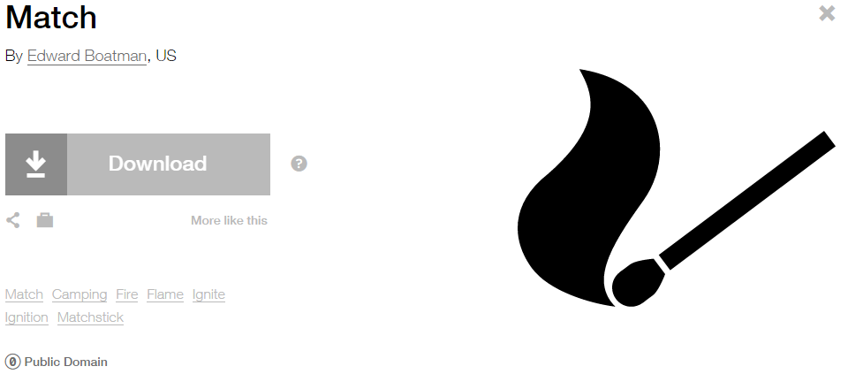

**Modified by:** Esri Solutions Team

**License:** Public Domain

**Acknowledgement:** None required

**Notes:** None

**Interbasin Water Transfer**

**Symbol Name:** Water Recreation

**Symbol Picture:** C:\Users\heat5533\Documents\GitHub\solutions-symbology-data\symbology\web\png\Interbasin-Water-Transfer.png

**Symbol Source:** Forestry style file

**Symbol Date:** September 2014



**Modified by:** Esri Solutions Team

**License:** None

**Acknowledgement:** None required

**Notes:** None

**Intruding Sealing Material**

**Symbol Name:**

**Symbol Picture:** C:\Data\Symbology\Utilities\Water\CCTVProcessor\web\Intruding-Sealing-Material.png

**Symbol Source:**

**Symbol Date:** May 2015

**Created by:** Esri Solutions Team

**License:** None

**Acknowledgement:** None required

**Notes:** None

**Joint**

**Symbol Name:**

**Symbol Picture:** C:\Data\Symbology\Utilities\Water\CCTVProcessor\web\Joint.png

**Symbol Source:**

**Symbol Date:** May 2015

**Created by:** Esri Solutions Team

**License:** None

**Acknowledgement:** None required

**Notes:** None

**Joint Use Survey - Assigned**

**Symbol Name:**

**Symbol Picture:** C:\Data\Symbology\Utilities\Electric\JointUseSurvey\web\Joint-Use-Survey-Assigned.png

**Symbol Source:**

**Symbol Date:** April 2015

**Created** **by:** Esri Solutions Team

**License:** None

**Acknowledgement:** None required

**Notes:** None

**Joint Use Survey - Completed**

**Symbol Name:**

**Symbol Picture:** C:\Data\Symbology\Utilities\Electric\JointUseSurvey\web\Joint-Use-Survey-Completed.png

**Symbol Source:**

**Symbol Date:** April 2015

**Created** **by:** Esri Solutions Team

**License:** None

**Acknowledgement:** None required

**Notes:** None

**Joint Use Survey – Not On Map**

**Symbol Name:**

**Symbol Picture:** C:\Data\Symbology\Utilities\Electric\JointUseSurvey\web\Joint-Use-Survey-Not-On-Map.png

**Symbol Source:**

**Symbol Date:** April 2015

**Created** **by:** Esri Solutions Team

**License:** None

**Acknowledgement:** None required

**Notes:** None

**Joint Use Survey – Pole Not Found**

**Symbol Name:**

**Symbol Picture:** C:\Data\Symbology\Utilities\Electric\JointUseSurvey\web\Joint-Use-Survey-Pole-Not-Found.png

**Symbol Source:**

**Symbol Date:** April 2015

**Created** **by:** Esri Solutions Team

**License:** None

**Acknowledgement:** None required

**Notes:** None

**Joint Use Survey – Unassigned**

**Symbol Name:** ?

**Symbol Picture:** C:\Data\Symbology\Utilities\Electric\JointUseSurvey\web\Joint-Use-Survey-Unassigned.png

**Symbol Source:** Arial Rounded MT Bold

**Symbol Date:** April 2015

**Modifed by:** Esri Solutions Team

**License:** None

**Acknowledgement:** None required

**Notes:** None

**Landslide**

**Symbol Name:** [Landslide](https://thenounproject.com/search/?q=landslide&i=4241)

**Symbol Picture:** C:\Data\Symbology\Solutions\HazardandRiskAssessment\web\Landslide.png

**Symbol Source:** The Noun Project

**Symbol Date:** September 2015

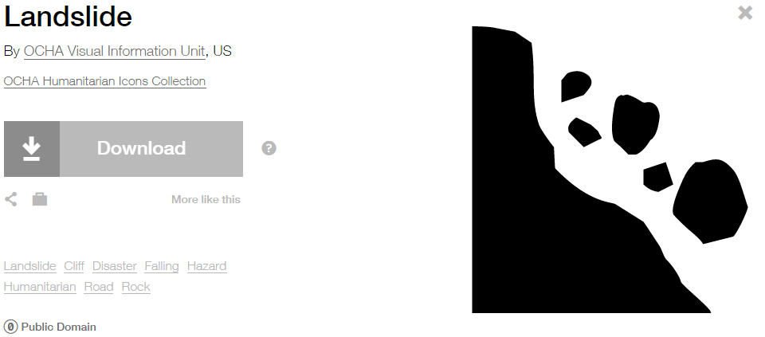

**Modified by:** EsriSolutions Team

**License:** Public Domain

**Acknowledgement:** None required

**Notes:** None

**Land Use Code Violation Closed**

**Symbol Name:** X

**Symbol Picture:** **C:\Data\Symbology\LocalGov\CodeViolation\mobile\Code-Violation-Open.png**

**Symbol Source:** Myriad Pro – Semi bold font

**Symbol Date:** March 2015

**Modified** **by:** Esri Solutions Team

**License:** None

**Acknowledgement:** None required

**Notes:** None

**Land Use Code Violation Open**

**Symbol Name:** Check 1

**Symbol Picture:** C:\Data\Symbology\LocalGov\CodeViolation\mobile\Code-Violation-Closed.png

**Symbol Source:** ESRI style file

**Symbol Date:** March 2015



**Modified** **by:** Esri Solutions Team

**License:** None

**Acknowledgement:** None required

**Notes:** None

**Large mammal**

**Symbol Name:** [Bear](https://thenounproject.com/term/bear/653/)

**Symbol Picture:** C:\Data\Symbology\StateGov\CitizenScience\web\Large-Mammal.png

**Symbol Source:** The Noun Project

**Symbol Date:** March 2015

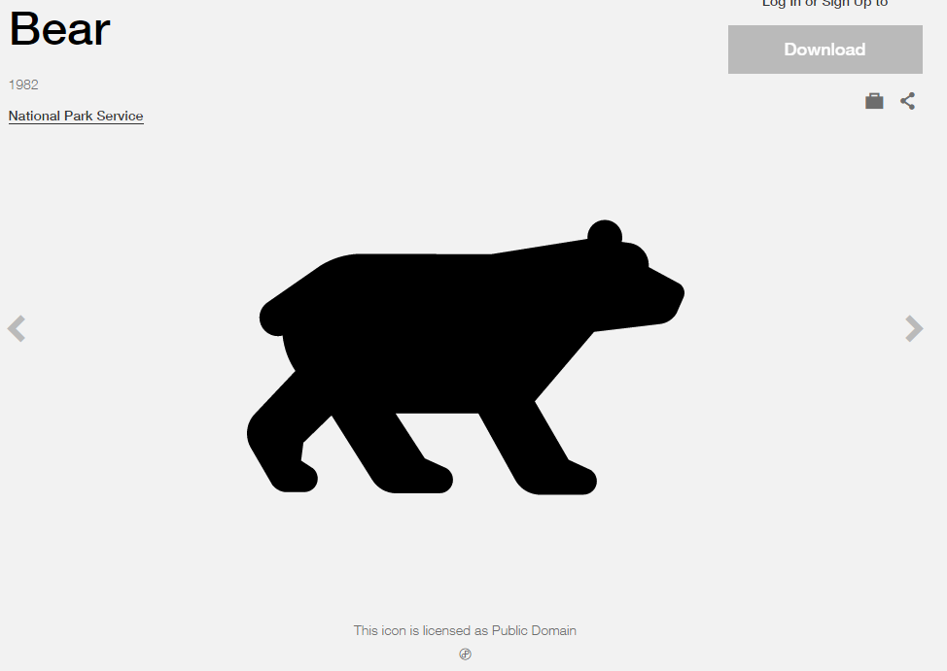

**Modified by:** Esri Solutions Team

**License:** Public Domain

**Acknowledgement:** None required

**Notes:** None

**Laser Light**

**Symbol Name:** Unicode 177

**Symbol Picture:** C:\Data\Symbology\Solutions\SpecialEventPlanning\mobile\Laser-Light.png

**Symbol Source:** ESRI AMFM Water font

**Symbol Date:** August 2015



**Modified by:** Esri Solutions Team

**License:** None

**Acknowledgement:** None required

**Notes:** None

**Law Enforcement and Security**

**Symbol Name:** Police Badge & L1 Law Enforcement Operations

**Symbol Picture:** C:\Data\UC\UC2015\SituationalAwareness\web\Law-Enforcement-and-Security.png

**Symbol Source:** ESRI Crime Analysis & ERS Homeland Security style file

**Symbol Date:** July 2015

 

**Modified** **by:** Esri Solutions Team

**License:** None

**Acknowledgement:** None required

**Notes:** None

**Leak Severity - Cosmetic**

**Symbol Name:** Oil Droplet

**Symbol Picture:** C:\Users\heat5533\Documents\GitHub\solutions-symbology-data\symbology\mobile\png\Leak-Severity-Cosmetic.pngC:\Users\heat5533\Documents\GitHub\solutions-symbology-data\symbology\web\png\Leak-Severity-Cosmetic.png

**Symbol Source:** Petroleum style files

**Symbol Date:** May 2015

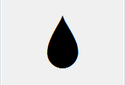

**Modified by:** Esri Solutions Team

**License:** None

**Acknowledgement:** None required

**Notes:** None

**Leak Severity - Critical**

**Symbol Name:** Oil Droplet

**Symbol Picture:** C:\Users\heat5533\Documents\GitHub\solutions-symbology-data\symbology\mobile\png\Leak-Severity-Critical.pngC:\Users\heat5533\Documents\GitHub\solutions-symbology-data\symbology\web\png\Leak-Severity-Critical.png

**Symbol Source:** Petroleum style files

**Symbol Date:** May 2015



**Modified by:** Esri Solutions Team

**License:** None

**Acknowledgement:** None required

**Notes:** None

**Leak Severity - Major**

**Symbol Name:** Oil Droplet

**Symbol Picture:** C:\Users\heat5533\Documents\GitHub\solutions-symbology-data\symbology\mobile\png\Leak-Severity-Major.pngC:\Users\heat5533\Documents\GitHub\solutions-symbology-data\symbology\web\png\Leak-Severity-Major.png

**Symbol Source:** Petroleum style files

**Symbol Date:** May 2015



**Modified by:** Esri Solutions Team

**License:** None

**Acknowledgement:** None required

**Notes:** None

**Leak Severity - Minor**

**Symbol Name:** Oil Droplet

**Symbol Picture:** C:\Users\heat5533\Documents\GitHub\solutions-symbology-data\symbology\mobile\png\Leak-Severity-Minor.pngC:\Users\heat5533\Documents\GitHub\solutions-symbology-data\symbology\web\png\Leak-Severity-Minor.png

**Symbol Source:** Petroleum style files

**Symbol Date:** May 2015



**Modified by:** Esri Solutions Team

**License:** None

**Acknowledgement:** None required

**Notes:** None

**Leak Severity - Moderate**

**Symbol Name:** Oil Droplet

**Symbol Picture:** C:\Users\heat5533\Documents\GitHub\solutions-symbology-data\symbology\mobile\png\Leak-Severity-Moderate.pngC:\Users\heat5533\Documents\GitHub\solutions-symbology-data\symbology\web\png\Leak-Severity-Moderate.png

**Symbol Source:** Petroleum style files

**Symbol Date:** May 2015



**Modified by:** Esri Solutions Team

**License:** None

**Acknowledgement:** None required

**Notes:** None

**Levee Failure**

**Symbol Name:**

**Symbol Picture:** C:\Data\Symbology\Solutions\HazardandRiskAssessment\web\Levee-Failure.png

**Symbol Source:**

**Symbol Date:** September 2015

**Created by:** EsriSolutions Team

**License:** None

**Acknowledgement:** None required

**Notes:** None

**Libraries**

**Symbol Name:** Library

**Symbol Picture:** C:\Users\heat5533\Documents\GitHub\solutions-symbology-data\symbology\web\png\Library.png

**Symbol Source:** Civic style file

**Symbol Date:** January 2015



**Modified** **by:** Esri Solutions Team

**License:** None

**Acknowledgement:** None required

**Notes:** None

**Lighting Truss**

**Symbol Name:**

**Symbol Picture:** C:\Data\Symbology\Solutions\SpecialEventPlanning\mobile\Lighting-Truss.png

**Symbol Source:**

**Symbol Date:** December 2015

**Created by:** Esri Solutions Team

**License:** None

**Acknowledgement:** None required

**Notes:** None

**Lightning**

**Symbol Name:** [Storm](https://thenounproject.com/search/?q=storm&i=24502)

**Symbol Picture:** C:\Data\Symbology\Solutions\HazardandRiskAssessment\web\Lightning.png

**Symbol Source:**  The Noun Project

**Symbol Date:** December 2015



**Modified by:** Esri Solutions Team

**License:** Public Domain

**Acknowledgement:** None required

**Notes:** None

**Line**

**Symbol Name:**

**Symbol Picture:** C:\Data\Symbology\Utilities\Water\CCTVProcessor\web\Line.png

**Symbol Source:**

**Symbol Date:** May 2015

**Created by:** Esri Solutions Team

**License:** None

**Acknowledgement:** None required

**Notes:** None

**Lining**

**Symbol Name:**

**Symbol Picture:** C:\Data\Symbology\Utilities\Water\CCTVProcessor\web\Lining.png

**Symbol Source:**

**Symbol Date:** May 2015

**Created by:** Esri Solutions Team

**License:** None

**Acknowledgement:** None required

**Notes:** None

**Liquefied Natural Gas Shut Off**

**Symbol Name:** [LNG Main\_With Line](http://napsg-web.s3.amazonaws.com/symbology/index.html#/single?PREPLAN%20SHUTOF%20BLUE%20%20DETAIL%20LNG%20Main%20With%20Line%20128x128)

**Symbol Picture:**



**Symbol Source:** NAPSG (National Alliance for Public Safety GIS Foundation)

**Symbol Date:** March 2017

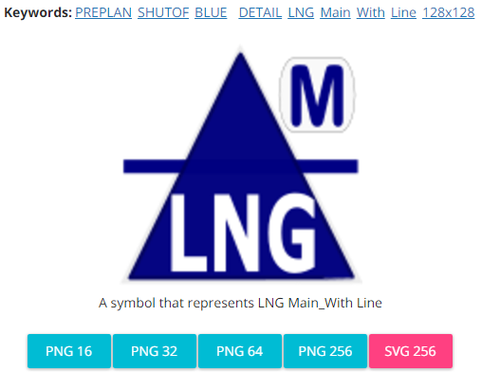

**Modified by:** Esri Solutions Team

**License:** None

**Acknowledgement:** None required

**Notes:** None

**Location Checks - Assigned**

**Symbol Name:** A

**Symbol Picture:** Location-Check-Assigned

**Symbol Source:** Arial font

**Symbol Date:** February 2017

**Modified by:** Esri Solutions Team

**License:** None

**Acknowledgement:** None required

**Notes:** None

**Location Checks – Complete - Evacuated**

**Symbol Name:** E

**Symbol Picture:**



**Symbol Source:** Arial font

**Symbol Date:** February 2017

**Modified by:** Esri Solutions Team

**License:** None

**Acknowledgement:** None required

**Notes:** None

**Location Checks – Completed - Follow up - Needed**

**Symbol Name:** F

**Symbol Picture:** C:\Users\heat5533\AppData\Local\Microsoft\Windows\INetCache\Content.Word\Location-Checks-Complete-Follow-up-Needed.png

**Symbol Source:** Arial font

**Symbol Date:** February 2017

**Modified by:** Esri Solutions Team

**License:** None

**Acknowledgement:** None required

**Notes:** None

**Location Checks – Completed - No - Information**

**Symbol Name:** N

**Symbol Picture:**



**Symbol Source:** Arial font

**Symbol Date:** February 2017

**Modified by:** Esri Solutions Team

**License:** None

**Acknowledgement:** None required

**Notes:** None

**Location Checks – Completed – Information - Discovered**

**Symbol Name:** I

**Symbol Picture:**



**Symbol Source:** Arial font

**Symbol Date:** February 2017

**Modified by:** Esri Solutions Team

**License:** None

**Acknowledgement:** None required

**Notes:** None

**Lost - Found**

**Symbol Name:** Lost and Found

**Symbol Picture:** C:\Data\Symbology\Solutions\SpecialEventPlanning\mobile\Lost-Found.png

**Symbol Source:** Public Signs style file

**Symbol Date:** December 2015



**Modified by:** Esri Solutions Team

**License:** None

**Acknowledgement:** None required

**Notes:** None

**Key Box**

**Symbol Name:** [Knox Plain](http://napsg-web.s3.amazonaws.com/symbology/index.html#/single?PREPLN%20ACCESS%20GREEN%20SOLID%20DETAIL%20Knox%20Plain%20128x128)

**Symbol Picture:**



**Symbol Source:** NAPSG (National Alliance for Public Safety GIS Foundation)

**Symbol Date:** March 2017

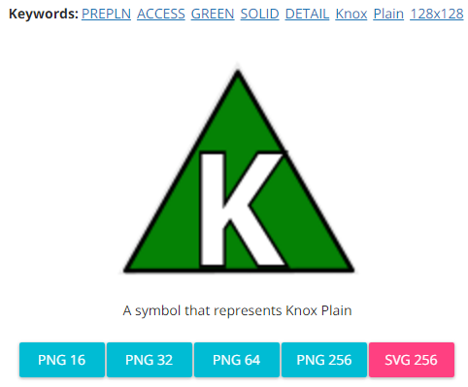

**Modified by:** Esri Solutions Team

**License:** None

**Acknowledgement:** None required

**Notes:** None

**Key Box - Cabinet**

**Symbol Name:** Knox Cabinet

**Symbol Picture:**



**Symbol Source:** NAPSG (National Alliance for Public Safety GIS Foundation) – NAPSG\_Preplan.style

**Symbol Date:** March 2017



**Modified by:** Esri Solutions Team

**License:** None

**Acknowledgement:** None required

**Notes:** None

**Key Box - Card**

**Symbol Name:** [Knox Keycard](http://napsg-web.s3.amazonaws.com/symbology/index.html#/single?PREPLN%20ACCESS%20GREEN%20SOLID%20DETAIL%20Knox%20Keycard%20128x128)

**Symbol Picture:**



**Symbol Source:** NAPSG (National Alliance for Public Safety GIS Foundation)

**Symbol Date:** March 2017

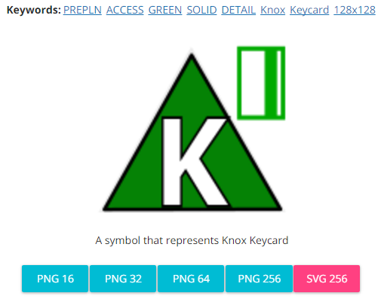

**Modified by:** Esri Solutions Team

**License:** None

**Acknowledgement:** None required

**Notes:** None

**Key Box – Drug Vault**

**Symbol Name:** Knox Drug Vault

**Symbol Picture:**



**Symbol Source:** NAPSG (National Alliance for Public Safety GIS Foundation) – NAPSG\_Preplan.style

**Symbol Date:** March 2017

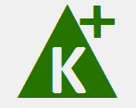

**Modified by:** Esri Solutions Team

**License:** None

**Acknowledgement:** None required

**Notes:** None

**Key Box – Electric Shunt Switch**

**Symbol Name:** [Knox KeyShunt](http://napsg-web.s3.amazonaws.com/symbology/index.html#/single?PREPLN%20ACCESS%20GREEN%20SOLID%20DETAIL%20Knox%20KeyShunt%20128x128)

**Symbol Picture:**



**Symbol Source:** NAPSG (National Alliance for Public Safety GIS Foundation)

**Symbol Date:** March 2017

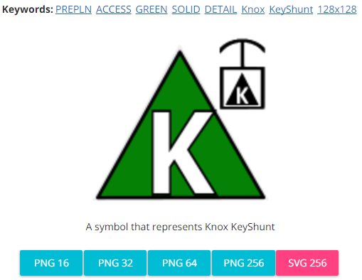

**Modified by:** Esri Solutions Team

**License:** None

**Acknowledgement:** None required

**Notes:** None

**Key Box – Other**

**Symbol Name:**

**Symbol Picture:**



**Symbol Source:**

**Symbol Date:** March 2017

**Modified by:** Esri Solutions Team

**License:** None

**Acknowledgement:** None required

**Notes:** None

**Key Box – Residential**

**Symbol Name:** [Knox Residential](http://napsg-web.s3.amazonaws.com/symbology/index.html#/single?PREPLN%20ACCESS%20GREEN%20SOLID%20DETAIL%20Knox%20Residential%20128x128)

**Symbol Picture:**



**Symbol Source:** NAPSG (National Alliance for Public Safety GIS Foundation)

**Symbol Date:** March 2017

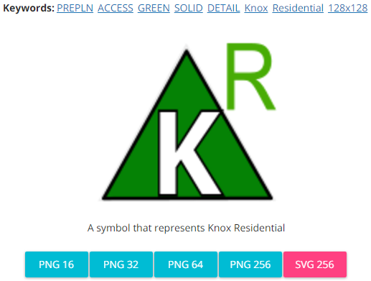

**Modified by:** Esri Solutions Team

**License:** None

**Acknowledgement:** None required

**Notes:** None

**Key Box – Vault**

**Symbol Name:** Knox Vault

**Symbol Picture:**



**Symbol Source:** NAPSG (National Alliance for Public Safety GIS Foundation) – NAPSG\_Preplan.style

**Symbol Date:** March 2017

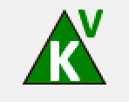

**Modified by:** Esri Solutions Team

**License:** None

**Acknowledgement:** None required

**Notes:** None

**Malaria**

**Symbol Name:** !

**Symbol Picture:**



**Symbol Source:**  Arial Rounded MT Bold

**Symbol Date:** December 2016

**Modified by:** Esri Solutions Team

**License:** None

**Acknowledgement:** None required

**Notes:** None

**Manhole**

**Symbol Name:** Manhole

**Symbol Picture:** C:\Users\heat5533\Documents\GitHub\solutions-symbology-data\symbology\mobile\png\Manholes.pngC:\Users\heat5533\Documents\GitHub\solutions-symbology-data\symbology\web\png\Manhole.png

**Symbol Source:** Water Wastewater style file

**Symbol Date:** April 2015



**Modified by:** Esri Solutions Team

**License:** None

**Acknowledgement:** None required

**Notes:** None

**Marina**

**Symbol Name:** [Ship](https://thenounproject.com/term/ship/4409/)

**Symbol Picture:** C:\Users\heat5533\Documents\GitHub\solutions-symbology-data\symbology\web\png\Marina.png

**Symbol Source:** The Noun Project

**Symbol Date:** March 2015

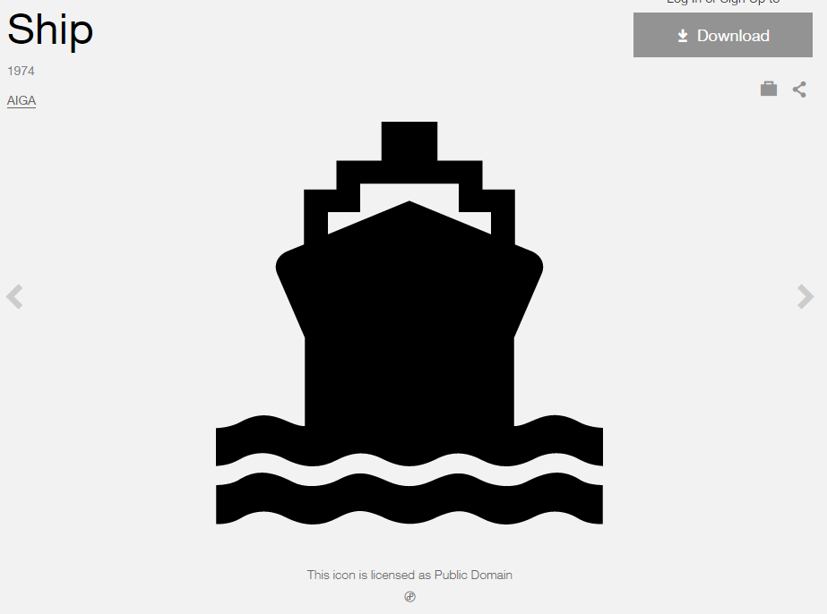

**Modified by:** Esri Solutions Team

**License:** Public Domain

**Acknowledgement:** None required

**Notes:** None

**Marine Incident**

**Symbol Name:** [Ship](http://thenounproject.com/term/ship/4409/)

**Symbol Picture: C:\Data\Symbology\Solutions\OpsIncident\web\Marine-Incident.png**

**Symbol Source:** The Noun Project

**Symbol Date:** March 2015



**Modified by:** Esri Solutions Team

**License:** Public Domain

**Acknowledgement:** None required

**Notes:** None

**Market**

**Symbol Name:** [Store](https://thenounproject.com/term/store/5284/)

**Symbol Picture:** C:\Users\heat5533\Documents\GitHub\solutions-symbology-data\symbology\web\png\Market.png

**Symbol Source:** The Noun Project

**Symbol Date:** February 2015

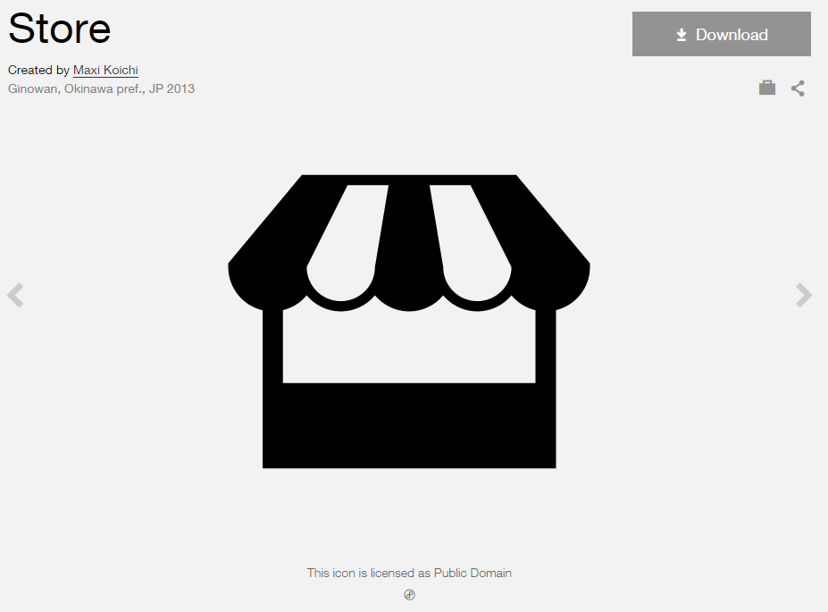

**Modified by:** Esri Solutions Team

**License:** Public Domain

**Acknowledgement:** None required

**Notes:** None

**Mass Transit Stations**

**Symbol Name:** Bus 2

**Symbol Picture:** C:\Users\heat5533\Documents\GitHub\solutions-symbology-data\symbology\web\png\Mass-Transit-Stations.png

**Symbol Source:** Business style file

**Symbol Date:** March 2015

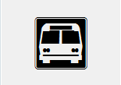

**Modified by:** Esri Solutions Team

**License:** None

**Acknowledgement:** None required

**Notes:** None

**Medical and Public Health**

**Symbol Name:** Men

**Symbol Picture:** C:\Data\UC\UC2015\SituationalAwareness\web\Medical-and-Public-Health.png

**Symbol Source:** Public Signs style file

**Symbol Date:** February 2015



**Modified** **by:** Esri Solutions Team

**License:** None

**Acknowledgement:** None required

**Notes:** None

**Medical Incident**

**Symbol Name:** Emergency Medical Services

**Symbol Picture:** C:\Users\heat5533\Documents\GitHub\solutions-symbology-data\symbology\web\png\Medical-Incident.png

**Symbol Source:**  Transportation style file

**Symbol Date:** July 2015



**Modified by:** Esri Solutions Team

**License:** None

**Acknowledgement:** None required

**Notes:** None

**Medical Vehicle**

**Symbol Name:** Emergency Medical Services

**Symbol Picture:** Medical-Vehicle

**Symbol Source:**  Transportation style file

**Symbol Date:** July 2015



**Modified by:** Esri Solutions Team

**License:** None

**Acknowledgement:** None required

**Notes:** None

**Medivac Site**

**Symbol Name:** MediVac Site

**Symbol Picture:** C:\Data\UC\UC2015\SituationalAwareness\web\Medivac-Sites.png

**Symbol Source:** GSTOP\_2014 style file ([Symbol Style set for ArcGIS](http://gis.nwcg.gov/gstop_symbol.html))

**Symbol Date:** July 2015



**Modified by:** Esri Solutions Team

**License:** None

**Acknowledgement:** National Wildfire Coordinating Group (NWCG)

**Notes:** None

**Meter Setting**

**Symbol Name:**

**Symbol Picture:** C:\Data\Symbology\Utilities\Gas\PotentialNewCustomers\web\Meter-Setting.png

**Symbol Source:**

**Symbol Date:** May 2015

**Created by:** Esri Solutions Team

**License:** None

**Acknowledgement:** None required

**Notes:** None

**Materials, Storage, Cleanup Violation**

**Symbol Name:** MST

**Symbol Picture:** C:\Data\Symbology\Utilities\Water\ConstructionSiteViolations\mobile\Materials-Storage-Cleanup-Violation.png

**Symbol Source:** Arial Rounded MT Bold Font

**Symbol Date:** March 2015

**Modified** **by:** Esri Solutions Team

**License:** None

**Acknowledgement:** None required

**Notes:** None

**Mine Incident**

**Symbol Name:** Mining/Process

**Symbol Picture:** C:\Users\heat5533\Documents\GitHub\solutions-symbology-data\symbology\web\png\Mining.png

**Symbol Source:** Environmental style file

**Symbol Date:** September 2014

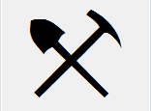

**Modified by:** Esri Solutions Team

**License:** None

**Acknowledgement:** None required

**Notes:** None

**Mining Permit**

**Symbol Name:** Mining/Process

**Symbol Picture:** C:\Users\heat5533\Documents\GitHub\solutions-symbology-data\symbology\web\png\Mining.png

**Symbol Source:** Environmental style file

**Symbol Date:** September 2014



**Modified by:** Esri Solutions Team

**License:** None

**Acknowledgement:** None required

**Notes:** None

**Miscellaneous**

**Symbol Name:**

**Symbol Picture:** C:\Data\Symbology\Utilities\Water\CCTVProcessor\web\Miscellaneous.png

**Symbol Source:**

**Symbol Date:** May 2015

**Created by:** Esri Solutions Team

**License:** None

**Acknowledgement:** None required

**Notes:** None

**Missing Asset**

**Symbol Name:** [Map](https://thenounproject.com/term/map/2312/)

**Symbol Picture:** C:\Users\heat5533\Documents\GitHub\solutions-symbology-data\symbology\mobile\png\Missing-Asset.pngC:\Users\heat5533\Documents\GitHub\solutions-symbology-data\symbology\web\png\Missing-Asset.png

**Symbol Source:** The Noun Project

**Symbol Date:** May 2015



**Modified by:** Esri Solutions Team

**License:** Public Domain

**Acknowledgement:** None required

**Notes:** None

**Mobile Stage**

**Symbol Name:**

**Symbol Picture:** C:\Data\Symbology\Solutions\SpecialEventPlanning\mobile\Mobile-Stage.png

**Symbol Source:**

**Symbol Date:** December 2015

**Created by:** Esri Solutions Team

**License:** None

**Acknowledgement:** None required

**Notes:** None

**Mosquito Larvicide Sites**

**Symbol Name:** [Mosquito](https://thenounproject.com/search/?q=mosquito&i=215264)

**Symbol Picture:**



**Symbol Source:** The Noun Project

**Symbol Date:** March 2016

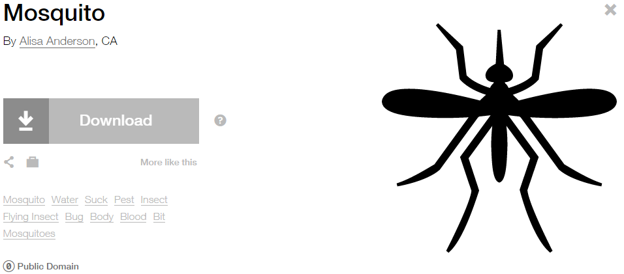

**Modified** **by:** EsriSolutions Team

**License:** Public Domain

**Acknowledgement:** None required

**Notes:** None

**Mosquito Surveillance Sites**

**Symbol Name:** [Mosquito](https://thenounproject.com/search/?q=mosquito&i=215264)

**Symbol Picture:**



**Symbol Source:** The Noun Project

**Symbol Date:** March 2016



**Modified** **by:** EsriSolutions Team

**License:** Public Domain

**Acknowledgement:** None required

**Notes:** None

**Municipal Stormwater Discharge Permit**

**Symbol Name:** Overboard Discharge (right)

**Symbol Picture:** C:\Users\heat5533\Documents\GitHub\solutions-symbology-data\symbology\web\png\Municipal-Stormwater-Discharge.png

**Symbol Source:** Environmental style file

**Symbol Date:** September 2014

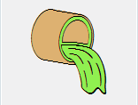

**Modified by:** Esri Solutions Team

**License:** None

**Acknowledgement:** None required

**Notes:** None

**Museums**

**Symbol Name:** Bank 1

**Symbol Picture:** C:\Users\heat5533\Documents\GitHub\solutions-symbology-data\symbology\web\png\Museum.png

**Symbol Source:** Business style file

**Symbol Date:** January 2015



**Modified** **by:** Esri Solutions Team

**License:** None

**Acknowledgement:** None required

**Notes:** None

**Music Venues**

**Symbol Name:** [Music](http://thenounproject.com/term/music/928/)

**Symbol Picture:** C:\Users\heat5533\Documents\GitHub\solutions-symbology-data\symbology\web\png\Music-Venue.png

**Symbol Source:** The Noun Project

**Symbol Date:** February 2015

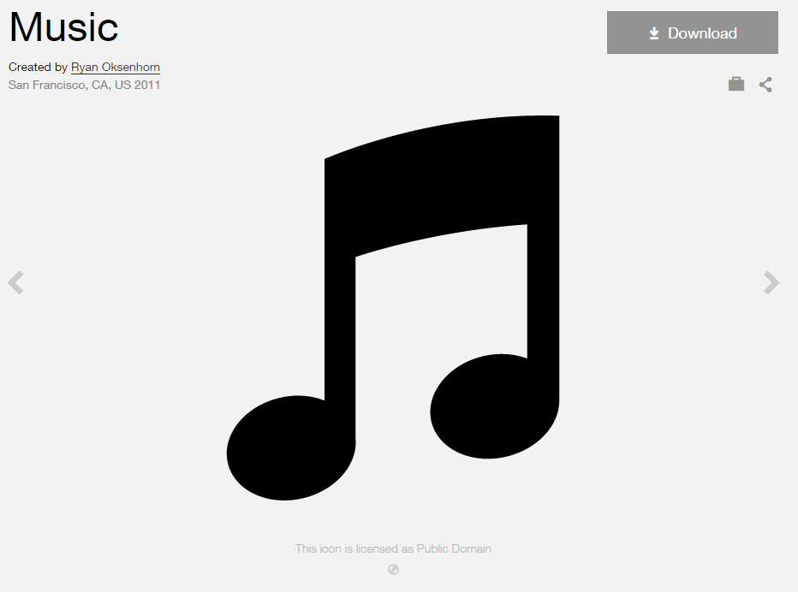

**Modified by:** Esri Solutions Team

**License:** Public Domain

**Acknowledgement:** None required

**Notes:** None

**Natural Disaster Incident**

**Symbol Name:** [Storm](https://thenounproject.com/search/?q=storm&i=24502)

**Symbol Picture:** C:\Users\heat5533\Documents\GitHub\solutions-symbology-data\symbology\web\png\Natural-Disaster-Incident.png

**Symbol Source:**  The Noun Project

**Symbol Date:** December 2015



**Modified by:** Esri Solutions Team

**License:** Public Domain

**Acknowledgement:** None required

**Notes:** None

**Near Repeat**

**Symbol Name:**

**Symbol Picture:** C:\Data\Symbology\LocalGov\NearRepeat\web\Near-Repeat.png

**Symbol Source:**

**Symbol Date:** June 2016

**Created by:** Esri Solutions Team

**License:** None

**Acknowledgement:** None required

**Notes:** None

**Negotiator**

**Symbol Name:** [Speech-Bubble](https://thenounproject.com/search/?q=speech+bubble&i=5097)

**Symbol Picture:** Negotiator

**Symbol Source:** The Noun Project

**Symbol Date:** February 2017

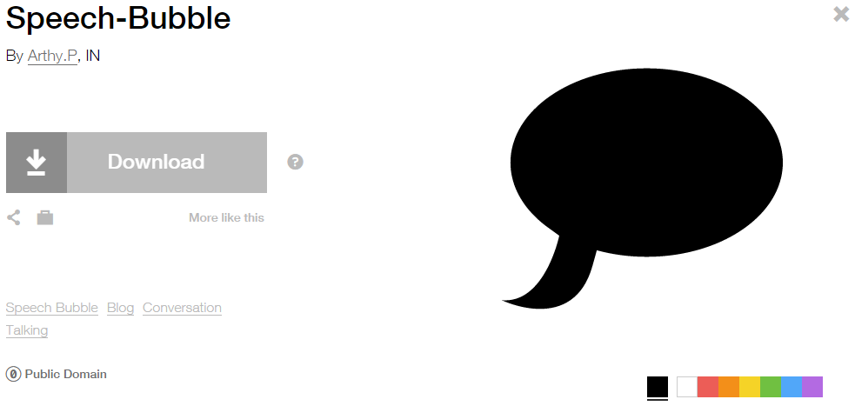

**Modified by:** Esri Solutions Team

**License:** Public Domain

**Acknowledgement:** None required

**Notes:** None

**Neighborhood Police Problem – Completed, In – Progress, Received, and Submitted**

**Symbol Name:** Police Badge

**Symbol Picture:** C:\Users\heat5533\Documents\GitHub\solutions-symbology-data\symbology\web\png\Neighborhood-Police-Problem-Completed.pngC:\Users\heat5533\Documents\GitHub\solutions-symbology-data\symbology\web\png\Neighborhood-Police-Problem-In-Progress.pngC:\Users\heat5533\Documents\GitHub\solutions-symbology-data\symbology\web\png\Neighborhood-Police-Problem-Received.pngC:\Users\heat5533\Documents\GitHub\solutions-symbology-data\symbology\web\png\Neighborhood-Police-Problem-Submitted.png

**Symbol Source:** ESRI Crime Analysis style file

**Symbol Date:** July 2015



**Modified** **by:** Esri Solutions Team

**License:** None

**Acknowledgement:** None required

**Notes:** None

**Observe**

**Symbol Name:** [Binoculars](https://thenounproject.com/term/binoculars/112/)

**Symbol Picture:** C:\Data\Symbology\StateGov\CitizenScience\web\Observe.png

**Symbol Source:** The Noun Project

**Symbol Date:** May 2016

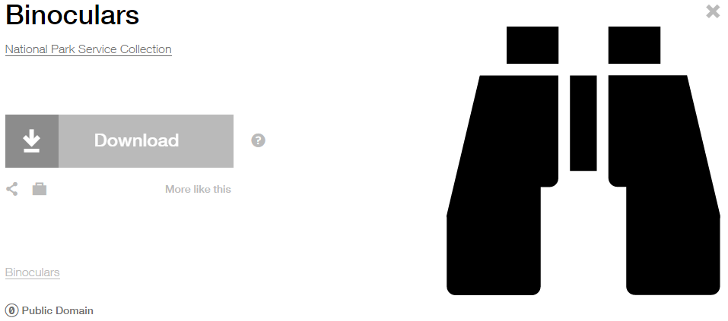

**Modified** **by:** Esri Solutions Team

**License:** Public Domain

**Acknowledgement:** None required

**Notes:** None

**Obstacle**

**Symbol Name:**

**Symbol Picture:** C:\Data\Symbology\Utilities\Water\CCTVProcessor\web\Obstacle.png

**Symbol Source:**

**Symbol Date:** May 2015

**Created by:** Esri Solutions Team

**License:** None

**Acknowledgement:** None required

**Notes:** None

**Occupancies**

**Symbol Name:**

**Symbol Picture:**



**Symbol Source:**

**Symbol Date:** March 2017

**Modified by:** Esri Solutions Team

**License:** None

**Acknowledgement:** None required

**Notes:** None

**Officer Post**

**Symbol Name:** Police Badge

**Symbol Picture:** Officer-Post

**Symbol Source:** ESRI Crime Analysis style file

**Symbol Date:** July 2015



**Modified** **by:** Esri Solutions Team

**License:** None

**Acknowledgement:** None required

**Notes:** None

**On Street Parking**

**Symbol Name:**

**Symbol Picture:** C:\Data\Symbology\LocalGov\PublicParking\web\On-Street-Parking.png

**Symbol Source:**

**Symbol Date:** July 2015

**Created by:** Esri Solutions Team

**License:** None

**Acknowledgement:** None required

**Notes:** None

**Originator**

**Symbol Name:**

**Symbol Picture:** **C:\Data\Symbology\LocalGov\NearRepeat\web\Originator.png**

**Symbol Source:**

**Symbol Date:** June 2016

**Created by:** Esri Solutions Team

**License:** None

**Acknowledgement:** None required

**Notes:** None

**Other**

**Symbol Name:**

**Symbol Picture:** C:\Data\Symbology\Solutions\SpecialEventPlanning\mobile\Other.png

**Symbol Source:**

**Symbol Date:** December 2015

**Created by:** Esri Solutions Team

**License:** None

**Acknowledgement:** None required

**Notes:** None

**Other**

**Symbol Name:**

**Symbol Picture:** C:\Data\Symbology\Utilities\Water\CCTVProcessor\web\Other.png

**Symbol Source:**

**Symbol Date:** May 2015

**Created by:** Esri Solutions Team

**License:** None

**Acknowledgement:** None required

**Notes:** None

**Outage - Planned**

**Symbol Name:** [Light Bulb](https://thenounproject.com/search?q=light-bulb&i=8699)

**Symbol Picture:** C:\Data\Symbology\Utilities\Electric\DamageAssessment\web\Damage-Assessment-Electric-High-Damage.png

**Symbol Source:** The Noun Project

**Symbol Date:** April 2015



**Modified by:** Esri Solutions Team

**License:** Public Domain

**Acknowledgement:** None required

**Notes:** None

**Outage - Unplanned**

**Symbol Name:** [Light Bulb](https://thenounproject.com/search?q=light-bulb&i=8699)

**Symbol Picture:** C:\Data\Symbology\Utilities\Electric\PublicOutageMap\web\Planned-Outage.png

**Symbol Source:** The Noun Project

**Symbol Date:** April 2015



**Modified by:** Esri Solutions Team

**License:** Public Domain

**Acknowledgement:** None required

**Notes:** None

**Outlet Protection Violation**

**Symbol Name:** OP

**Symbol Picture:** C:\Data\Symbology\Utilities\Water\ConstructionSiteViolations\mobile\Outlet-Protection-Violation.png

**Symbol Source:** Arial Rounded MT Bold Font

**Symbol Date:** March 2015

**Modified** **by:** Esri Solutions Team

**License:** None

**Acknowledgement:** None required

**Notes:** None

**Outpatient**

**Symbol Name:** [Outpatient](http://thenounproject.com/term/outpatient/576/)

**Symbol Picture: C:\Data\Symbology\StateGov\MyHealthServices\web\Outpatient-Surgery.png**

**Symbol Source:** The Noun Project

**Symbol Date:** March 2015

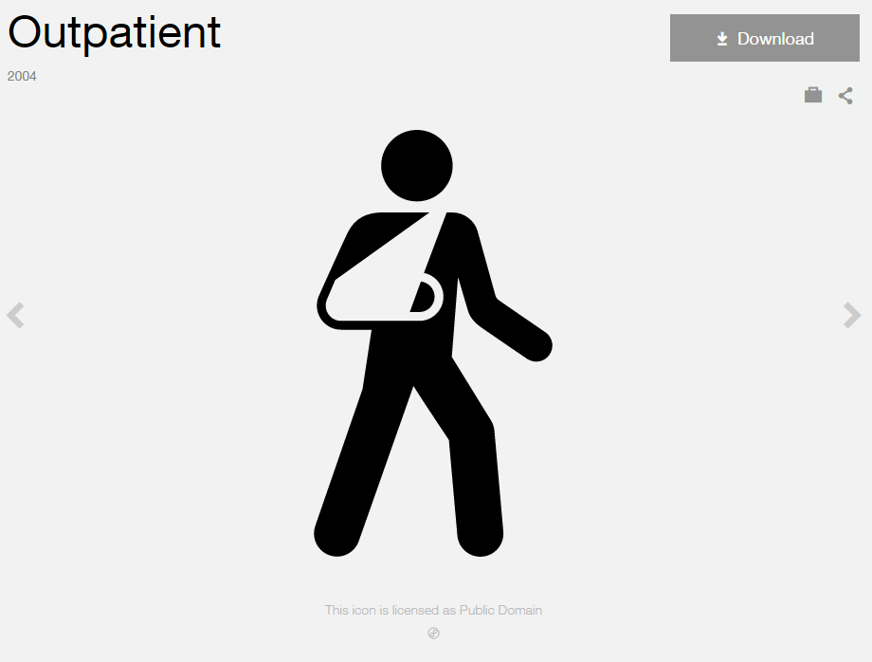

**Modified by:** Esri Solutions Team

**License:** Public Domain

**Acknowledgement:** None Required

**Notes:** None

**Oxygen Shut Off**

**Symbol Name:** [Oxygen\_With Line](http://napsg-web.s3.amazonaws.com/symbology/index.html#/single?PREPLAN%20SHUTOF%20BLUE%20%20SIMPLE%20Oxygen%20With%20Line%20128x128)

**Symbol Picture:**



**Symbol Source:** NAPSG (National Alliance for Public Safety GIS Foundation)

**Symbol Date:** March 2017

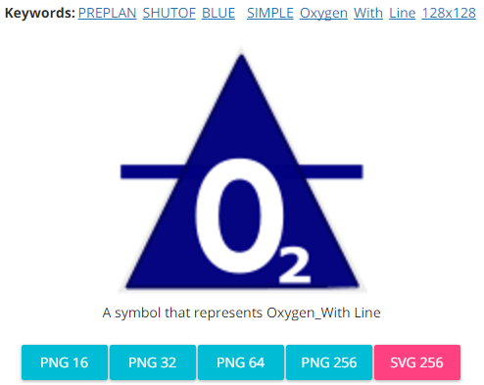

**Modified** **by:** Esri Solutions Team

**License:** None

**Acknowledgement:** None required

**Notes:** None

**Pandemic**

**Symbol Name:** [Mask](https://thenounproject.com/search/?q=mask&i=34491)

**Symbol Picture:** C:\Data\Symbology\Solutions\HazardandRiskAssessment\web\Pandemic.png

**Symbol Source:** The Noun Project

**Symbol Date:** September 2015

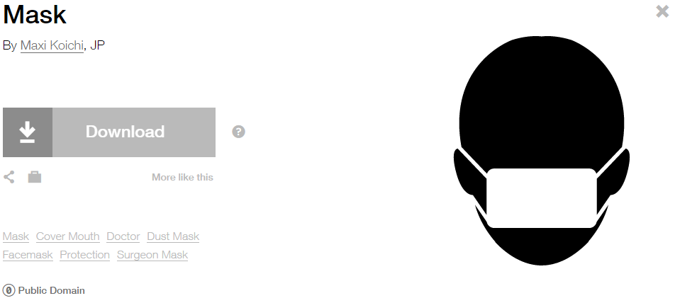

**Modified by:** EsriSolutions Team

**License:** Public Domain

**Acknowledgement:** None required

**Notes:** None

**Park**

**Symbol Name:** National Park

**Symbol Picture:** C:\Users\heat5533\Documents\GitHub\solutions-symbology-data\symbology\web\png\Parks.png

**Symbol Source:** Environmental style file

**Symbol Date:** January 2015

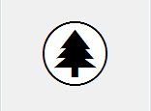

**Modified** **by:** Esri Solutions Team

**License:** None

**Acknowledgement:** None required

**Notes:** None

**Park Mowing Program – In Progress**

**Symbol Name:** National Park

**Symbol Picture:** C:\Data\Symbology\LocalGov\ParkMowing\Mobile\Inprogress.png

**Symbol Source:** Environmental style file

**Symbol Date:** May 2014



**Modified** **by:** Esri Solutions Team

**License:** None

**Acknowledgement:** None required

**Notes:** None

**Park Mowing Program – Inspected**

**Symbol Name:** National Park

**Symbol Picture:** C:\Data\Symbology\LocalGov\ParkMowing\Mobile\Inspected.png

**Symbol Source:** Environmental style file

**Symbol Date:** May 2014



**Modified** **by:** Esri Solutions Team

**License:** None

**Acknowledgement:** None required

**Notes:** None

**Park Mowing Program – Not Inspected**

**Symbol Name:** National Park

**Symbol Picture:** C:\Users\heat5533\Documents\GitHub\solutions-symbology-data\symbology\mobile\png\Park-Mowing-Program-Not-Inspected.png

**Symbol Source:** Environmental style file

**Symbol Date:** May 2014



**Modified** **by:** Esri Solutions Team

**License:** None

**Acknowledgement:** None required

**Notes:** None

**Park Tree Problem – Completed, In – Progress, Received, and Submitted**

**Symbol Name:** Picnic Area w/Tree

**Symbol Picture:** C:\Users\heat5533\Documents\GitHub\solutions-symbology-data\symbology\web\png\Park-Tree-Problem-Completed.pngC:\Users\heat5533\Documents\GitHub\solutions-symbology-data\symbology\web\png\Park-Tree-Problem-In-Progress.pngC:\Users\heat5533\Documents\GitHub\solutions-symbology-data\symbology\web\png\Park-Tree-Problem-Received.pngC:\Users\heat5533\Documents\GitHub\solutions-symbology-data\symbology\web\png\Park-Tree-Problem-Submitted.png

**Symbol Source:** Civic style file

**Symbol Date:** March 2016



**Modified** **by:** EsriSolutions Team

**License:** None

**Acknowledgement:** None required

**Notes:** None

**Parking**

**Symbol Name:** P

**Symbol Picture:** C:\Data\Symbology\LocalGov\PublicParking\web\Parking.png

**Symbol Source:** Arial Rounded MT Bold

**Symbol Date:** July 2015

**Modified by:** Esri Solutions Team

**License:** None

**Acknowledgement:** None required

**Notes:** None

**Pavement Marking - Blue**

**Symbol Name:**

**Symbol Picture:** C:\Users\heat5533\Documents\GitHub\solutions-symbology-data\symbology\web\png\Pavement-Marking-Blue.png

**Symbol Source:**

**Symbol Date:** September 2014

**Created by:** Esri Solutions Team

**License:** None

**Acknowledgement:** None required

**Notes:** None

**Pavement Marking - Green**

**Symbol Name:**

**Symbol Picture:** C:\Users\heat5533\Documents\GitHub\solutions-symbology-data\symbology\web\png\Pavement-Marking-Green.png

**Symbol Source:**

**Symbol Date:** September 2014

**Created by:** Esri Solutions Team

**License:** None

**Acknowledgement:** None required

**Notes:** None

**Pavement Marking - Other**

**Symbol Name:**

**Symbol Picture:** C:\Users\heat5533\Documents\GitHub\solutions-symbology-data\symbology\web\png\Pavement-Marking-Other.png

**Symbol Source:**

**Symbol Date:** September 2014

**Created by:** Esri Solutions Team

**License:** None

**Acknowledgement:** None required

**Notes:** None

**Pavement Marking - Red**

**Symbol Name:**

**Symbol Picture:** C:\Users\heat5533\Documents\GitHub\solutions-symbology-data\symbology\web\png\Pavement-Marking-Red.png

**Symbol Source:**

**Symbol Date:** September 2014

**Created by:** Esri Solutions Team

**License:** None

**Acknowledgement:** None required

**Notes:** None

**Pavement Marking - White**

**Symbol Name:**

**Symbol Picture:** C:\Users\heat5533\Documents\GitHub\solutions-symbology-data\symbology\web\png\Pavement-Marking-White.png

**Symbol Source:**

**Symbol Date:** September 2014

**Created by:** Esri Solutions Team

**License:** None

**Acknowledgement:** None required

**Notes:** None

**Pavement Marking - Yellow**

**Symbol Name:**

**Symbol Picture:** C:\Users\heat5533\Documents\GitHub\solutions-symbology-data\symbology\web\png\Pavement-Marking-Yellow.png

**Symbol Source:**

**Symbol Date:** September 2014

**Created by:** Esri Solutions Team

**License:** None

**Acknowledgement:** None required

**Notes:** None

**Pay Stations**

**Symbol Name:** [Parking Meter](https://thenounproject.com/search/?q=parking%20pay%20stations&i=755) & P

**Symbol Picture:** C:\Data\Symbology\LocalGov\PublicParking\web\Pay-Stations.png

**Symbol Source:** The Noun Project & Arial Rounded MT Bold

**Symbol Date:** July 2015

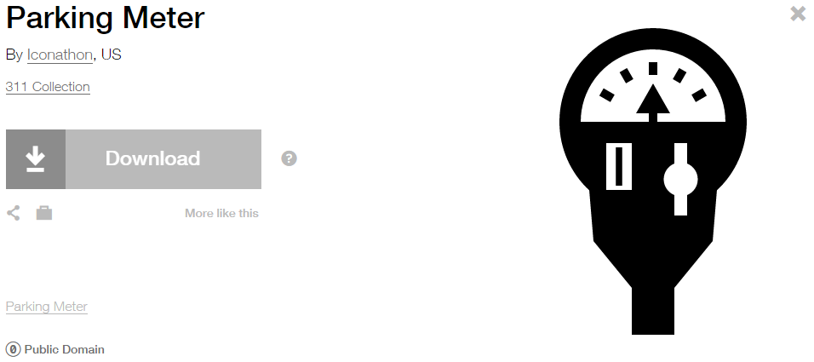

**Modified by:** Esri Solutions Team

**License:** Public Domain

**Acknowledgement:** None required

**Notes:** None

**Personal Property**

**Symbol Name:** [Community](http://thenounproject.com/term/community/288/)

**Symbol Picture:** C:\Data\Symbology\Solutions\Debris\web\Personal-Property.png

**Symbol Source:** The Noun Project



**Symbol Date:** February 2015

**Modified** **by:** Esri Solutions Team

**License:** Public Domain

**Acknowledgement:** None required

**Notes:** None

**Pesticide Discharge Permit**

**Symbol Name:** Water Recreation

**Symbol Picture:** C:\Users\heat5533\Documents\GitHub\solutions-symbology-data\symbology\web\png\Pesticides-Discharge.png

**Symbol Source:** Forestry style file

**Symbol Date:** September 2014



**Modified by:** Esri Solutions Team

**License:** None

**Acknowledgement:** None required

**Notes:** None

**Pet Collection Area**

**Symbol Name:** Unicode 117

**Symbol Picture:** C:\Data\UC\UC2015\SituationalAwareness\web\Pet-Collection.png

**Symbol Source:** ESRI Public 1 font

**Symbol Date:** July 2015



**Modified by:** Esri Solutions Team

**License:** None

**Acknowledgement:** None required

**Notes:** None

**Planning Limits Permit**

**Symbol Name:** City

**Symbol Picture:** C:\Users\heat5533\Documents\GitHub\solutions-symbology-data\symbology\web\png\Planning-Limits.png

**Symbol Source:** Business style file

**Symbol Date:** September 2014

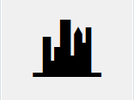

**Modified by:** Esri Solutions Team

**License:** None

**Acknowledgement:** None required

**Notes:** None

**Point Repair**

**Symbol Name:**

**Symbol Picture:** C:\Data\Symbology\Utilities\Water\CCTVProcessor\web\Point-Repair.png

**Symbol Source:**

**Symbol Date:** May 2015

**Created by:** Esri Solutions Team

**License:** None

**Acknowledgement:** None required

**Notes:** None

**Pole**

**Symbol Name:** P

**Symbol Picture:** C:\Data\Symbology\LocalGov\SignInventory\mobile\Poles.png

**Symbol Source:** Arial Rounded MT Bold

**Symbol Date:** July 2015

**Modified by:** Esri Solutions Team

**License:** None

**Acknowledgement:** None required

**Notes:** None

**Police Stations**

**Symbol Name:** Police Badge

**Symbol Picture:** C:\Users\heat5533\Documents\GitHub\solutions-symbology-data\symbology\web\png\Police-Stations.png

**Symbol Source:** Crime Analysis style file

**Symbol Date:** February 2015



**Modified** **by:** Esri Solutions Team

**License:** None

**Acknowledgement:** None required

**Notes:** None

**Police Vehicle**

**Symbol Name:** Police Badge

**Symbol Picture:** Police-Vehicle

**Symbol Source:** ESRI Crime Analysis style file

**Symbol Date:** July 2015



**Modified** **by:** Esri Solutions Team

**License:** None

**Acknowledgement:** None required

**Notes:** None

**Polling Places**

**Symbol Name:** [Polling-Place](http://thenounproject.com/term/polling-place/14292/) & Check 1

**Symbol Picture:** C:\Users\heat5533\Documents\GitHub\solutions-symbology-data\symbology\web\png\Polling-Place.png

**Symbol Source:** The Noun Project & ESRI style file

**Symbol Date:** March 2015

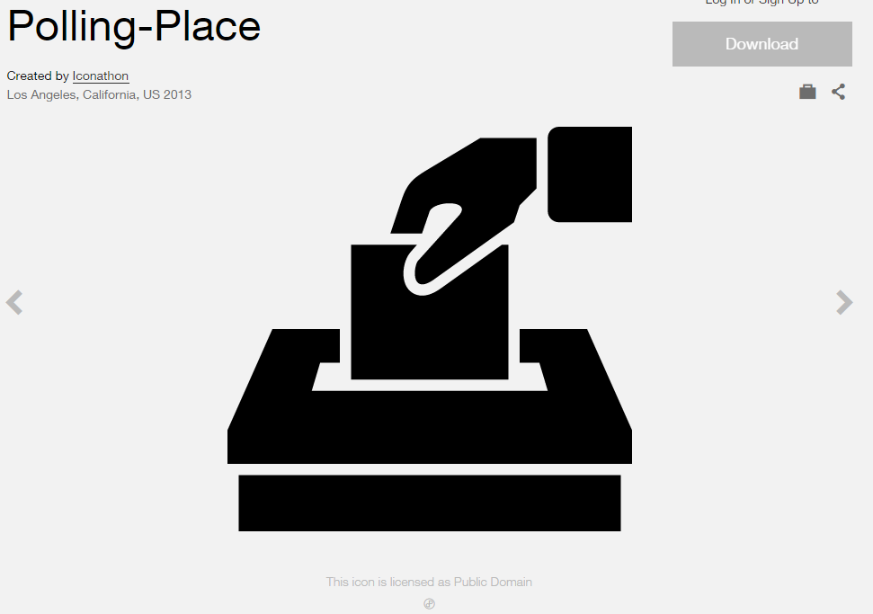 

**Modified by:** Esri Solutions Team

**License:** Public Domain

**Acknowledgement:** None required

**Notes:** None

**Porous Pavement**

**Symbol Name:** PP

**Symbol Picture:** C:\Data\Symbology\Utilities\Water\GreenInfrastructure\mobile\Porous-Pavement.pngC:\Data\Symbology\Utilities\Water\GreenInfrastructure\web\Porous-Pavement.png

**Symbol Source:** Arial Rounded MT Bold Font

**Symbol Date:** March 2015

**Modified** **by:** Esri Solutions Team

**License:** None

**Acknowledgement:** None required

**Notes:** None

**Post Offices**

**Symbol Name:** Post Office

**Symbol Picture:** C:\Users\heat5533\Documents\GitHub\solutions-symbology-data\symbology\web\png\Post-Office.png

**Symbol Source:** Forestry style file

**Symbol Date:** January 2015



**Modified** **by:** Esri Solutions Team

**License:** None

**Acknowledgement:** None required

**Notes:** None

**Potential Customer**

**Symbol Name:**

**Symbol Picture:** C:\Data\Symbology\Utilities\Gas\PotentialNewCustomers\web\Potential-Customers.png

**Symbol Source:**

**Symbol Date:** May 2015

**Created by:** Esri Solutions Team

**License:** None

**Acknowledgement:** None required

**Notes:** None

**Power Distribution**

**Symbol Name:**

**Symbol Picture:** C:\Data\Symbology\Solutions\SpecialEventPlanning\mobile\Power-Distribution.png

**Symbol Source:**

**Symbol Date:** December 2015

**Created by:** Esri Solutions Team

**License:** None

**Acknowledgement:** None required

**Notes:** None

**Power Failure**

**Symbol Name:** [Light Bulb](https://thenounproject.com/search?q=light-bulb&i=8699)

**Symbol Picture:** C:\Data\Symbology\Solutions\HazardandRiskAssessment\web\Power-Failure.png

**Symbol Source:** The Noun Project

**Symbol Date:** April 2015



**Modified by:** Esri Solutions Team

**License:** Public Domain

**Acknowledgement:** None required

**Notes:** None

**Pressure Reducing Valve**

**Symbol Name:** PRV

**Symbol Picture:** C:\Data\Symbology\Utilities\Water\GreenInfrastructure\mobile\Pressure-Reducing-Valve.pngC:\Data\Symbology\Utilities\Water\GreenInfrastructure\web\Pressure-Reducing-Valve.png

**Symbol Source:** Arial Rounded MT Bold Font

**Symbol Date:** March 2015

**Modified** **by:** Esri Solutions Team

**License:** None

**Acknowledgement:** None required

**Notes:** None

**Primary Entry Point**

**Symbol Name:** P

**Symbol Picture:** Primary-Entry-Point

**Symbol Source:** Arial font

**Symbol Date:** December 2015

**Modified by:** Esri Solutions Team

**License:** None

**Acknowledgement:** None required

**Notes:** None

**Private Security**

**Symbol Name:** [Shield](https://thenounproject.com/search/?q=security+shield&i=216921)

**Symbol Picture:** C:\Data\Symbology\Solutions\SpecialEventPlanning\mobile\Private-Security.png

**Symbol Source:** The Noun Project

**Symbol Date:** December 2015

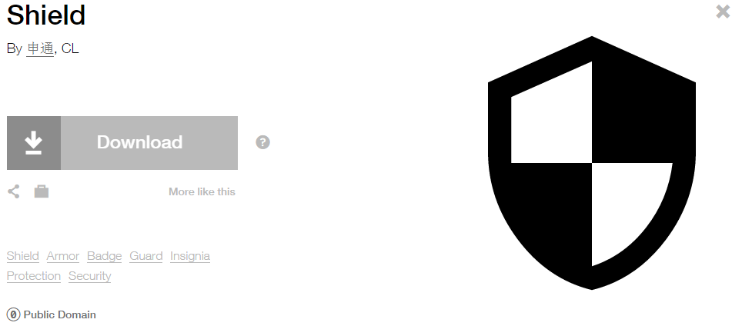

**Modified by:** Esri Solutions Team

**License:** Public Domain

**Acknowledgement:** None required

**Notes:** None

**Project Operations Violation**

**Symbol Name:** PO

**Symbol Picture:** C:\Data\Symbology\Utilities\Water\ConstructionSiteViolations\mobile\Project-Operations-Violation.png

**Symbol Source:** Arial Rounded MT Bold Font

**Symbol Date:** March 2015

**Modified** **by:** Esri Solutions Team

**License:** None

**Acknowledgement:** None required

**Notes:** None

**Public Health Incident**

**Symbol Name:** Men

**Symbol Picture:** C:\Data\Symbology\Solutions\OpsIncident\web\Public-Health-Incident.png

**Symbol Source:** Public Signs style file

**Symbol Date:** February 2015



**Modified** **by:**

**License:** None

**Acknowledgement:** None required

**Notes:**

**Radiological Attack**

**Symbol Name:** L1 Radiological Sensor

**Symbol Picture:** C:\Data\Symbology\Solutions\HazardandRiskAssessment\web\Radiological-Attack.png

**Symbol Source:** ERS Homeland Security style file

**Symbol Date:** October 2015



**Modified by:** EsriSolutions Team

**License:** None

**Acknowledgement:** None required

**Notes:** None

**Radiological Release**

**Symbol Name:** L1 Radiological Sensor

**Symbol Picture:** C:\Data\Symbology\Solutions\HazardandRiskAssessment\web\Radiological-Release.png

**Symbol Source:** ERS Homeland Security style file

**Symbol Date:** October 2015



**Modified by:** EsriSolutions Team

**License:** None

**Acknowledgement:** None required

**Notes:** None

**Rail Incident**

**Symbol Name:** Rail Transportation

**Symbol Picture:** C:\Data\Symbology\Solutions\OpsIncident\web\Rail-Incident.png

**Symbol Source:** Public Signs style file

**Symbol Date:** February 2015

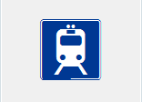

**Modified** **by:** Esri Solutions Team

**License:** None

**Acknowledgement:** None required

**Notes:** None

**Railroad Crossing**

**Symbol Name:** Railroad Crossing 2

**Symbol Picture:** **C:\Users\heat5533\Documents\GitHub\solutions-symbology-data\symbology\mobile\png\Railroad-Crossing.png**

**Symbol Source:** Transportation style file

**Symbol Date:** July 2015



**Modified by:** Esri Solutions Team

**License:** None

**Acknowledgement:** None required

**Notes:** None

**Railroad Stations**

**Symbol Name:** Rail Transportation

**Symbol Picture:** C:\Users\heat5533\Documents\GitHub\solutions-symbology-data\symbology\web\png\Railroad-Station.png

**Symbol Source:** ESRI Public Signs style file

**Symbol Date:** January 2015

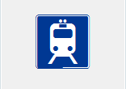

**Modified** **by:** Esri Solutions Team

**License:** None

**Acknowledgement:** None required

**Notes:** None

**Rain Barrel**

**Symbol Name:** RB

**Symbol Picture:** C:\Data\Symbology\Utilities\Water\GreenInfrastructure\mobile\Rain-Barrel.pngC:\Data\Symbology\Utilities\Water\GreenInfrastructure\web\Rain-Barrel.png

**Symbol Source:** Arial Rounded MT Bold Font

**Symbol Date:** March 2015

**Modified** **by:** Esri Solutions Team

**License:** None

**Acknowledgement:** None required

**Notes:** None

**Rain Water Catchment**

**Symbol Name:** RWC

**Symbol Picture:** C:\Data\Symbology\Utilities\Water\GreenInfrastructure\mobile\Rain-Water-Catchment.pngC:\Data\Symbology\Utilities\Water\GreenInfrastructure\web\Rain-Water-Catchment.png

**Symbol Source:** Arial Rounded MT Bold Font

**Symbol Date:** March 2015

**Modified** **by:** Esri Solutions Team

**License:** None

**Acknowledgement:** None required

**Notes:** None

**Ready Mix Concrete Facilities Permit**

**Symbol Name:**

**Symbol Picture:** C:\Users\heat5533\Documents\GitHub\solutions-symbology-data\symbology\web\png\Ready-Mix-Concrete-Facilities.png

**Symbol Source:**

**Symbol Date:** October 2014

**Created by:** Esri Solutions Team

**License:** None

**Acknowledgement:** None required

**Notes:** None

**Reconnaissance**

**Symbol Name:**

**Symbol Picture:** C:\Data\Symbology\StateGov\Transportation511\web\Camera.png

**Symbol Source:**

**Symbol Date:** December 2015

**Created by:** Esri Solutions Team

**License:** None

**Acknowledgement:** None required

**Notes:** None

**Recycling Bin**

**Symbol Name:** Unicode 93

**Symbol Picture:** C:\Data\Symbology\Solutions\SpecialEventPlanning\mobile\Recycling-Bin.png

**Symbol Source:** ESRI ArcPad font

**Symbol Date:** February 2015



**Modified** **by:** Esri Solutions Team

**License:** None

**Acknowledgement:** None required

**Notes:** None

**Recycling Facility**

**Symbol Name:** Unicode 93

**Symbol Picture:** C:\Users\heat5533\Documents\GitHub\solutions-symbology-data\symbology\web\png\Recycling-Facility.png

**Symbol Source:** ESRI ArcPad font

**Symbol Date:** February 2015



**Modified** **by:** Esri Solutions Team

**License:** None

**Acknowledgement:** None required

**Notes:** None

**Repeat**

**Symbol Name:**

**Symbol Picture:** C:\Data\Symbology\LocalGov\NearRepeat\web\Repeat.png

**Symbol Source:**

**Symbol Date:** June 2015

**Modified by:** Esri Solutions Team

**License:** None

**Acknowledgement:** None required

**Reptiles**

**Symbol Name:** [Turtle](https://thenounproject.com/term/turtle/78103/)

**Symbol Picture:** C:\Data\Symbology\StateGov\CitizenScience\web\Reptiles.png

**Symbol Source:** The Noun Project

**Symbol Date:** March 2015

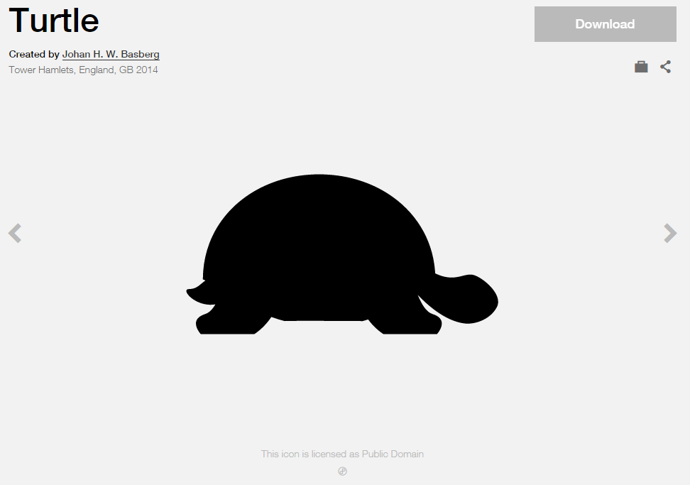

**Modified by:** Esri Solutions Team

**License:** Public Domain

**Acknowledgement:** None required

**Notes:** None

**Research Parks**

**Symbol Name:** [Microscope](http://thenounproject.com/term/microscope/648/)

**Symbol Picture:** C:\Users\heat5533\Documents\GitHub\solutions-symbology-data\symbology\web\png\Research-Parks.png

**Symbol Source:** The Noun Project

**Symbol Date:** March 2015

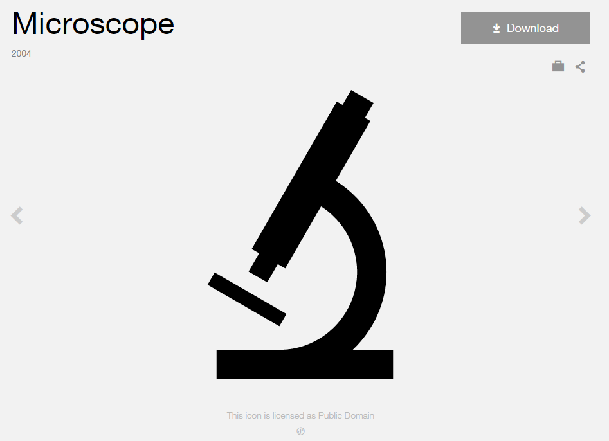

**Modified by:** Esri Solutions Team

**License:** Public Domain

**Acknowledgement:** None required

**Notes:** None

**Responding Company - Command**

**Symbol Name:**

**Symbol Picture:** C:\Users\heat5533\Documents\GitHub\solutions-symbology-data\symbology\web\png\Responding-Company-Command.png

**Symbol Source:**

**Symbol Date:** December 2015

**Created by:** Esri Solutions Team

**License:** None

**Acknowledgement:** None required

**Notes:** None

**Responding Company - Engine**

**Symbol Name:**

**Symbol Picture:** C:\Users\heat5533\Documents\GitHub\solutions-symbology-data\symbology\web\png\Responding-Company-Engine.png

**Symbol Source:**

**Symbol Date:** December 2015

**Created by:** Esri Solutions Team

**License:** None

**Acknowledgement:** None required

**Notes:** None

**Responding Company - Medical**

**Symbol Name:**

**Symbol Picture:** C:\Users\heat5533\Documents\GitHub\solutions-symbology-data\symbology\web\png\Responding-Company-Medical.png

**Symbol Source:**

**Symbol Date:** December 2015

**Created by:** Esri Solutions Team

**License:** None

**Acknowledgement:** None required

**Notes:** None

**Responding Company - Squad**

**Symbol Name:**

**Symbol Picture:** C:\Users\heat5533\Documents\GitHub\solutions-symbology-data\symbology\web\png\Responding-Company-Engine.png

**Symbol Source:**

**Symbol Date:** December 2015

**Created by:** Esri Solutions Team

**License:** None

**Acknowledgement:** None required

**Notes:** None

**Responding Company - Truck**

**Symbol Name:**

**Symbol Picture:** C:\Users\heat5533\Documents\GitHub\solutions-symbology-data\symbology\web\png\Responding-Company-Engine.png

**Symbol Source:**

**Symbol Date:** December 2015

**Created by:** Esri Solutions Team

**License:** None

**Acknowledgement:** None required

**Notes:** None

**Responding Company - Utility**

**Symbol Name:**

**Symbol Picture:** C:\Users\heat5533\Documents\GitHub\solutions-symbology-data\symbology\web\png\Responding-Company-Utility.png

**Symbol Source:**

**Symbol Date:** December 2015

**Created by:** Esri Solutions Team

**License:** None

**Acknowledgement:** None required

**Notes:** None

**Rest Area**

**Symbol Name:** L1 Rest Stop

**Symbol Picture:** C:\Data\Symbology\StateGov\Transportation511\web\Rest-Area.png

**Symbol Source:** ERS Homeland Security style file

**Symbol Date:** February 2016

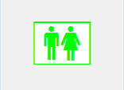

**Modified by:** Esri Solutions Team

**License:** None

**Acknowledgement:** None required

**Notes:** None

**Restaurant Inspections**

**Symbol Name:** Restaurant

**Symbol Picture:**



**Symbol Source:** Public Signs style file

**Symbol Date:** December 2016

****

**Modified by:** Esri Solutions Team

**License:** None

**Acknowledgement:** None required

**Notes:** None

**Restaurant Grade - A**

**Symbol Name:** A

**Symbol Picture:**



**Symbol Source:** Arial Rounded MT Bold font

**Symbol Date:** December 2016

**Modified by:** Esri Solutions Team

**License:** None

**Acknowledgement:** None required

**Notes:** None

**Restaurant Grade - B**

**Symbol Name:** B

**Symbol Picture:** **C:\Users\heat5533\AppData\Local\Microsoft\Windows\INetCache\Content.Word\Restarurant-Grade-B.PNG**

**Symbol Source:** Arial Rounded MT Bold font

**Symbol Date:** December 2016

**Modified by:** Esri Solutions Team

**License:** None

**Acknowledgement:** None required

**Notes:** None

**Restaurant Grade - C**

**Symbol Name:** C

**Symbol Picture:**



**Symbol Source:** Arial Rounded MT Bold font

**Symbol Date:** December 2016

**Modified by:** Esri Solutions Team

**License:** None

**Acknowledgement:** None required

**Notes:** None

**Restroom**

**Symbol Name:** Restrooms

**Symbol Picture:** C:\Data\Symbology\Solutions\SpecialEventPlanning\mobile\Restroom.png

**Symbol Source:** Forestry style file

**Symbol Date:** December 2015



**Modified** **by:** Esri Solutions Team

**License:** None

**Acknowledgement:** None required

**Notes:** None

**Retail Centers**

**Symbol Name:** Vagrancy, Shopping Cart

**Symbol Picture:** C:\Data\Symbology\Solutions\Live-Work-Locate\web\Shopping-Retail.png

**Symbol Source:** Crime Analysis style file

**Symbol Date:** January 2015



**Modified** **by:** Esri Solutions Team

**License:** None

**Acknowledgement:** None required

**Notes:** None

**Riser Valve**

**Symbol Name:** [Riser, General](http://napsg-web.s3.amazonaws.com/symbology/index.html#/single?Riser%20 General%20Fire%20Suppression,%20General%20Features)

**Symbol Picture:**



**Symbol Source:** NAPSG (National Alliance for Public Safety GIS Foundation)

**Symbol Date:** March 2017



**Modified by:** Esri Solutions Team

**License:** None

**Acknowledgement:** None required

**Notes:** None

**Road Blocks**

**Symbol Name:**

**Symbol Picture:** C:\Data\UC\UC2015\SituationalAwareness\web\Road-Blocks.png

**Symbol Source:**

**Symbol Date:** July 2015

**Created by:** Esri Solutions Team

**License:** None

**Acknowledgement:** None required

**Notes:** None

**Road Closed/Blocked**

**Symbol Name:**

**Symbol Picture:C:\Data\Symbology\StateGov\Transportation511\web\Road-Closed-Blocked.png**

**Symbol Source:**

**Symbol Date:** June 2015

**Created by:** Esri Solutions Team

**License:** None

**Acknowledgement:** None required

**Notes:** None

**Road Not Passable**

**Symbol Name:**

**Symbol Picture:C:\Data\Symbology\Utilities\Electric\HazardReportingCollector\mobile\Road-Not-Passable.pngC:\Data\Symbology\Utilities\Electric\HazardReportingCollector\web\Road-Not-Passable.png**

**Symbol Source:**

**Symbol Date:** June 2015

**Created by:** Esri Solutions Team

**License:** None

**Acknowledgement:** None required

**Notes:** None

**Road Problem – Completed, In – Progress, Received, and Submitted**

**Symbol Name:** [Pothole](https://thenounproject.com/search/?q=pothole&i=753)

**Symbol Picture:** **C:\Users\heat5533\Documents\GitHub\solutions-symbology-data\symbology\web\png\Road-Problem-Completed.pngC:\Users\heat5533\Documents\GitHub\solutions-symbology-data\symbology\web\png\Road-Problem-In-Progress.png**C:\Users\heat5533\Documents\GitHub\solutions-symbology-data\symbology\web\png\Road-Problem-Received.pngC:\Users\heat5533\Documents\GitHub\solutions-symbology-data\symbology\web\png\Road-Problem-Submitted.png

**Symbol Source:** The Noun Project

**Symbol Date:** March 2016

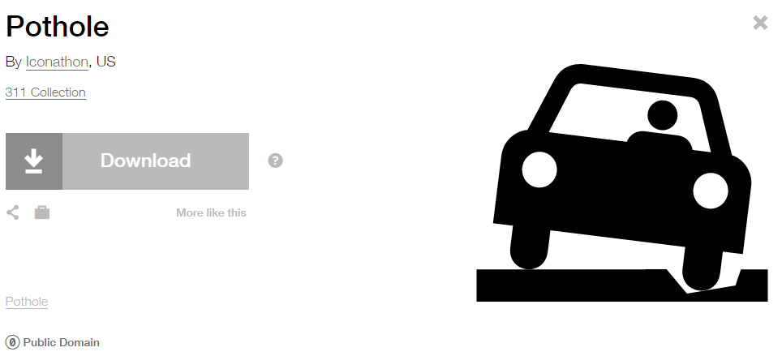

**Modified** **by:** EsriSolutions Team

**License:** Public Domain

**Acknowledgement:** None required

**Notes:** None

**Roof Access**

**Symbol Name:** [Roof Access](http://napsg-web.s3.amazonaws.com/symbology/index.html#/single?PREPLN%20ACCESS%20GREEN%20SOLID%20SIMPLE%20Roof%20Access%20128x128)

**Symbol Picture:**



**Symbol Source:** NAPSG (National Alliance for Public Safety GIS Foundation)

**Symbol Date:** March 2017

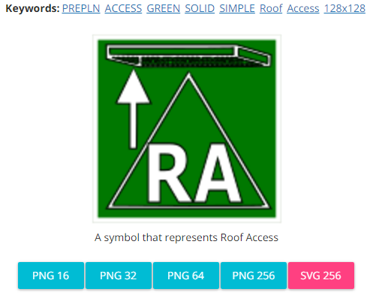

**Created by:** Esri Solutions Team

**License:** None

**Acknowledgement:** None required

**Notes:** None

**Roots**

**Symbol Name:**

**Symbol Picture:** C:\Data\Symbology\Utilities\Water\CCTVProcessor\web\Roots.png

**Symbol Source:**

**Symbol Date:** May 2015

**Created by:** Esri Solutions Team

**License:** None

**Acknowledgement:** None required

**Notes:** None

**Route End**

**Symbol Name:** F

**Symbol Picture:C:\Data\Symbology\Solutions\SpecialEventPlanning\mobile\Route-End.png**

**Symbol Source:** Arial Rounded MT Bold

**Symbol Date:** December 2015

**Modified by:** Esri Solutions Team

**License:** None

**Acknowledgement:** None required

**Notes:** None

**Route Start**

**Symbol Name:** S

**Symbol Picture:** C:\Data\Symbology\Solutions\SpecialEventPlanning\mobile\Route-Start.png

**Symbol Source:**

**Symbol Date:** April 2016

**Modified by:** Esri Solutions Team

**License:** None

**Acknowledgement:** None required

**Notes:** None

**Sabotage**

**Symbol Name:** Robbery

**Symbol Picture:** C:\Data\Symbology\Solutions\HazardandRiskAssessment\web\Sabotage.png

**Symbol Source:** The Noun Project

**Symbol Date:** October 2015

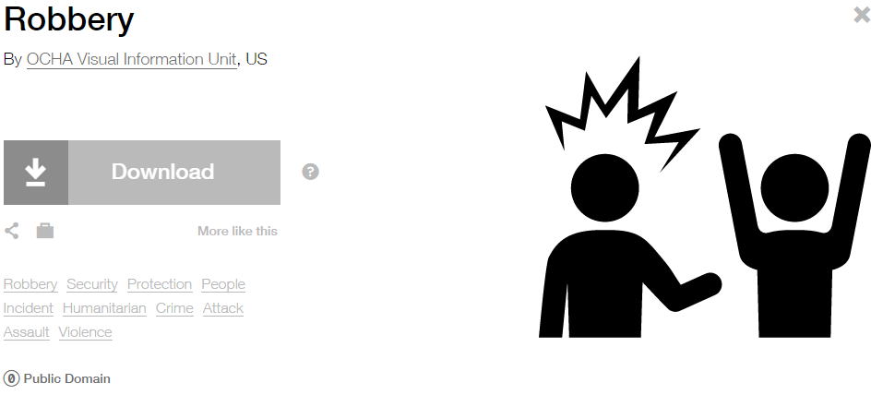

**Modified by:** EsriSolutions Team

**License:** Public Domain

**Acknowledgement:** None required

**Notes:** None

**Safety Problem – Completed, In – Progress, Received, and Submitted**

**Symbol Name:** !

**Symbol Picture:** C:\Users\heat5533\Documents\GitHub\solutions-symbology-data\symbology\web\png\Safety-Problem-Completed.pngC:\Users\heat5533\Documents\GitHub\solutions-symbology-data\symbology\web\png\Safety-Problem-In-Progress.pngC:\Users\heat5533\Documents\GitHub\solutions-symbology-data\symbology\web\png\Safety-Problem-Received.pngC:\Users\heat5533\Documents\GitHub\solutions-symbology-data\symbology\web\png\Safety-Problem-Submitted.png

**Symbol Source:**  Arial Rounded MT Bold

**Symbol Date:** July 2015

**Modified by:** Esri Solutions Team

**License:** None

**Acknowledgement:** None required

**Notes:** None

**Schools**

**Symbol Name:** School 1

**Symbol Picture:** C:\Users\heat5533\Documents\GitHub\solutions-symbology-data\symbology\web\png\School.png

**Symbol Source:** Civic style file

**Symbol Date:** January 2015

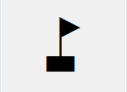

**Modified** **by:** Esri Solutions Team

**License:** None

**Acknowledgement:** None required

**Notes:** None

**School and workplace violence**

**Symbol Name:** Assault, Solid Fist

**Symbol Picture:** C:\Data\Symbology\Solutions\HazardandRiskAssessment\web\School-and-workplace-violence.png

**Symbol Source:** Crime Analysis style file

**Symbol Date:** June 2015



**Modified** **by:** Esri Solutions Team

**License:** None

**Acknowledgement:** None required

**Notes:** None

**Sea Ports**

**Symbol Name:** Marina

**Symbol Picture: C:\Users\heat5533\Documents\GitHub\solutions-symbology-data\symbology\web\png\Sea-Port.png**

**Symbol Source:** Forestry style file

**Symbol Date:** March 2015



**Modified by:** Esri Solutions Team

**License:** None

**Acknowledgement:** None Required

**Notes:** None

**Search and Rescue**

**Symbol Name:** Walk 1

**Symbol Picture:** C:\Data\UC\UC2015\SituationalAwareness\web\Search-and-Rescue.png

**Symbol Source:** Transportation style file

**Symbol Date:** July 2015



**Modified** **by:** Esri Solutions Team

**License:** None

**Acknowledgement:** None required

**Notes:** None

**Security Checkpoint**

**Symbol Name:** [Safety and Security](https://thenounproject.com/ochaavmu/collection/ocha-humanitarian-icons/?i=4227)

**Symbol Picture:C:\Data\Symbology\Solutions\SpecialEventPlanning\mobile\Security-Checkpoint.png**

**Symbol Source:** The Noun Project

**Symbol Date:** December 2015

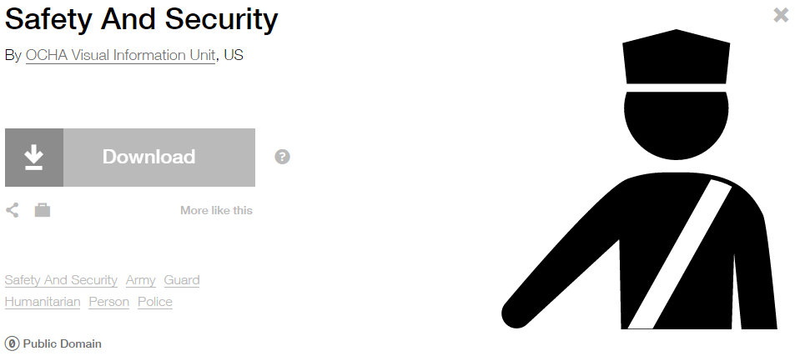

**Modified by:** Esri Solutions Team

**License:** Public Domain

**Acknowledgement:** None required

**Notes:** None

**Sediment**

**Symbol Name:**

**Symbol Picture:** C:\Data\Symbology\Solutions\Debris\web\Sediment.png

**Symbol Source:** ESRI Enviro Hazard Sites Unicode 50

**Symbol Date:** September 2014



**Modified by:** Esri Solutions Team

**License:** None

**Acknowledgement:** None required

**Notes:** None

**Sediment Barriers Violation**

**Symbol Name:** SB

**Symbol Picture:** C:\Data\Symbology\Utilities\Water\ConstructionSiteViolations\mobile\Sediment-Barriers-Violation.png

**Symbol Source:** Arial Rounded MT Bold Font

**Symbol Date:** March 2015

**Modified** **by:** Esri Solutions Team

**License:** None

**Acknowledgement:** None required

**Notes:** None

**Sediment Traps and Basins Violation**

**Symbol Name:** STB

**Symbol Picture:** C:\Data\Symbology\Utilities\Water\ConstructionSiteViolations\mobile\Sediment-Traps-and-Basins-Violation.png

**Symbol Source:** Arial Rounded MT Bold Font

**Symbol Date:** March 2015

**Modified** **by:** Esri Solutions Team

**License:** None

**Acknowledgement:** None required

**Notes:** None

**Service Call Incident**

**Symbol Name:** Phone 1

**Symbol Picture:** C:\Users\heat5533\Documents\GitHub\solutions-symbology-data\symbology\web\png\Service-Call-Incident.png

**Symbol Source:**  Civic style file

**Symbol Date:** November 2015



**Modified by:** Esri Solutions Team

**License:** None

**Acknowledgement:** None required

**Notes:** None

**Severe Thunderstorm**

**Symbol Name:** [Thunderstorm](https://thenounproject.com/search/?q=thunderstorm&i=13513)

**Symbol Picture:** C:\Data\Symbology\Solutions\HazardandRiskAssessment\web\Severe-Thunderstorm.png

**Symbol Source:** The Noun Project

**Symbol Date:** January 2016

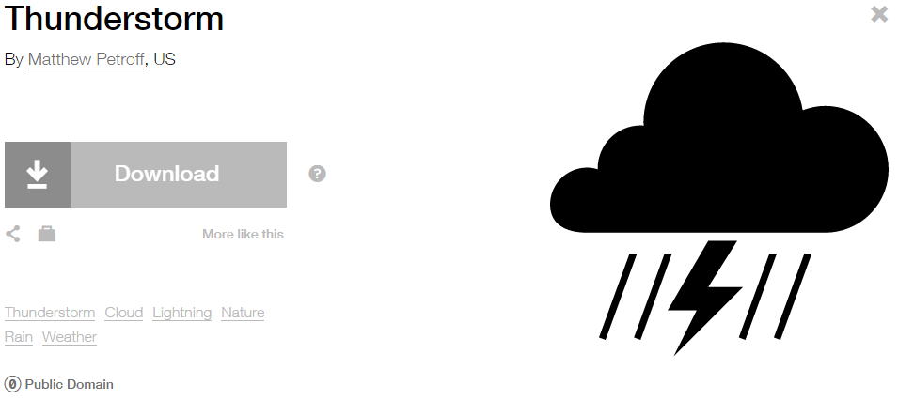

**Modified** **by:** Esri Solutions Team

**License:** Public Domain

**Acknowledgement:** None required

**Notes:** None

**Service Request**

**Symbol Name:** [Tools](https://thenounproject.com/term/tools/28771/)

**Symbol Picture:** C:\Users\heat5533\Documents\GitHub\solutions-symbology-data\symbology\web\png\Service-Request.png

**Symbol Source:** The Noun Project

**Symbol Date:** May 2015

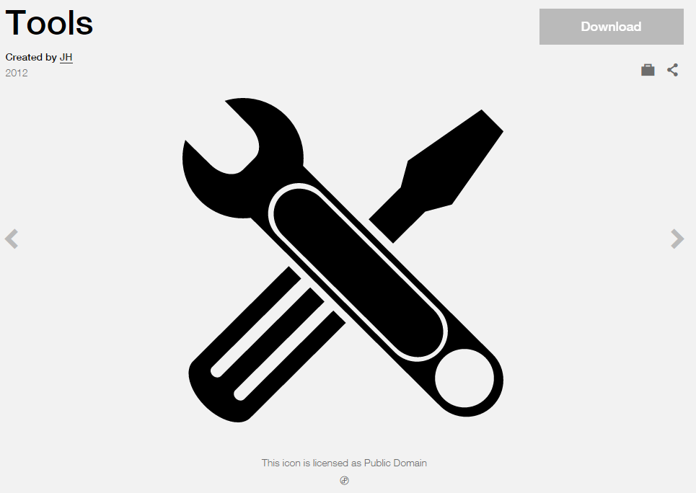

**Modified by:** Esri Solutions Team

**License:** Public Domain

**Acknowledgement:** None required

**Notes:** None

**Sewer Map Change Request**

**Symbol Name:** [Map](https://thenounproject.com/term/map/2312/)

**Symbol Picture:** C:\Users\heat5533\Documents\GitHub\solutions-symbology-data\symbology\mobile\png\Asset-Misplaced.pngC:\Users\heat5533\Documents\GitHub\solutions-symbology-data\symbology\web\png\Asset-Misplaced.png

**Symbol Source:** The Noun Project

**Symbol Date:** May 2015



**Modified by:** Esri Solutions Team

**License:** Public Domain

**Acknowledgement:** None required

**Notes:** None

**Sewer Map Change Request Critical**

**Symbol Name:** S

**Symbol Picture:** C:\Users\heat5533\Documents\GitHub\solutions-symbology-data\symbology\mobile\png\Sewer-Map-Change-Request-Critical.pngC:\Users\heat5533\Documents\GitHub\solutions-symbology-data\symbology\web\png\Sewer-Map-Change-Request-Critical.png

**Symbol Source:** Arial Rounded MT Bold Font

**Symbol Date:** March 2015

**Modified** **by:** Esri Solutions Team

**License:** None

**Acknowledgement:** None required

**Notes:** None

**Sewer Map Change Request Not Critical**

**Symbol Name:** S

**Symbol Picture:** C:\Users\heat5533\Documents\GitHub\solutions-symbology-data\symbology\mobile\png\Sewer-Map-Change-Request-Not-Critical.pngC:\Users\heat5533\Documents\GitHub\solutions-symbology-data\symbology\web\png\Sewer-Map-Change-Request-Not-Critical.png

**Symbol Source:** Arial Rounded MT Bold Font

**Symbol Date:** March 2015

**Modified** **by:** Esri Solutions Team

**License:** None

**Acknowledgement:** None required

**Notes:** None

**Shelter - Alert**

**Symbol Name:** Sleeping Shelter

**Symbol Picture:** C:\Data\Symbology\Solutions\ShelterLocator\Shelter-Alert.png

**Symbol Source:** Forestry style file

**Symbol Date:** December 2015



**Modified by:** Esri Solutions Team

**License:** None

**Acknowledgement:** None required

**Notes:** None

**Shelter - Closed**

**Symbol Name:** Sleeping Shelter

**Symbol Picture:** C:\Data\Symbology\Solutions\ShelterLocator\Shelter-Closed.png

**Symbol Source:** Forestry style file

**Symbol Date:** December 2015



**Modified by:** Esri Solutions Team

**License:** None

**Acknowledgement:** None required

**Notes:** None

**Shelter - Open**

**Symbol Name:** Sleeping Shelter

**Symbol Picture:** C:\Data\Symbology\Solutions\ShelterLocator\Shelter-Open.pngC:\Data\Symbology\Solutions\ShelterLocator\Shelter-Open(2).pngw

**Symbol Source:** Forestry style file

**Symbol Date:** December 2015



**Modified by:** Esri Solutions Team

**License:** None

**Acknowledgement:** None required

**Notes:** None

**Shelter - Standby**

**Symbol Name:** Sleeping Shelter

**Symbol Picture:** C:\Data\Symbology\Solutions\ShelterLocator\Shelter-Standby.png

**Symbol Source:** Forestry style file

**Symbol Date:** December 2015



**Modified by:** Esri Solutions Team

**License:** None

**Acknowledgement:** None required

**Notes:** None

**Shelter - Unknown**

**Symbol Name:** Sleeping Shelter

**Symbol Picture:** C:\Data\Symbology\Solutions\ShelterLocator\Shelter-Unknown.png

**Symbol Source:** Forestry style file

**Symbol Date:** December 2015



**Modified by:** Esri Solutions Team

**License:** None

**Acknowledgement:** None required

**Notes:** None

**Sniper**

**Symbol Name:** [SWAT Sniper Location](http://napsg-web.s3.amazonaws.com/symbology/index.html#/single?INCDNT%20COMAND%20WHITE%20SOLID%20DETAIL%20SWAT%20Sniper%20Location%20256x256)

**Symbol Picture:** Sniper

**Symbol Source:** NAPSG (National Alliance for Public Safety GIS Foundation)

**Symbol Date:** February 2017

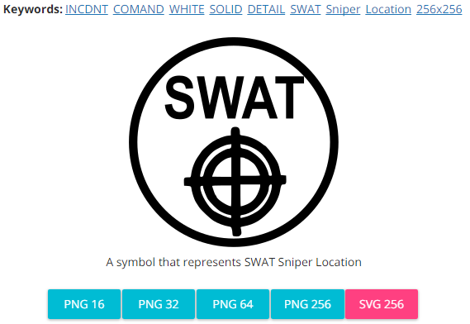

**Modified by:** Esri Solutions Team

**License:** None

**Acknowledgement:** None required

**Notes:** None

**Snow**

**Symbol Name:** [Snow](https://thenounproject.com/term/snow/24499/)

**Symbol Picture:** C:\Data\Symbology\StateGov\Transportation511\web\Snow.png

**Symbol Source:** The Noun Project

**Symbol Date:** January 2016



**Modified** **by:** Esri Solutions Team

**License:** Public Domain

**Acknowledgement:** None required

**Notes:** None

**Sound Stage**

**Symbol Name:**

**Symbol Picture:C:\Data\Symbology\Solutions\SpecialEventPlanning\mobile\Soundstage.png**

**Symbol Source:**

**Symbol Date:** December 2015

**Created by:** Esri Solutions Team

**License:** None

**Acknowledgement:** None required

**Notes:** None

**Signal**

**Symbol Name:**

**Symbol Picture:** C:\Users\heat5533\Documents\GitHub\solutions-symbology-data\symbology\mobile\png\Signal.png

**Symbol Source:** None

**Symbol Date:** July 2015

**Created by:** Esri Solutions Team

**License:** None

**Acknowledgement:** None required

**Notes:** None

**Signal Cabinet**

**Symbol Name:**

**Symbol Picture:** **C:\Users\heat5533\Documents\GitHub\solutions-symbology-data\symbology\mobile\png\Signal-Cabinet.png**

**Symbol Source:**

**Symbol Date:** July 2015

**Created by:** Esri Solutions Team

**License:** None

**Acknowledgement:** None required

**Notes:** None

**Slope Protection Violation**

**Symbol Name:** SP

**Symbol Picture:** C:\Data\Symbology\Utilities\Water\ConstructionSiteViolations\mobile\Slope-Protection-Violation.png

**Symbol Source:** Arial Rounded MT Bold Font

**Symbol Date:** March 2015

**Modified** **by:** Esri Solutions Team

**License:** None

**Acknowledgement:** None required

**Notes:** None

**Sprinkler Control Valve**

**Symbol Name:** [Sprinkler Control Valves, General](http://napsg-web.s3.amazonaws.com/symbology/index.html#/single?Sprinkler%20Control%20Valves%20 General%20Fire%20Suppression,%20General%20Features)

**Symbol Picture:** C:\Users\heat5533\AppData\Local\Microsoft\Windows\INetCacheContent.Word\Sprinkler-Control-Valve.png

**Symbol Source:** NAPSG (National Alliance for Public Safety GIS Foundation)

**Symbol Date:** March 2015



**Modified** **by:** Esri Solutions Team

**License:** None

**Acknowledgement:** None required

**Notes:** None

**Stairs**

**Symbol Name:** Stairs

**Symbol Picture:**



**Symbol Source:** Public Signs style file

**Symbol Date:** March 2017



**Modified** **by:** Esri Solutions Team

**License:** None

**Acknowledgement:** None required

**Notes:** None

**Stairway**

**Symbol Name:** Stairs

**Symbol Picture:** Stairway

**Symbol Source:** Public Signs style file

**Symbol Date:** February 2017



**Modified by:** Esri Solutions Team

**License:** None

**Acknowledgement:** None required

**Notes:** None

**Special Incident**

**Symbol Name:** !

**Symbol Picture:** C:\Users\heat5533\Documents\GitHub\solutions-symbology-data\symbology\web\png\Special-Incident.png

**Symbol Source:**

**Symbol Date:** December 2015

**Modified by:** Esri Solutions Team

**License:** None

**Acknowledgement:** None required

**Notes:** None

**Sprinkler Control Valve**

**Symbol Name:** [Sprinkler Control Valves, General](http://napsg-web.s3.amazonaws.com/symbology/index.html#/single?Sprinkler%20Control%20Valves%20 General%20Fire%20Suppression,%20General%20Features)

**Symbol Picture:** C:\Users\heat5533\AppData\Local\Microsoft\Windows\INetCacheContent.Word\Sprinkler-Control-Valve.png

**Symbol Source:** NAPSG (National Alliance for Public Safety GIS Foundation)

**Symbol Date:** March 2017



**Created by:** Esri Solutions Team

**License:** None

**Acknowledgement:** None required

**Notes:** None

**Staging Area**

**Symbol Name:** S

**Symbol Picture:** C:\Data\UC\UC2015\SituationalAwareness\web\Staging-Area.png

**Symbol Source:** Arial font

**Symbol Date:** July 2015

**Modified by:** Esri Solutions Team

**License:** None

**Acknowledgement:** None required

**Notes:** None

**State Operating Permit**

**Symbol Name:**

**Symbol Picture:** C:\Users\heat5533\Documents\GitHub\solutions-symbology-data\symbology\web\png\State-Operating-Permit.png

**Symbol Source:**

**Symbol Date:** October 2014

**Modified by:** Esri Solutions Team

**License:** None

**Acknowledgement:** None required

**Notes:** None

**Stormwater Map Change Request**

**Symbol Name:** [Map](https://thenounproject.com/term/map/2312/)

**Symbol Picture:** C:\Users\heat5533\Documents\GitHub\solutions-symbology-data\symbology\mobile\png\Stormwater-Map-Change-Request.pngC:\Users\heat5533\Documents\GitHub\solutions-symbology-data\symbology\web\png\Stormwater-Map-Change-Request.png

**Symbol Source:** The Noun Project

**Symbol Date:** May 2015



**Modified by:** Esri Solutions Team

**License:** Public Domain

**Acknowledgement:** None required

**Notes:** None

**Stormwater Map Change Request Critical**

**Symbol Name:** SW

**Symbol Picture:** C:\Users\heat5533\Documents\GitHub\solutions-symbology-data\symbology\mobile\png\Stormwater-Map-Change-Request-Critical.pngC:\Users\heat5533\Documents\GitHub\solutions-symbology-data\symbology\web\png\Stormwater-Map-Change-Request-Critical.png

**Symbol Source:** Arial Rounded MT Bold Font

**Symbol Date:** March 2015

**Modified** **by:** Esri Solutions Team

**License:** None

**Acknowledgement:** None required

**Notes:** None

**Stormwater Map Change Request Not Critical**

**Symbol Name:** SW

**Symbol Picture:** C:\Users\heat5533\Documents\GitHub\solutions-symbology-data\symbology\mobile\png\Stormwater-Map-Change-Request-Not-Critical.pngC:\Users\heat5533\Documents\GitHub\solutions-symbology-data\symbology\web\png\Stormwater-Map-Change-Request-Not-Critical.png

**Symbol Source:** Arial Rounded MT Bold Font

**Symbol Date:** March 2015

**Modified** **by:** Esri Solutions Team

**License:** None

**Acknowledgement:** None required

**Notes:** None

**Stormwater Multisector Permit**

**Symbol Name:** Overboard Discharge (right)

**Symbol Picture:** C:\Users\heat5533\Documents\GitHub\solutions-symbology-data\symbology\web\png\Stormwater-Multisector-Permit.png

**Symbol Source:** Environmental style file

**Symbol Date:** September 2014



**Modified by:** Esri Solutions Team

**License:** None

**Acknowledgement:** None required

**Notes:** None

**Street Furniture**

**Symbol Name:** [Park](https://thenounproject.com/search/?q=park&i=12246)

**Symbol Picture:** C:\Data\Symbology\LocalGov\StreetFurnitureInventory\mobile\Street-Furniture.png

**Symbol Source:** The Noun Project

**Symbol Date:** June 2015

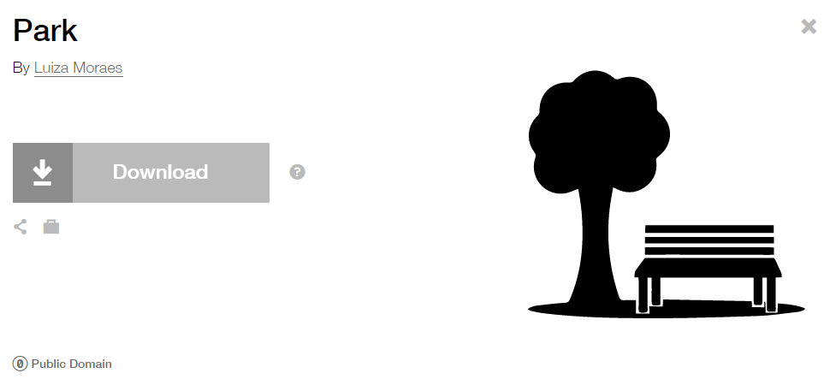

**Modified by:** Esri Solutions Team

**License:** Public Domain

**Acknowledgement:** None required

**Notes:** None

**Streetlight**

**Symbol Name:** [Light Bulb](https://thenounproject.com/search?q=light-bulb&i=8699)

**Symbol Picture:** C:\Data\Symbology\Utilities\Electric\DamageAssessment\mobile\Damage-Assessment-Electric-High-Damage.png

**Symbol Source:** The Noun Project

**Symbol Date:** April 2015



**Modified by:** Esri Solutions Team

**License:** Public Domain

**Acknowledgement:** None required

**Notes:** None

**Street Sign**

**Symbol Name:**

**Symbol Picture:** C:\Data\Symbology\LocalGov\SignInventory\mobile\Street-Sign.png

**Symbol Source:** None

**Symbol Date:** July 2015

**Created by:** Esri Solutions Team

**License:** None

**Acknowledgement:** None required

**Notes:** None

**Strobe Light**

**Symbol Name:**

**Symbol Picture:C:\Data\Symbology\Solutions\SpecialEventPlanning\mobile\Strobe-Light.png**

**Symbol Source:**

**Symbol Date:** December 2015

**Created by:** Esri Solutions Team

**License:** None

**Acknowledgement:** None required

**Notes:** None

**Substance Abuse**

**Symbol Name:** [Substance-Abuse-Service](http://thenounproject.com/term/substance-abuse-service/41339/)

**Symbol Picture: C:\Data\Symbology\StateGov\MyHealthServices\web\Sustance-Abuse.png**

**Symbol Source:** The Noun Project

**Symbol Date:** March 2015

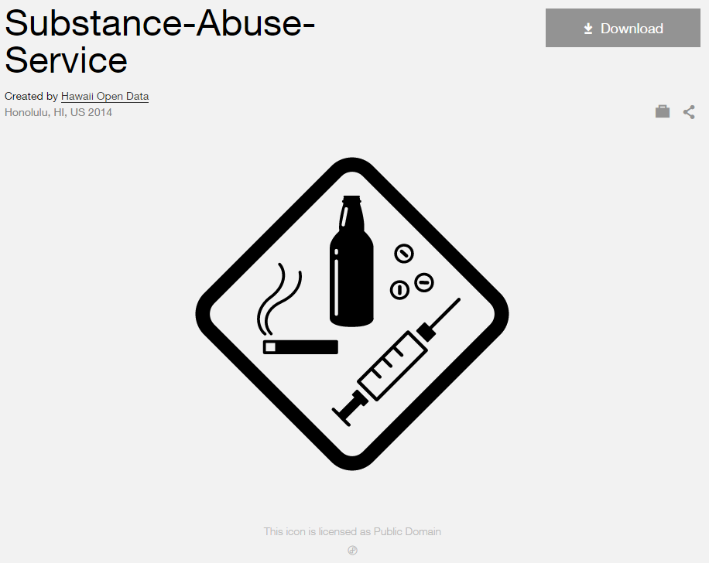

**Modified by:** Esri Solutions Team

**License:** Public Domain

**Acknowledgement:** None Required

**Notes:** None

**Suppression Control Valve**

**Symbol Name:** [Fire Supp. Control Panel, General](http://napsg-web.s3.amazonaws.com/symbology/index.html#/single?Fire%20Supp%20 Control%20Panel%20 General%20Fire%20Suppression,%20General%20Features)

**Symbol Picture:**



**Symbol Source:** NAPSG (National Alliance for Public Safety GIS Foundation)

**Symbol Date:** March 2017



**Created by:** Esri Solutions Team

**License:** None

**Acknowledgement:** None required

**Notes:** None

**Surface**

**Symbol Name:**

**Symbol Picture:** C:\Data\Symbology\Utilities\Water\CCTVProcessor\web\Surface.png

**Symbol Source:**

**Symbol Date:** May 2015

**Created by:** Esri Solutions Team

**License:** None

**Acknowledgement:** None required

**Notes:** None

**Suspect**

**Symbol Name:** [Magnifying Glass](https://thenounproject.com/search/?q=cog&i=907)

**Symbol Picture:** Suspect

**Symbol Source:**  The Noun Project

**Symbol Date:** December 2015

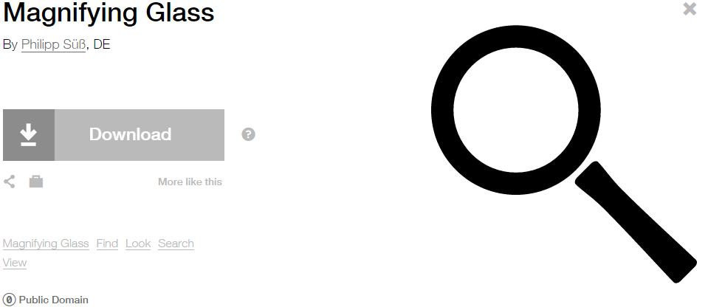

**Modified by:** Esri Solutions Team

**License:** Public Domain

**Acknowledgement:** None required

**Notes:** None

**SWAT Vehicle**

**Symbol Name:** SWAT

**Symbol Picture:** SWAT-Vehicle

**Symbol Source:** Arial font

**Symbol Date:** February 2017

**Modified by:** Esri Solutions Team

**License:** None

**Acknowledgement:** None required

**Notes:** None

**Tap**

**Symbol Name:**

**Symbol Picture:** C:\Data\Symbology\Utilities\Water\CCTVProcessor\web\Tap.png

**Symbol Source:**

**Symbol Date:** May 2015

**Created by:** Esri Solutions Team

**License:** None

**Acknowledgement:** None required

**Notes:** None

**Target**

**Symbol Name:**

**Symbol Picture:** Target

**Symbol Source:**

**Symbol Date:** February 2017

**Modified by:** Esri Solutions Team

**License:** None

**Acknowledgement:** None required

**Notes:** None

**Team 1**

**Symbol Name:** 1

**Symbol Picture:** Team-1

**Symbol Source:** Arial font

**Symbol Date:** December 2015

**Modified by:** Esri Solutions Team

**License:** None

**Acknowledgement:** None required

**Notes:** None

**Team 2**

**Symbol Name:** 2

**Symbol Picture:** C:\Users\heat5533\AppData\Local\Microsoft\Windows\INetCache\Content.Word\Team-2.png

**Symbol Source:** Arial font

**Symbol Date:** December 2015

**Modified by:** Esri Solutions Team

**License:** None

**Acknowledgement:** None required

**Notes:** None

**Team 3**

**Symbol Name:** 3

**Symbol Picture:** Team-3

**Symbol Source:** Arial font

**Symbol Date:** December 2015

**Modified by:** Esri Solutions Team

**License:** None

**Acknowledgement:** None required

**Notes:** None

**Team 4**

**Symbol Name:** 4

**Symbol Picture:** Team-4

**Symbol Source:** Arial font

**Symbol Date:** December 2015

**Modified by:** Esri Solutions Team

**License:** None

**Acknowledgement:** None required

**Notes:** None

**Telecommunications Shut Off**

**Symbol Name:** [Refrigeration\_With Line](http://napsg-web.s3.amazonaws.com/symbology/index.html#/single?PREPLAN%20SHUTOF%20BLUE%20%20SIMPLE%20Refrigeration%20With%20Line%20128x128)

**Symbol Picture:**



**Symbol Source:** NAPSG (National Alliance for Public Safety GIS Foundation

**Symbol Date:** March 2017

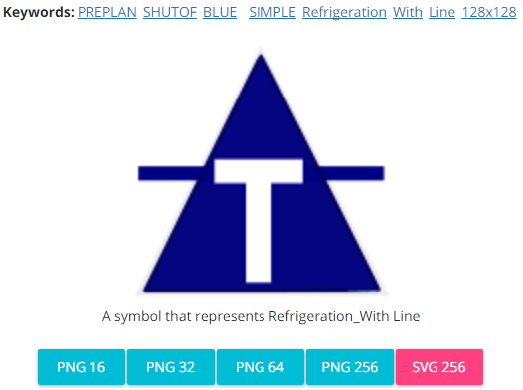

**Modified by:** Esri Solutions Team

**License:** None

**Acknowledgement:** None required

**Notes:** None

**Tent**

**Symbol Name:** Tent

**Symbol Picture: C:\Data\Symbology\Solutions\SpecialEventPlanning\mobile\Tent.png**

**Symbol Source:** Forestrystyle file

**Symbol Date:** December 2015



**Modified by:** Esri Solutions Team

**License:** None

**Acknowledgement:** None required

**Notes:** None

**Threat**

**Symbol Name:** !

**Symbol Picture:** Threat

**Symbol Source:** Arial font

**Symbol Date:** February 2017

**Modified by:** Esri Solutions Team

**License:** None

**Acknowledgement:** None required

**Notes:** None

**Ticket Purchase**

**Symbol Name:** Ticket Purchase

**Symbol Picture:C:\Data\Symbology\Solutions\SpecialEventPlanning\mobile\Ticket-Office.png**

**Symbol Source:** Public Signsstyle file

**Symbol Date:** December 2015

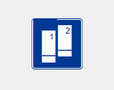

**Modified by:** Esri Solutions Team

**License:** None

**Acknowledgement:** None required

**Notes:** None

**Tornado**

**Symbol Name:** Tornado

**Symbol Picture:** C:\Data\Symbology\Solutions\HazardandRiskAssessment\web\Tornado.png

**Symbol Source:** ERS Homeland Security style file

**Symbol Date:** October 2015



**Modified** **by:** Esri Solutions Team

**License:** None

**Acknowledgement:** None required

**Notes:** None

**Traffic Checkpoint**

**Symbol Name:**

**Symbol Picture:C:\Data\Symbology\Solutions\SpecialEventPlanning\mobile\Traffic-Checkpoint.png**

**Symbol Source:**

**Symbol Date:** December 2015

**Created by:** Esri Solutions Team

**License:** None

**Acknowledgement:** None required

**Notes:** None

**Traffic Safety Problem – Completed, In – Progress, Received, and Submitted**

**Symbol Name:** [Car](https://thenounproject.com/term/car/72/) & Men

**Symbol Picture:** C:\Users\heat5533\Documents\GitHub\solutions-symbology-data\symbology\web\png\Traffic-Safety-Problem-Completed.pngC:\Users\heat5533\Documents\GitHub\solutions-symbology-data\symbology\web\png\Traffic-Safety-Problem-In-Progress.pngC:\Users\heat5533\Documents\GitHub\solutions-symbology-data\symbology\web\png\Traffic-Safety-Problem-Received.pngC:\Users\heat5533\Documents\GitHub\solutions-symbology-data\symbology\web\png\Traffic-Safety-Problem-Submitted.png

**Symbol Source:** The Noun Project & Public Signs style file

**Symbol Date:** March 2016

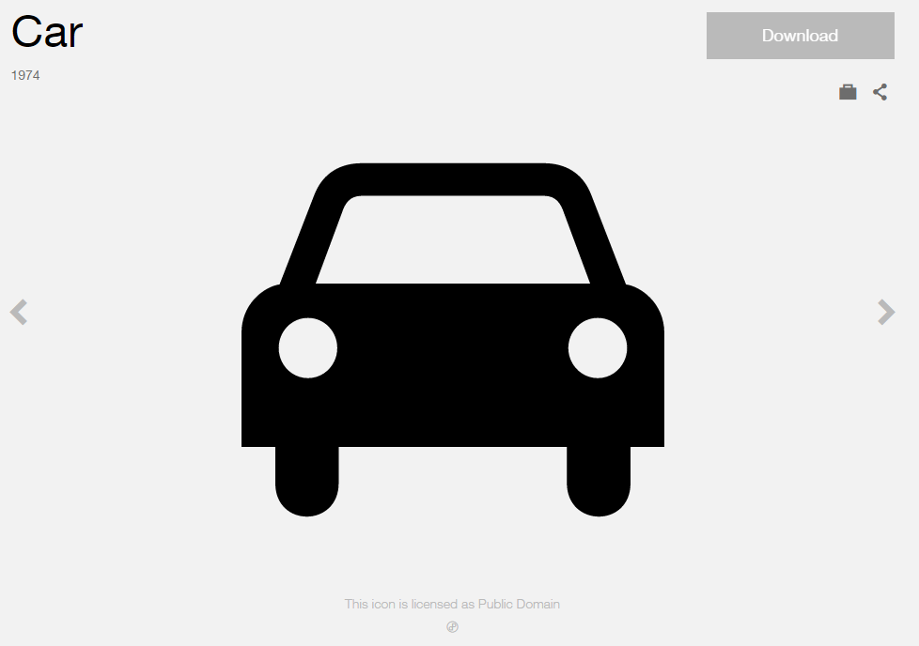 

**Modified** **by:** Esri Solutions Team

**License:** Public Domain

**Acknowledgement:** None required

**Notes:** None

**Train Derailment**

**Symbol Name:** Rail Transportation

**Symbol Picture:** C:\Data\Symbology\Solutions\HazardandRiskAssessment\web\Train-Derailment.png

**Symbol Source:** Public Signs style file

**Symbol Date:** February 2015



**Modified** **by:** Esri Solutions Team

**License:** None

**Acknowledgement:** None required

**Notes:** None

**Trash Dumpster**

**Symbol Name:** [Dumpster Diving](https://thenounproject.com/term/dumpster/162584/)

**Symbol Picture:C:\Data\Symbology\Solutions\SpecialEventPlanning\mobile\Trash-Dumpster.png**

**Symbol Source:** The Noun Project

**Symbol Date:** December 2015

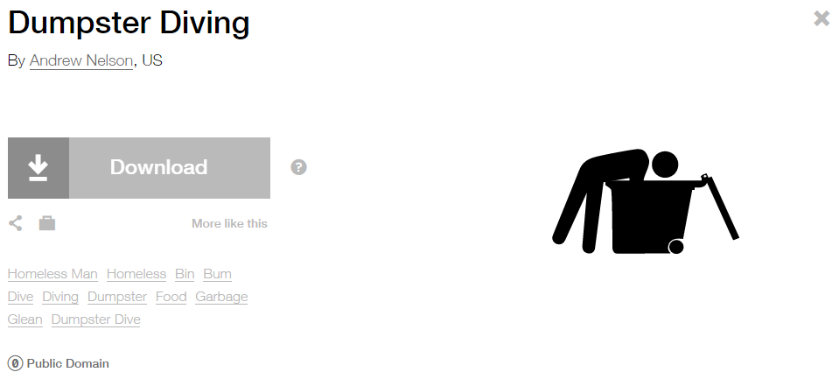

**Modified by:** Esri Solutions Team

**License:** Public Domain

**Acknowledgement:** None required

**Notes:** None

**Trash Problem – Completed, In – Progress, Received, and Submitted**

**Symbol Name:** [Solid Waste](https://thenounproject.com/search/?q=garbage&i=4337)

**Symbol Picture:** C:\Users\heat5533\Documents\GitHub\solutions-symbology-data\symbology\web\png\Trash-Problem-Completed.pngC:\Users\heat5533\Documents\GitHub\solutions-symbology-data\symbology\web\png\Trash-Problem-In-Progress.pngC:\Users\heat5533\Documents\GitHub\solutions-symbology-data\symbology\web\png\Trash-Problem-Received.pngC:\Users\heat5533\Documents\GitHub\solutions-symbology-data\symbology\web\png\Trash-Problem-Submitted.png

**Symbol Source:** The Noun Project

**Symbol Date:** March 2016

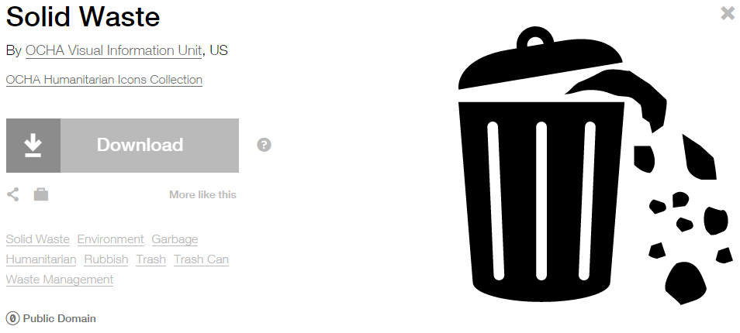

**Modified** **by:** EsriSolutions Team

**License:** Public Domain

**Acknowledgement:** None required

**Notes:** None

**Trash Receptacle**

**Symbol Name:** Unicode 123

**Symbol Picture:C:\Data\Symbology\Solutions\SpecialEventPlanning\mobile\Trash-Receptacle.png**

**Symbol Source:** ESRI Public 1 Font

**Symbol Date:** December 2015



**Modified by:** Esri Solutions Team

**License:** None

**Acknowledgement:** None required

**Notes:** None

**Treatment Exception**

**Symbol Name:** [No Spray](https://thenounproject.com/search/?q=no+spray&i=58374)

**Symbol Picture:**



**Symbol Source:** The Noun Project

**Symbol Date:** March 2016

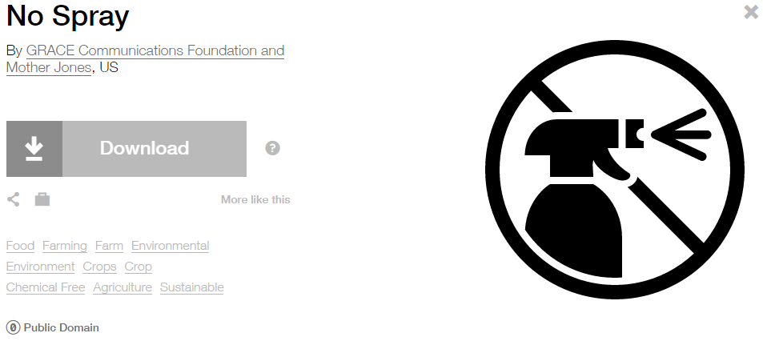

**Modified by:** Esri Solutions Team

**License:** Public Domain

**Acknowledgement:** None required

**Notes:** None

**Tsunami**

**Symbol Name:** Tsunami

**Symbol Picture:** C:\Data\Symbology\Solutions\HazardandRiskAssessment\web\Tsunami.png

**Symbol Source:** ERS Homeland Security style file

**Symbol Date:** October 2015



**Modified** **by:** Esri Solutions Team

**License:** None

**Acknowledgement:** None required

**Notes:** None

**Typha**

**Symbol Name:** [Wetland](https://thenounproject.com/term/wetland/6275/)

**Symbol Picture:** C:\Data\Symbology\StateGov\CitizenScience\web\Typha.png

**Symbol Source:** The Noun Project

**Symbol Date:** May 2016

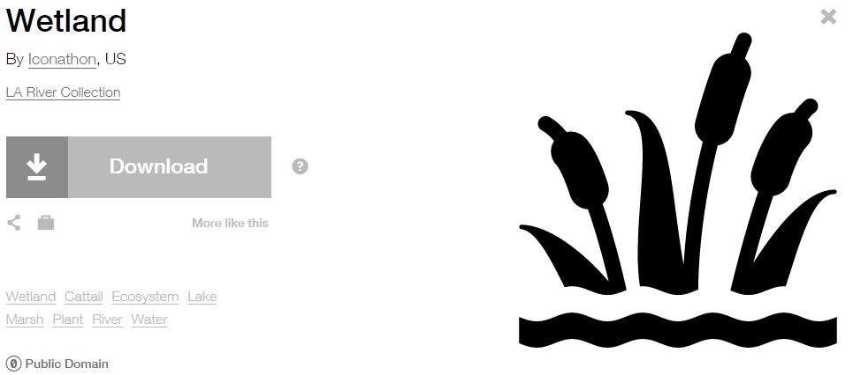

**Modified** **by:** Esri Solutions Team

**License:** Public Domain

**Acknowledgement:** None required

**Notes:** None

**Trees**

**Symbol Name:** Tree, Deciduous, Top

**Symbol Picture:** **C:\Data\Symbology\LocalGov\StreetTreeInventory\mobile\Street-Trees.png**

**Symbol Source:** Environmental style file

**Symbol Date:** July 2015



**Modified** **by:** EsriSolutions Team

**License:** None

**Acknowledgement:** None required

**Notes:** None

**Unauthorized Attachment - Cable**

**Symbol Name:** C

**Symbol Picture:** C:\Data\Symbology\Utilities\Electric\JointUseSurvey\web\Unauthorized-Attachment-Cable.png

**Symbol Source:** Arial Rounded MT Bold

**Symbol Date:** April 2015

**Modified by:** Esri Solutions Team

**License:** None

**Acknowledgement:** None required

**Notes:** None

**Unauthorized Attachment - Fiber**

**Symbol Name:** Fb

**Symbol Picture:** C:\Data\Symbology\Utilities\Electric\JointUseSurvey\web\Unauthorized-Attachment-Fiber.png

**Symbol Source:** Arial Rounded MT Bold

**Symbol Date:** April 2015

**Modified by:** Esri Solutions Team

**License:** None

**Acknowledgement:** None required

**Notes:** None

**Unauthorized Attachment - Fire**

**Symbol Name:** Fr

**Symbol Picture:** C:\Data\Symbology\Utilities\Electric\JointUseSurvey\web\Unauthorized-Attachment-Fire.png

**Symbol Source:** Arial Rounded MT Bold

**Symbol Date:** April 2015

**Modified by:** Esri Solutions Team

**License:** None

**Acknowledgement:** None required

**Notes:** None

**Unauthorized Attachment - Other**

**Symbol Name:** O

**Symbol Picture:** C:\Data\Symbology\Utilities\Electric\JointUseSurvey\web\Unauthorized-Attachment-Other.png

**Symbol Source:** Arial Rounded MT Bold

**Symbol Date:** April 2015

**Modified by:** Esri Solutions Team

**License:** None

**Acknowledgement:** None required

**Notes:** None

**Unauthorized Attachment - Sign**

**Symbol Name:** S

**Symbol Picture:** C:\Data\Symbology\Utilities\Electric\JointUseSurvey\web\Unauthorized-Attachment-Sign.png

**Symbol Source:** Arial Rounded MT Bold

**Symbol Date:** April 2015

**Modified by:** Esri Solutions Team

**License:** None

**Acknowledgement:** None required

**Notes:** None

**Unauthorized Attachment - Telecommunications**

**Symbol Name:** T

**Symbol Picture:** C:\Data\Symbology\Utilities\Electric\JointUseSurvey\web\Unauthorized-Attachment-Telecommunication.png

**Symbol Source:** Arial Rounded MT Bold

**Symbol Date:** April 2015

**Modified by:** Esri Solutions Team

**License:** None

**Acknowledgement:** None required

**Notes:** None

**Underground Storage Tank Permit**

**Symbol Name:** Underground Storage Tank

**Symbol Picture:** C:\Users\heat5533\Documents\GitHub\solutions-symbology-data\symbology\web\png\Underground-Storage-Tank.png

**Symbol Source:** Environmental style file

**Symbol Date:** September 2014

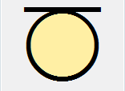

**Modified by:** Esri Solutions Team

**License:** None

**Acknowledgement:** None required

**Notes:** None

**Under Investigation**

**Symbol Name:** [Magnifying Glass](https://thenounproject.com/search/?q=cog&i=907)

**Symbol Picture:** C:\Users\heat5533\Documents\GitHub\solutions-symbology-data\symbology\web\png\Under-Investigation.png

**Symbol Source:**  The Noun Project

**Symbol Date:** December 2015



**Modified by:** Esri Solutions Team

**License:** Public Domain

**Acknowledgement:** None required

**Notes:** None

**Undetermined after Investigation**

**Symbol Name:** ?

**Symbol Picture:** C:\Users\heat5533\Documents\GitHub\solutions-symbology-data\symbology\web\png\Undetermined-after-Investigation.png

**Symbol Source:**  Arial Rounded MT Bold

**Symbol Date:** December 2015

**Modified by:** Esri Solutions Team

**License:** None

**Acknowledgement:** None required

**Notes:** None

**Unintentional**

**Symbol Name:** Fire Incident

**Symbol Picture:** C:\Users\heat5533\Documents\GitHub\solutions-symbology-data\symbology\web\png\Unintentional.png

**Symbol Source:** ERS Homeland Security style file

**Symbol Date:** July 2015



**Modified** **by:** Esri Solutions Team

**License:** None

**Acknowledgement:** None required

**Notes:** None

**Urban Conflagration**

**Symbol Name:** City

**Symbol Picture:** C:\Data\Symbology\Solutions\HazardandRiskAssessment\web\Urban-Conflagration.png

**Symbol Source:** Business style file

**Symbol Date:** September 2014



**Modified by:** Esri Solutions Team

**License:** None

**Acknowledgement:** None required

**Notes:** None

**Utility Problem – Completed, In – Progress, Received, and Submitted**

**Symbol Name:** Water Recreation & Droplet, Water

**Symbol Picture:** C:\Users\heat5533\Documents\GitHub\solutions-symbology-data\symbology\web\png\Utility-Problem-Completed.pngC:\Users\heat5533\Documents\GitHub\solutions-symbology-data\symbology\web\png\Utility-Problem-In-Progress.pngC:\Users\heat5533\Documents\GitHub\solutions-symbology-data\symbology\web\png\Utility-Problem-Received.pngC:\Users\heat5533\Documents\GitHub\solutions-symbology-data\symbology\web\png\Utility-Problem-Submitted.png

**Symbol Source:** Forestry & Environmental style file

**Symbol Date:** December 2015

 

**Modified by:** Esri Solutions Team

**License:** None

**Acknowledgement:** None required

**Notes:** None

**Vector Control Problem – Completed, In – Progress, Received, and Submitted**

**Symbol Name:** [Mosquito](https://thenounproject.com/search/?q=mosquito&i=215264)

**Symbol Picture:** C:\Users\heat5533\Documents\GitHub\solutions-symbology-data\symbology\web\png\Vector-Control-Problem-Completed.pngC:\Users\heat5533\Documents\GitHub\solutions-symbology-data\symbology\web\png\Vector-Control-Problem-In-Progress.pngC:\Users\heat5533\Documents\GitHub\solutions-symbology-data\symbology\web\png\Vector-Control-Problem-Received.pngC:\Users\heat5533\Documents\GitHub\solutions-symbology-data\symbology\web\png\Vector-Control-Problem-Submitted.png

**Symbol Source:** bi Project

**Symbol Date:** March 2016



**Modified** **by:** EsriSolutions Team

**License:** Public Domain

**Acknowledgement:** None required

**Notes:** None

**Vegetation**

**Symbol Name:** [Leaf](https://thenounproject.com/term/leaf/5077/)

**Symbol Picture:** C:\Data\Symbology\Utilities\Electric\HazardReportingCollector\mobile\Vegetation.pngC:\Data\Symbology\Utilities\Electric\HazardReportingCollector\web\Vegetation.png

**Symbol Source:** The Noun Project

**Symbol Date:** March 2015

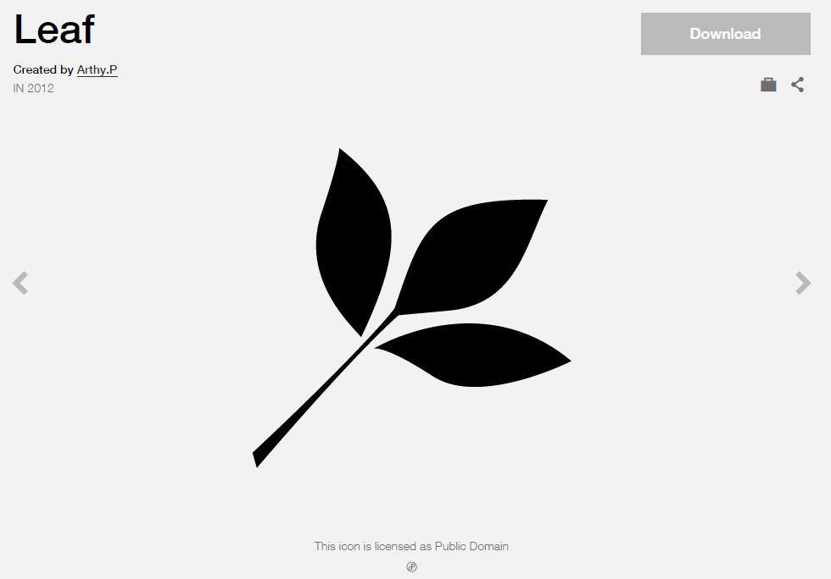

**Modified** **by:** Esri Solutions Team

**License:** Public Domain

**Acknowledgement:** None required

**Notes:** None

**Vehicle Incident**

**Symbol Name:** [Car](https://thenounproject.com/term/car/72/)

**Symbol Picture:** C:\Data\Symbology\Solutions\OpsIncident\web\Vehicle-Incident.png

**Symbol Source:** The Noun Project

**Symbol Date:** March 2015



**Modified** **by:** Esri Solutions Team

**License:** Public Domain

**Acknowledgement:** None required

**Notes:** None

**Vermin**

**Symbol Name:**

**Symbol Picture:** C:\Data\Symbology\Utilities\Water\CCTVProcessor\web\Vermin.png

**Symbol Source:**

**Symbol Date:** May 2015

**Created by:** Esri Solutions Team

**License:** None

**Acknowledgement:** None required

**Notes:** None

**Vehicles and Vessels**

**Symbol Name:** [Ship](http://thenounproject.com/term/ship/4409/)

**Symbol Picture: C:\Data\Symbology\Solutions\OpsIncident\web\Marine-Incident.png**

**Symbol Source:** The Noun Project

**Symbol Date:** March 2015



**Modified by:** Esri Solutions Team

**License:** Public Domain

**Acknowledgement:** None Required

**Notes:** None

**Victim**

**Symbol Name:** Homicide Location

**Symbol Picture:** Victim

**Symbol Source:** Crime Analysis style file

**Symbol Date:** February 2017

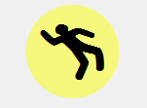

**Modified by:** Esri Solutions Team

**License:** None

**Acknowledgement:** None required

**Notes:** None

**Video**

**Symbol Name:**

**Symbol Picture:** C:\Data\Symbology\StateGov\Transportation511\web\Video.png

**Symbol Source:**

**Symbol Date:** December 2015

**Created by:** Esri Solutions Team

**License:** None

**Acknowledgement:** None required

**Notes:** None

**Violations - Severe**

**Symbol Name:** !

**Symbol Picture:** C:\Data\Symbology\Utilities\Electric\JointUseSurvey\mobile\Violation-Severe.pngC:\Data\Symbology\Utilities\Electric\JointUseSurvey\web\Violation-High.png

**Symbol Source:** Arial Rounded MT Bold

**Symbol Date:** April 2015

**Modified by:** Esri Solutions Team

**License:** None

**Acknowledgement:** None required

**Notes:** None

**Violations - Medium**

**Symbol Name:** !

**Symbol Picture:** C:\Data\Symbology\Utilities\Electric\JointUseSurvey\mobile\Violation-Medium.pngC:\Data\Symbology\Utilities\Electric\JointUseSurvey\web\Violation-Medium.png

**Symbol Source:** Arial Rounded MT Bold

**Symbol Date:** April 2015

**Modified by:** Esri Solutions Team

**License:** None

**Acknowledgement:** None required

**Notes:** None

**Violations - Low**

**Symbol Name:** !

**Symbol Picture:** C:\Data\Symbology\Utilities\Electric\JointUseSurvey\mobile\Violation-Low.pngC:\Data\Symbology\Utilities\Electric\JointUseSurvey\web\Violation-Low.png

**Symbol Source:** Arial Rounded MT Bold

**Symbol Date:** April 2015

**Modified by:** Esri Solutions Team

**License:** None

**Acknowledgement:** None required

**Notes:** None

**Violent Person**

**Symbol Name:** Assault, Solid Fist

**Symbol Picture:** C:\Data\Symbology\Utilities\Electric\HazardReportingCollector\mobile\Violent-Person.pngC:\Data\Symbology\Utilities\Electric\HazardReportingCollector\web\Violent-Person.png

**Symbol Source:** Crime Analysis style file

**Symbol Date:** June 2015



**Modified** **by:** Esri Solutions Team

**License:** None

**Acknowledgement:** None required

**Notes:** None

**Volcano Eruption**

**Symbol Name:** [Volcano](https://thenounproject.com/ochaavmu/collection/ocha-humanitarian-icons/?q=volcano&i=4253)

**Symbol Picture:** C:\Data\Symbology\Solutions\HazardandRiskAssessment\web\Volcanic-Eruption.png

**Symbol Source:** The Noun Project

**Symbol Date:** September 2015

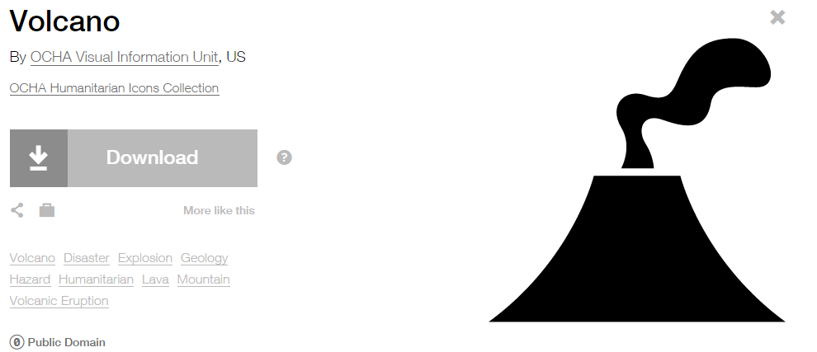

**Modified by:** EsriSolutions Team

**License:** Public Domain

**Acknowledgement:** None required

**Notes:** None

**Volunteer Services**

**Symbol Name:** Men

**Symbol Picture:C:\Data\Symbology\Solutions\SpecialEventPlanning\mobile\Volunteer-Services.png**

**Symbol Source:** Public Signs style file

**Symbol Date:** December 2015



**Modified by:** Esri Solutions Team

**License:** None

**Acknowledgement:** None required

**Notes:** None

**Warming Center**

**Symbol Name:** Unicode 113

**Symbol Picture:** C:\Users\heat5533\Documents\GitHub\solutions-symbology-data\symbology\web\png\Warming-Center.png

**Symbol Source:** ESRI Enviro Hazard Analysis

**Symbol Date:** February 2015



**Modified** **by:** Esri Solutions Team

**License:** None

**Acknowledgement:** None required

**Notes:** None

**Warning**

**Symbol Name:** !

**Symbol Picture:** C:\Data\Symbology\StateGov\Transportation511\web\Warning.png

**Symbol Source:** Arial Rounded MT Bold

**Symbol Date:** May 2015

**Modified by:** Esri Solutions Team

**License:** None

**Acknowledgement:** None required

**Notes:** None

**Warning – on/near road**

**Symbol Name:** !

**Symbol Picture:** C:\Data\Symbology\StateGov\Transportation511\web\Warning-on-or-near-road.png

**Symbol Source:** Arial Rounded MT Bold

**Symbol Date:** May 2015

**Modified by:** Esri Solutions Team

**License:** None

**Acknowledgement:** None required

**Notes:** None

**Water Distribution Center**

**Symbol Name:** Faucet

**Symbol Picture:** C:\Data\UC\UC2015\SituationalAwareness\web\Water-Distribution-Center.png

**Symbol Source:**  Civic style file

**Symbol Date:** July 2015

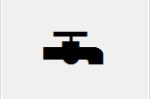

**Modified by:** Esri Solutions Team

**License:** None

**Acknowledgement:** None required

**Notes:** None

**Waste Disposal Violation**

**Symbol Name:** WD

**Symbol Picture:** C:\Data\Symbology\Utilities\Water\ConstructionSiteViolations\mobile\Waste-Disposal-Violation.png

**Symbol Source:** Arial Rounded MT Bold Font

**Symbol Date:** March 2015

**Modified** **by:** Esri Solutions Team

**License:** None

**Acknowledgement:** None required

**Notes:** None

**Water Map Change Request**

**Symbol Name:** [Map](https://thenounproject.com/term/map/2312/)

**Symbol Picture:** C:\Users\heat5533\Documents\GitHub\solutions-symbology-data\symbology\mobile\png\Water-Map-Change-Request.pngC:\Users\heat5533\Documents\GitHub\solutions-symbology-data\symbology\web\png\Water-Map-Change-Request.png

**Symbol Source:** The Noun Project

**Symbol Date:** May 2015



**Modified by:** Esri Solutions Team

**License:** Public Domain

**Acknowledgement:** None required

**Notes:** None

**Water Map Change Request Critical**

**Symbol Name:** W

**Symbol Picture:** C:\Users\heat5533\Documents\GitHub\solutions-symbology-data\symbology\mobile\png\Water-Map-Change-Request-Critical.pngC:\Users\heat5533\Documents\GitHub\solutions-symbology-data\symbology\web\png\Water-Map-Change-Request-Critical.png

**Symbol Source:** Arial Rounded MT Bold Font

**Symbol Date:** March 2015

**Modified** **by:** Esri Solutions Team

**License:** None

**Acknowledgement:** None required

**Notes:** None

**Water Map Change Request Not Critical**

**Symbol Name:** W

**Symbol Picture:** C:\Users\heat5533\Documents\GitHub\solutions-symbology-data\symbology\mobile\png\Water-Map-Change-Request-Not-Critical.pngC:\Users\heat5533\Documents\GitHub\solutions-symbology-data\symbology\web\png\Water-Map-Change-Request-Not-Critical.png

**Symbol Source:** Arial Rounded MT Bold Font

**Symbol Date:** March 2015

**Modified** **by:** Esri Solutions Team

**License:** None

**Acknowledgement:** None required

**Notes:** None

**Water Quality Advisory - No**

**Symbol Name:** Water Recreation & Droplet, Water

**Symbol Picture:** C:\Users\heat5533\Documents\GitHub\solutions-symbology-data\symbology\web\png\Water-Quality-Advisory-No.png



**Symbol Source:** Forestry & Environmental style file

**Symbol Date:** December 2015

 

**Modified by:** Esri Solutions Team

**License:** None

**Acknowledgement:** None required

**Notes:** None

**Water Quality – Not Applicable**

**Symbol Name:** Water Recreation & Droplet, Water

**Symbol Picture:** C:\Users\heat5533\Documents\GitHub\solutions-symbology-data\symbology\web\png\Water-Quality-Advisory-Not-Applicable.png



**Symbol Source:** Forestry & Environmental style file

**Symbol Date:** December 2015

 

**Modified by:** Esri Solutions Team

**License:** None

**Acknowledgement:** None required

**Notes:** None

**Water Quality - Yes**

**Symbol Name:** Water Recreation & Droplet, Water

**Symbol Picture:** C:\Users\heat5533\Documents\GitHub\solutions-symbology-data\symbology\web\png\Water-Quality-Advisory-Yes.png



**Symbol Source:** Forestry & Environmental style file

**Symbol Date:** December 2015

 

**Modified by:** Esri Solutions Team

**License:** None

**Acknowledgement:** None required

**Notes:** None

**Water Shut Off**

**Symbol Name:** [Water Shutoff\_With Line](http://napsg-web.s3.amazonaws.com/symbology/index.html#/single?PREPLAN%20SHUTOF%20BLUE%20%20SIMPLE%20Water%20Shutoff%20With%20Line%20128x128)

**Symbol Picture:**



**Symbol Source:** NAPSG (National Alliance for Public Safety GIS Foundation)

**Symbol Date:** March 2017

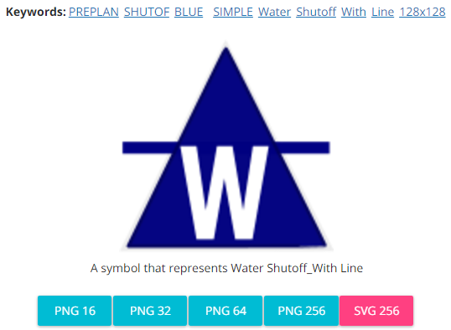

**Modified by:** Esri Solutions Team

**License:** None

**Acknowledgement:** None required

**Notes:** None

**Water Treatment Plant Permit**

**Symbol Name:** Tank Farm

**Symbol Picture:** C:\Users\heat5533\Documents\GitHub\solutions-symbology-data\symbology\web\png\Water-Treatment-Plant.png

**Symbol Source:** Environmental style file

**Symbol Date:** September 2014

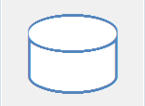

**Modified by:** Esri Solutions Team

**License:** None

**Acknowledgement:** None required

**Notes:** None

**Watering Violations - Commercial**

**Symbol Name:** !

**Symbol Picture:C:\Users\heat5533\Documents\GitHub\solutions-symbology-data\symbology\mobile\png\Watering-Violations-Commerial.png**

**Symbol Source:** Arial Rounded MT Bold

**Symbol Date:** May 2015

**Modified by:** Esri Solutions Team

**License:** None

**Acknowledgement:** None required

**Notes:** None

**Watering Violations - Industrial**

**Symbol Name:** !

**Symbol Picture:** C:\Users\heat5533\Documents\GitHub\solutions-symbology-data\symbology\mobile\png\Watering-Violations-Industrial.png

**Symbol Source:** Arial Rounded MT Bold

**Symbol Date:** May 2015

**Modified by:** Esri Solutions Team

**License:** None

**Acknowledgement:** None required

**Notes:** None

**Watering Violations - Parks**

**Symbol Name:** !

**Symbol Picture:** C:\Users\heat5533\Documents\GitHub\solutions-symbology-data\symbology\mobile\png\Watering-Violations-Parks.png

**Symbol Source:** Arial Rounded MT Bold

**Symbol Date:** May 2015

**Modified by:** Esri Solutions Team

**License:** None

**Acknowledgement:** None required

**Notes:** None

**Watering Violations - Residential**

**Symbol Name:** !

**Symbol Picture:** C:\Users\heat5533\Documents\GitHub\solutions-symbology-data\symbology\mobile\png\Watering-Violations-Residential.png

**Symbol Source:** Arial Rounded MT Bold

**Symbol Date:** May 2015

**Modified by:** Esri Solutions Team

**License:** None

**Acknowledgement:** None required

**Notes:** None

**Weeds**

**Symbol Name:** [Dandelion](https://thenounproject.com/term/dandelion/20016/)

**Symbol Picture:** C:\Data\Symbology\StateGov\CitizenScience\web\Weeds.png

**Symbol Source:** The Noun Project

**Symbol Date:** March 2015

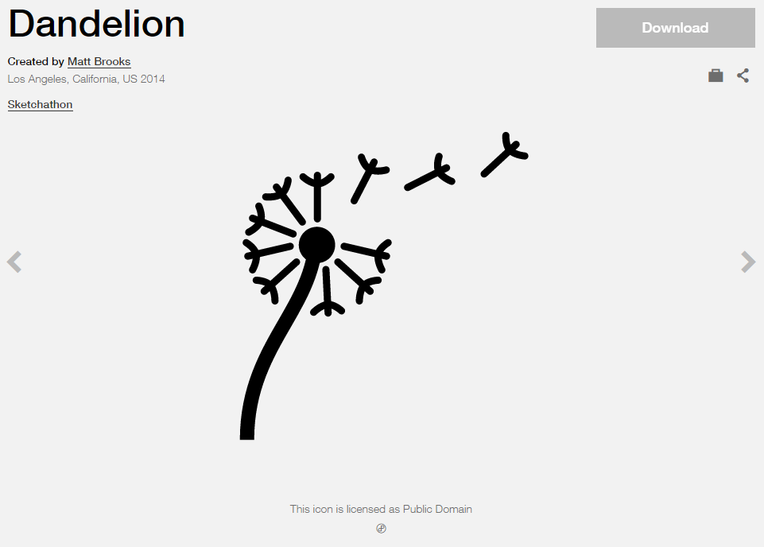

**Modified by:** Esri Solutions Team

**License:** Public Domain

**Acknowledgement:** None required

**Notes:** None

**Weld**

**Symbol Name:**

**Symbol Picture:** C:\Data\Symbology\Utilities\Water\CCTVProcessor\web\Weld.png

**Symbol Source:**

**Symbol Date:** May 2015

**Created by:** Esri Solutions Team

**License:** None

**Acknowledgement:** None required

**Notes:** None

**West Nile Virus**

**Symbol Name:** !

**Symbol Picture:**



**Symbol Source:**  Arial Rounded MT Bold

**Symbol Date:** December 2016

**Modified by:** Esri Solutions Team

**License:** None

**Acknowledgement:** None required

**Notes:** None

**Width and Height Restriction**

**Symbol Name:**

**Symbol Picture:** C:\Data\Symbology\StateGov\Transportation511\web\Width-Height-Restriction.png

**Symbol Source:**

**Symbol Date:** February 2016

**Created by:** Esri Solutions Team

**License:** None

**Acknowledgement:** None Required

**Notes:** None

**Width and Height Restriction - Alert**

**Symbol Name:**

**Symbol Picture:** C:\Data\Symbology\StateGov\Transportation511\web\Width-Height-Restriction-Alert.png

**Symbol Source:**

**Symbol Date:** February 2016

**Created by:** Esri Solutions Team

**License:** None

**Acknowledgement:** None Required

**Notes:** None

**Width and Height Restriction – Work Zones**

**Symbol Name:**

**Symbol Picture:** C:\Data\Symbology\StateGov\Transportation511\web\Width-Height-Restriction-Work-Zones.png

**Symbol Source:**

**Symbol Date:** February 2016

**Created by:** Esri Solutions Team

**License:** None

**Acknowledgement:** None Required

**Notes:** None

**Wildfire**

**Symbol Name:** Wildfire

**Symbol Picture:** C:\Data\Symbology\Solutions\HazardandRiskAssessment\web\Wildfire.png

**Symbol Source:** ERS Homeland Security style file

**Symbol Date:** October 2015



**Modified** **by:** Esri Solutions Team

**License:** None

**Acknowledgement:** None required

**Notes:** None

**Wildlife Management Areas**

**Symbol Name:** Wildlife 2

**Symbol Picture:** C:\Users\heat5533\Documents\GitHub\solutions-symbology-data\symbology\web\png\Wildlife-Management-Areas.png

**Symbol Source:** Conservation style file

**Symbol Date:** May 2014



**Modified by:** Esri Solutions Team

**License:** None

**Acknowledgement:** None required

**Notes:** None

**Wind**

**Symbol Name:** [Wind](https://thenounproject.com/term/wind/7702/)

**Symbol Picture:** C:\Data\Symbology\Solutions\HazardandRiskAssessment\web\Wind.png

**Symbol Source:** The Noun Project

**Symbol Date:** January 2016

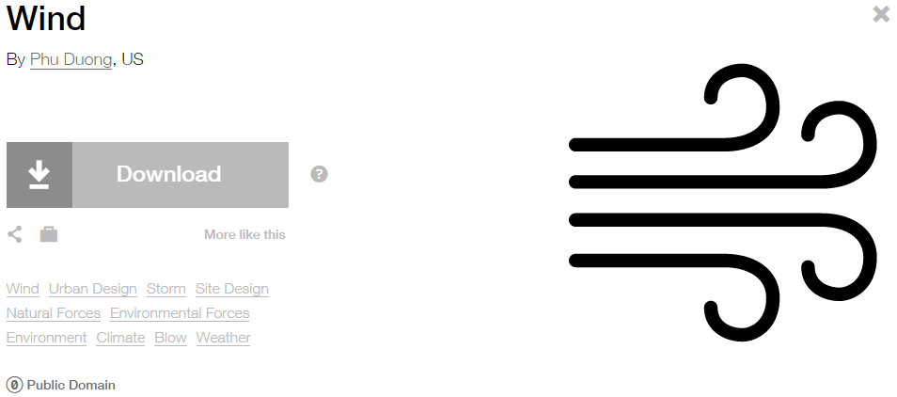

**Modified** **by:** Esri Solutions Team

**License:** Public Domain

**Acknowledgement:** None required

**Notes:** None

**Window**

**Symbol Name:**

**Symbol Picture:** Window

**Symbol Source:**

**Symbol Date:** February 2017

**Modified by:** Esri Solutions Team

**License:** None

**Acknowledgement:** None required

**Notes:** None

**Wineries**

**Symbol Name:**

**Symbol Picture:** C:\Users\heat5533\Documents\GitHub\solutions-symbology-data\symbology\web\png\Wineries.png

**Symbol Source:**

**Symbol Date:** March 2015

**Created by:** Esri Solutions Team

**License:** None

**Acknowledgement:** None required

**Notes:** None

**Winter Storm**

**Symbol Name:** [Snow](https://thenounproject.com/term/snow/24499/)

**Symbol Picture:** C:\Data\Symbology\Solutions\HazardandRiskAssessment\web\Winter-Storm.png

**Symbol Source:** The Noun Project

**Symbol Date:** January 2016



**Modified** **by:** Esri Solutions Team

**License:** Public Domain

**Acknowledgement:** None required

**Notes:** None

**Wire Down**

**Symbol Name:** [Power Lines](https://thenounproject.com/search/?q=power&i=4928)

**Symbol Picture:** C:\Data\Symbology\Utilities\Electric\HazardReportingCollector\mobile\Wire-Down.pngC:\Data\Symbology\Utilities\Electric\HazardReportingCollector\web\Wire-Down.png

**Symbol Source:** The Noun Project

**Symbol Date:** June 2015

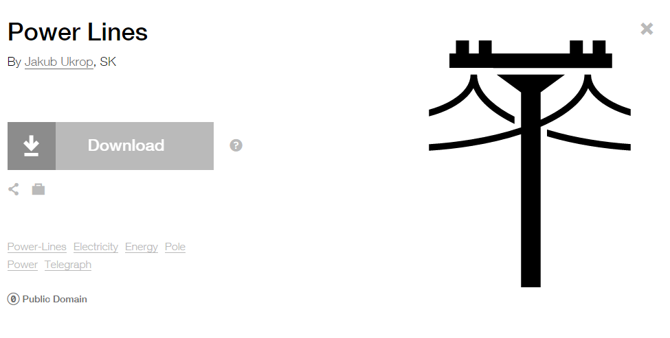

**Modified by:** Esri Solutions Team

**License:** Public Domain

**Acknowledgement:** None required

**Notes:** None

**Work Zone - Inactive**

**Symbol Name:** Worker

**Symbol Picture:** C:\Data\Symbology\StateGov\Transportation511\web\Work-Zone-Inactive.png

**Symbol Source:** Transportation style file

**Symbol Date:** April 2014



**Modified by:** Esri Solutions Team

**License:** None

**Acknowledgement:** None Required

**Notes:** None

**Work Zone Line**

**Symbol Name:** Worker

**Symbol Picture:** C:\Data\Symbology\StateGov\Transportation511\web\Work-Zone-Line.png

**Symbol Source:** Transportation style file

**Symbol Date:** April 2014



**Modified by:** Esri Solutions Team

**License:** None

**Acknowledgement:** None Required

**Work Zones**

**Symbol Name:** Worker

**Symbol Picture:** C:\Data\Symbology\StateGov\Transportation511\web\Work-Zones.png

**Symbol Source:** Transportation style file

**Symbol Date:** April 2014



**Modified by:** Esri Solutions Team

**License:** None

**Acknowledgement:** None Required

**Notes:** None

**Yellow Fever**

**Symbol Name:** !

**Symbol Picture:** **C:\Users\heat5533\AppData\Local\Microsoft\Windows\INetCache\Content.Word\Yellow-Fever.png**

**Symbol Source:**  Arial Rounded MT Bold

**Symbol Date:** December 2016

**Modified by:** Esri Solutions Team

**License:** None

**Acknowledgement:** None required

**Notes:** None

**Zebra Mussel**

**Symbol Name:**

**Symbol Picture: C:\Data\Symbology\StateGov\CitizenScience\web\Zebra-Mussel.png**

**Symbol Source:**

**Symbol Date:** May 2016

**Created by:** Esri Solutions Team

**License:** None

**Acknowledgement:** None required

**Notes:** None

**Zika Fever**

**Symbol Name:** !

**Symbol Picture:**



**Symbol Source:**  Arial Rounded MT Bold

**Symbol Date:** December 2016

**Modified by:** Esri Solutions Team

**License:** None

**Acknowledgement:** None required

**Notes:** None